

**Centre Name: FPT-HCM3**

**TUNGA RESTAURANTS WEBSITE**

**< Design Document >**

|  |  |  |  |
| --- | --- | --- | --- |
| **Faculty:** |  | **Mr.Ngo Phuoc Nguyen** |  |
| **Batch No:** |  | **F3-1303-S1** |
| **Group No:** |  | **1** |
| **Semester:** |  | **4** |
| **Students:** |  | **Full Name** | **Roll No.** |
|  | 1. | Nguyen Anh Tu | Student714887 |
|  | 2. | Nguyen Minh Dung | Student703814 |
|  | 3. | Nguyen Kim Huy | Student729490 |
|  | 4. | Nguyen Thanh Binh | Student719500 |

November 2014

This is to certify that

|  |  |  |
| --- | --- | --- |
| **Mr.** | **Nguyen** | **Anh Tu** |
| **Mr.** | **Nguyen** | **Minh Dung** |
| **Mr.** | **Nguyen** | **Kim Huy** |
| **Mr.** | **Nguyen** | **Thanh Binh** |

Has successfully Designed & Developed

TUNGA RESTAURANTS WEBSITE Submitted by: **Group 1**

Date of Issue: **14/11/2014**

Authorized Signature:

Contents

...................................................................................................................................................................... 2

1. Acknowledgements .................................................................................................................... 9

2. Problem Definition...................................................................................................................... 9

3. Project Information.................................................................................................................. 10

3.1 Project Name: TUNGA RESTAURANTS WEBSITE ..................................................... 10

3.2 Team Member........................................................................................................................ 10

3.3 Customer Requirement Specification (CRS) .............................................................. 10

3.3 Hardware/Software Requirement .................................................................................. 11

**3.3.1 Hardware**....................................................................................................................... 11

**3.3.2 Software** ........................................................................................................................ 12

3.4 Scope of the work: .............................................................................................................. 12

Review 1 Task Sheet........................................................................................................................... 14

4 Use Case and Sequence Diagram .......................................................................................... 15

4.1 Guest: ....................................................................................................................................... 15

4.2 Login/Log Out: ...................................................................................................................... 17

**4.2.1 Login:**............................................................................................................................... 17

**4.2.2 Log out:** .......................................................................................................................... 18

4.3 Customer: ............................................................................................................................... 19

**4.3.1 Change Password:** ................................................................................................... 19

**4.3.2 Edit Individual Information:**.............................................................................. 20

**4.3.3 Order Table:**................................................................................................................. 22

**4.3.4 Order Food:** .................................................................................................................. 25

**4.3.5 Feedback:**...................................................................................................................... 26

4.4 Staff: ......................................................................................................................................... 27

**4.4.1 Change Password:** ................................................................................................... 27

**4.4.2 Manage Order Food:** ............................................................................................... 29

|  |  |  |
| --- | --- | --- |
|  | **Prepared by (Student)** | **Approved by (Faculty)** |
| **Date** | **Project Group No : 1** |  |
| **Signature** | **All members** |  |

|  |  |  |
| --- | --- | --- |
| **Design Plan :** | **Document Name :** TUNGA RESTAURANTS  WEBSITE | **SWD/Form No.** |
| **Effective Date: 14/11/2014** | **Version: 1.0** | **Page No :** 4**/** 172 |

**4.4.3 Manage Order Table:**.............................................................................................. 31

**4.4.4 Manage Feedback:** ................................................................................................... 34

4.5 Admin: ...................................................................................................................................... 35

**4.5.1 Manage Staff:**.............................................................................................................. 36

**4.5.2 Manage Branch:** ........................................................................................................ 38

**4.5.3 Manage Room:** ........................................................................................................... 42

**4.5.4 Manage Category Table:**....................................................................................... 46

**4.5.5 Manage Category Food:** ........................................................................................ 49

**4.5.6 Manage Food:** ............................................................................................................. 53

**4.5.7 Manage Customer:**................................................................................................... 56

5 Data Flow Diagram ...................................................................................................................... 58

6 Process Diagram: ................................................................................................................. 67

5.1 Login: ........................................................................................................................................ 67

**5.1.1 Admin Login:** ............................................................................................................... 67

**5.1.2 Customer Login:**........................................................................................................ 68

5.2 Registry user (for guest): ................................................................................................. 69

5.3 Order/Individual Management (for customer): ........................................................ 70

**5.3.1 View Individual Information:** ........................................................................... 70

**5.3.2 Change Individual Information** ....................................................................... 71

**5.3.3 Change Password:** ................................................................................................... 72

**5.3.4 Order Table:**................................................................................................................. 73

**5.3.5 View Ordering Table Information:**................................................................. 74

**5.3.6 Cancel Ordering Table:**.......................................................................................... 75

**5.3.7 Feedback:**...................................................................................................................... 76

**5.3.8 Order Food:** .................................................................................................................. 77

**5.3.9 View Ordering Food Information:** .................................................................. 78

5.4 Order Management /Individual Management (for staff): ..................................... 79

|  |  |  |
| --- | --- | --- |
|  | **Prepared by (Student)** | **Approved by (Faculty)** |
| **Date** | **Project Group No : 1** |  |
| **Signature** | **All members** |  |

|  |  |  |
| --- | --- | --- |
| **Design Plan :** | **Document Name :** TUNGA RESTAURANTS  WEBSITE | **SWD/Form No.** |
| **Effective Date: 14/11/2014** | **Version: 1.0** | **Page No :** 5**/** 172 |

**5.4.1 Change Password:** ................................................................................................... 79

**5.4.2 View Ordering Table Information:**................................................................. 80

**5.4.3 Delete Ordering Table:**.......................................................................................... 81

**5.4.4 View Feedback:** ......................................................................................................... 82

**5.4.5 View Ordering Food Information:** .................................................................. 83

**5.4.6 Delete Ordering Food:** ........................................................................................... 84

**5.4.7 Search Order Table by banquet date:** .......................................................... 85

**5.4.8 Search Order Food By Order Date:** ................................................................ 86

5.5 Resource Management (for admin):............................................................................. 87

**5.5.1 Change individual password:** ............................................................................ 87

**5.5.2 View Staff:** .................................................................................................................... 88

**5.5.3 Add Staff:** ...................................................................................................................... 89

**5.5.4 Delete Staff:** ................................................................................................................ 90

**5.5.5 View Branch:** ............................................................................................................... 91

**5.5.6 Add Branch:** ................................................................................................................. 92

**5.5.7 Edit branch:** ................................................................................................................. 93

**5.5.8 Change Status Branch:**.......................................................................................... 94

**5.1.1 View Room:**.................................................................................................................. 95

**5.5.12 Add Room:** ................................................................................................................ 96

**5.5.13 Edit Room:** ................................................................................................................ 97

**5.5.14 View Category Table:** ......................................................................................... 98

**5.5.15 Add Category Table:** ........................................................................................... 99

**5.5.16 Edit Category Table:** ......................................................................................... 100

**5.5.17 View Detail Room:** ............................................................................................. 101

**5.5.18 Add Detail Room:**................................................................................................ 102

**5.5.19 Edit Detail Room:**................................................................................................ 103

**5.5.20 Change Status Detail Room:** ........................................................................ 104

|  |  |  |
| --- | --- | --- |
|  | **Prepared by (Student)** | **Approved by (Faculty)** |
| **Date** | **Project Group No : 1** |  |
| **Signature** | **All members** |  |

|  |  |  |
| --- | --- | --- |
| **Design Plan :** | **Document Name :** TUNGA RESTAURANTS  WEBSITE | **SWD/Form No.** |
| **Effective Date: 14/11/2014** | **Version: 1.0** | **Page No :** 6**/** 172 |

**5.5.21 View Detail Branch:** .......................................................................................... 105

**5.5.22 Add Detail Branch:**............................................................................................. 106

**5.5.23 Edit Detail Branch:**............................................................................................. 107

**5.5.24 Change Status Detail Branch:** ..................................................................... 108

**5.5.25 View Category Food:** ........................................................................................ 109

**5.5.26 Add Category Food:**........................................................................................... 110

**5.5.27 Edit Category Food:**........................................................................................... 111

**5.5.28 Change Status Category Food:** ................................................................... 112

**5.5.29 View Food:**.............................................................................................................. 113

**5.5.30 Add Food:** ................................................................................................................ 114

**5.5.31 Edit Food:** ................................................................................................................ 115

**5.5.32 Change Status Food:** ........................................................................................ 116

**5.5.33 Search food by name:**...................................................................................... 117

**5.5.34 Block Customer:** .................................................................................................. 118

7 Entity Relationship (ER) Diagram: ...................................................................................... 119

6.1 Logical model : .................................................................................................................... 119

6.2 Entity: ..................................................................................................................................... 120

6.2.1 **Admin:**........................................................................................................................... 120

6.2.2 **Branch:** ......................................................................................................................... 120

6.2.3 **Room:** ............................................................................................................................ 120

6.2.4 **DetailBranch:** ............................................................................................................ 121

6.2.5 **Category Table:** ....................................................................................................... 121

6.2.6 **DetailRoom:** ............................................................................................................... 121

6.2.7 **CategoryFood:** .......................................................................................................... 122

6.2.8 **Food:** .............................................................................................................................. 122

6.2.9 **Customer:** ................................................................................................................... 122

6.2.10 **Feedback:**................................................................................................................ 123

|  |  |  |
| --- | --- | --- |
|  | **Prepared by (Student)** | **Approved by (Faculty)** |
| **Date** | **Project Group No : 1** |  |
| **Signature** | **All members** |  |

|  |  |  |
| --- | --- | --- |
| **Design Plan :** | **Document Name :** TUNGA RESTAURANTS  WEBSITE | **SWD/Form No.** |
| **Effective Date: 14/11/2014** | **Version: 1.0** | **Page No :** 7**/** 172 |

6.2.11 **OrderFood:** ............................................................................................................. 123

6.2.12 **DetailOrderFood:** ................................................................................................ 124

6.2.13 **OrderTable:** ............................................................................................................ 124

6.3 E-R Diagram: ....................................................................................................................... 125

8 Database Design / Structure:................................................................................................ 126

Review 2 Task Sheet......................................................................................................................... 131

9 Interface Design:........................................................................................................................ 132

9.1 index.jsp: .............................................................................................................................. 132

9.1.1 **Menu:**............................................................................................................................. 134

9.1.2 **Login:**............................................................................................................................. 135

9.1.3 **Manage Account:** .................................................................................................... 136

9.1.4 **Bottom:**......................................................................................................................... 136

9.2 changePass.jsp: .................................................................................................................. 137

9.3 updateProfile.jsp: ............................................................................................................... 138

9.4 menu.jsp: .............................................................................................................................. 139

9.5 orderFood.jsp: ..................................................................................................................... 140

9.5.1 **Display Order Form:** ............................................................................................. 140

9.5.2 **Display Edit Form:**.................................................................................................. 141

9.6 tableReservation.jsp:........................................................................................................ 142

9.7 feedback.jsp: ....................................................................................................................... 143

9.8 adLogin.jsp:.......................................................................................................................... 144

9.9 adHome.jsp:......................................................................................................................... 145

9.9.1 **adHome.jsp For Staff:**.......................................................................................... 145

9.9.2 **adHome.jsp For Admin:** ...................................................................................... 147

9.10 adChangePass.jsp: ........................................................................................................ 150

9.11 adBranch.jsp:................................................................................................................... 151

9.11.1 **Display Insert Form:** ........................................................................................ 151

|  |  |  |
| --- | --- | --- |
|  | **Prepared by (Student)** | **Approved by (Faculty)** |
| **Date** | **Project Group No : 1** |  |
| **Signature** | **All members** |  |

|  |  |  |
| --- | --- | --- |
| **Design Plan :** | **Document Name :** TUNGA RESTAURANTS  WEBSITE | **SWD/Form No.** |
| **Effective Date: 14/11/2014** | **Version: 1.0** | **Page No :** 8**/** 172 |

9.11.2 **Display Update Form:** ...................................................................................... 153

9.12 adRoom.jsp: ..................................................................................................................... 155

9.12.1 **Display Insert Form:** ........................................................................................ 155

9.12.2 **Display Update Form:** ...................................................................................... 157

9.13 adCategoryTable.jsp:.................................................................................................... 158

9.13.1 **Display Insert Form:** ........................................................................................ 158

9.13.2 **Display Update Form:** ...................................................................................... 159

9.14 adCategoryFood.jsp:..................................................................................................... 160

9.14.1 **display Insert Form:** ......................................................................................... 160

9.14.2 **Display Update Form:** ...................................................................................... 161

9.15 adFood.jsp:....................................................................................................................... 162

9.15.1 **Display Insert Form:** ........................................................................................ 162

9.15.2 **Display Update Form:** ...................................................................................... 164

9.16 adCustomer.jsp: ............................................................................................................. 166

9.17 adOrderFood.jsp: ............................................................................................................... 167

9.18 adOrderTable.jsp: .......................................................................................................... 168

9.19 adFeedback.jsp:.............................................................................................................. 169

9.20 adAdmin.jsp:.................................................................................................................... 170

Review 3 Task Sheet.................................................................................................................................. 171

|  |  |  |
| --- | --- | --- |
|  | **Prepared by (Student)** | **Approved by (Faculty)** |
| **Date** | **Project Group No : 1** |  |
| **Signature** | **All members** |  |

|  |  |  |
| --- | --- | --- |
| **Design Plan :** | **Document Name :** TUNGA RESTAURANTS  WEBSITE | **SWD/Form No.** |
| **Effective Date: 14/11/2014** | **Version: 1.0** | **Page No :** 9**/** 172 |

**1. Acknowledgements**

We would like to acknowledge all those who have given moral support and helped us make the project a success.

We wish to express our gratitude to the e-Project Team at the Head Ofice, who guide and helped us. Particular thanks to Mr.Ngo Phuoc Nguyen. I would also like to express my gratitude to all the student members of my center (FPT Aptech 3).

Althought, there have been many attemped but by the time the limited practice should not be able to avoid the mistakes and missions. Hope is the understanding of e-Project Team at the Head Office. And finally, we would like to offer many thanks to all my friends for their valuable suggestions and constructive feedback.

**2. Problem Definition**

FUN ‘N’ FOOD is a big name in the hospitality business (Hotels & Resorts) and has a very successful independent chain of restaurants TUNGA in the country. TUNGA restaurants are known for their wide range of continental cuisine and consummate style.

TUNGA provides range fully-equipped, private meeting rooms, and regal banquet halls which offer the perfect combination of efficiency and convenience. They are also popular among school & college students for range of bakery & fast food products.

With increasing popularity and the customer base, organization has decided to go techno savvy to meet customer expectations with respect to its exclusive services in the market.

Organization has decided to reach out to its customers via online services through a web site on the internet.

The web site talks about other business aspects of the firm and has online reservation and home delivery service as one of its premium services.

|  |  |  |
| --- | --- | --- |
|  | **Prepared by (Student)** | **Approved by (Faculty)** |
| **Date** | **Project Group No : 1** |  |
| **Signature** | **All members** |  |

|  |  |  |
| --- | --- | --- |
| **Design Plan :** | **Document Name :** TUNGA RESTAURANTS  WEBSITE | **SWD/Form No.** |
| **Effective Date: 14/11/2014** | **Version: 1.0** | **Page No :** 10**/** 172 |

**3. Project Information**

**3.1 Project Name: TUNGA RESTAURANTS WEBSITE**

**3.2 Team Member**

|  |  |
| --- | --- |
| **Member Name** | **Position** |
| Nguyen Anh Tu | Leader |
| Nguyen Minh Dung | Member |
| Nguyen Kim Huy | Member |
| Nguyen Thanh Binh | Member |

**3.3 Customer Requirement Specification (CRS)**

➢ Online table reservation in the restaurant for specific date and time

• Provide the list of restaurants in the country so that the user can choose accordingly.

• Provide the list of tables available for online reservation at different dining rooms in the restaurant.

• Mention the number of guests that can be accommodated on the particular table.

• Accept the booking for tables.

• Online table reservations are done 6hrs in advance for the current date.

• Table reservation can be done up to one month in advance.

• Give a token number to the customer as an acknowledgement of booking.

|  |  |  |
| --- | --- | --- |
|  | **Prepared by (Student)** | **Approved by (Faculty)** |
| **Date** | **Project Group No : 1** |  |
| **Signature** | **All members** |  |

|  |  |  |
| --- | --- | --- |
| **Design Plan :** | **Document Name :** TUNGA RESTAURANTS  WEBSITE | **SWD/Form No.** |
| **Effective Date: 14/11/2014** | **Version: 1.0** | **Page No :** 11**/** 172 |

➢ Online order for food under restaurant’s exclusive home delivery

service.

• This facility is valid for 24hrs. from the time of order.

• Accept the customers order so that the nearest restaurant can service the order in stipulated time (60 - 120 Minutes).

• Record the customer’s name, residence address and

contact numbers and other vital details if required.

• Facilitate with the choice of food keeping Vegetarian and non-vegetarian customers in mind.

• Provide the menu list with their price tags accordingly and

also mention the number of persons that can be served with one unit of order. This will help the customer to decide the quantity to be ordered.

• Display the list items select from the menu and exact

amount (itemized bill) that the customer is supposed to pay (inclusive of all taxes applicable).

• Give a token number as an acknowledgement to the customer that the order has been noted down by the restaurant.

• Show the approximate time (in minutes) in which the ordered will be delivered to the customer.

➢ The site should have the appropriate look and feel suitable to the

restaurant’s reputation and status.

**3.3 Hardware/Software Requirement**

**3.3.1 Hardware**

• A minimum computer system that will help you access all the tools in the courses is a Pentium 166 or better.

• 256 Megabytes of RAM or better.

• Windows 2000 (or higher if possible).

|  |  |  |
| --- | --- | --- |
|  | **Prepared by (Student)** | **Approved by (Faculty)** |
| **Date** | **Project Group No : 1** |  |
| **Signature** | **All members** |  |

|  |  |  |
| --- | --- | --- |
| **Design Plan :** | **Document Name :** TUNGA RESTAURANTS  WEBSITE | **SWD/Form No.** |
| **Effective Date: 14/11/2014** | **Version: 1.0** | **Page No :** 12**/** 172 |

**3.3.2 Software**

• Notepad/HTML editor /J2EE

• Java/asp.net

• SQL Sever 2008

• IE 5.0/ Netscape 6.0

• J2EE

**3.4 Scope of the work: Staff:**

• Allow Staff to manage(view, delete) Order Table, Detail

Order table, Order Food, Detail Order Food, Feedback.

• Allow admin2 change individual password.

**Amin:**

• All roles of Staff

• Allow admin to manage(view, add, update, delete) Admin.

• Allow admin to manage(view, add, update) Branch, Room, Category Table, Detail Room, Detail Branch, Category Food, Food.

• Allow admin to manage(view) Customer.

• Allow admin to block Customer

• Allow admin to change status of Branch, Detail Room, Detail Branch, category Food, Food.

**Customer:**

• Allow view information.

• Allow feedback.

• Allow change password.

• Allow edit individual information.

• Allow order table, cancel ordering table

• Allow order food.

|  |  |  |
| --- | --- | --- |
|  | **Prepared by (Student)** | **Approved by (Faculty)** |
| **Date** | **Project Group No : 1** |  |
| **Signature** | **All members** |  |

|  |  |  |
| --- | --- | --- |
| **Design Plan :** | **Document Name :** TUNGA RESTAURANTS  WEBSITE | **SWD/Form No.** |
| **Effective Date: 14/11/2014** | **Version: 1.0** | **Page No :** 13**/** 172 |

**Guest:**

• Allow guest view information.

• Allow guest registry user.

|  |  |  |
| --- | --- | --- |
|  | **Prepared by (Student)** | **Approved by (Faculty)** |
| **Date** | **Project Group No : 1** |  |
| **Signature** | **All members** |  |

|  |  |  |
| --- | --- | --- |
| **Design Plan :** | **Document Name :** TUNGA RESTAURANTS  WEBSITE | **SWD/Form No.** |
| **Effective Date: 14/11/2014** | **Version: 1.0** | **Page No :** 14**/** 172 |

Review 1 Task Sheet

|  |  |  |  |  |  |  |
| --- | --- | --- | --- | --- | --- | --- |
| **Group: 1** | | **Project Name:**  **TUNGA RESTAURANTS WEBSITE** | **Timeline** | | | |
| **Nu m** | **Job** | **Description** | **Start**  **Date** | **Date**  **Finish** | **Student Name** | **Status** |
| **01** | **R e vi e w**  **1** | **Acknowledgements** | **25**  **-**  **10**  **-**  **20**  **14** | **26**  **–**  **10**  **-**  **20**  **14** | **Nguyen Anh Tu Nguyen Minh Dung Nguyen Kim Huy**  **Nguyen Thanh Binh** | Complete |
| **02** | **Problem Definition** | Completed |
| **03** | **Project Information** | Completed |

Team Leader’s Signature Instructor’ Signature

Nguyen Anh Tu Mr. Ngo Phuoc Nguyen

|  |  |  |
| --- | --- | --- |
|  | **Prepared by (Student)** | **Approved by (Faculty)** |
| **Date** | **Project Group No : 1** |  |
| **Signature** | **All members** |  |

|  |  |  |
| --- | --- | --- |
| **Design Plan :** | **Document Name :** TUNGA RESTAURANTS  WEBSITE | **SWD/Form No.** |
| **Effective Date: 14/11/2014** | **Version: 1.0** | **Page No :** 15**/** 172 |

**4 Use Case and Sequence Diagram**

**4.1 Guest:**

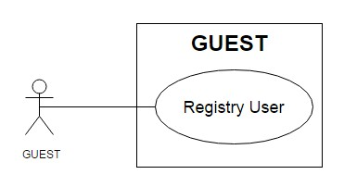

|  |  |  |
| --- | --- | --- |
| **Use Case Name** | Register user | |
| **Actors** | Guest | |
| **Description** | Guest wants to register with the website to become a customer. | |
| **Requirements** | Guest provides Guest’s information | |
| **Pre-conditions** |  | |
| **Post-conditions** | Success: Guest creates a account in this website  Fail: Refill information | |
| **Basic flow** | Actor Actions:  1. Actor clicks ‘Register’ link in Home page  3. Actor inputs register’s information and  click ‘Register’ button. | System Responses:  2. System redirects to Register page and displays Registration form with the following control :  - ‘UserName’ text field  - ‘Password’ text field  - ‘Confirm Password’ text field  - ‘Name’ text field  - ‘Address’ text field  - ‘Phone’ text field  - ‘Email’ text field  - ‘Register’ button  - ‘Cancel’ button  4. System checks the information  [Exception]  5. System inserts the account into database, show message: ‘Your account has been created!’ and then redirects to Login page. |

|  |  |  |
| --- | --- | --- |
|  | **Prepared by (Student)** | **Approved by (Faculty)** |
| **Date** | **Project Group No : 1** |  |
| **Signature** | **All members** |  |

|  |  |  |
| --- | --- | --- |
| **Design Plan :** | **Document Name :** TUNGA RESTAURANTS  WEBSITE | **SWD/Form No.** |
| **Effective Date: 14/11/2014** | **Version: 1.0** | **Page No :** 16**/** 172 |

**Exception** Actor Actions: [Exception]

1. Actor lefts ‘UserName’ text field blank.

2. UserName has already exists.

3. Actor lefts ‘Password’ text field blank.

4. Actor lefts ‘Confirm Password’ text

field blank.

5. Password and confirm password don’t

match.

6. Actor lefts ‘Name’ text field blank.

7. Actor lefts ‘Address’ text field blank.

8. Actor lefts ‘Phone’ text field blank.

9. Input phone not in numeric or phone length not in range 10 – 11 character.

12. Actor lefts ‘Email’ text field blank or

input an invalid email address.

System Responses:

System displays message to Actor :

- ‘UserName cannot be blank’.

- ‘This Username has already exist!’.

- ‘Password cannot be blank’’.

- ‘Confirm Password can’t be

blank’.

- ‘Confirm password not match password.’

- ‘Name cannot be blank’.

- ‘Address cannot be blank’.

- ‘Phone cannot be blank’.

- ‘The phone number should be

numeric only and must be between

10 and 11 digits’.

- ‘Email is invalid’.

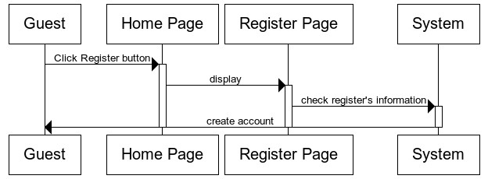

|  |  |  |
| --- | --- | --- |
|  | **Prepared by (Student)** | **Approved by (Faculty)** |
| **Date** | **Project Group No : 1** |  |
| **Signature** | **All members** |  |

|  |  |  |
| --- | --- | --- |
| **Design Plan :** | **Document Name :** TUNGA RESTAURANTS  WEBSITE | **SWD/Form No.** |
| **Effective Date: 14/11/2014** | **Version: 1.0** | **Page No :** 17**/** 172 |

**4.2 Login/Log Out:**

**4.2.1 Login:**

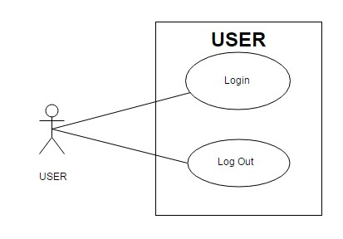

|  |  |  |
| --- | --- | --- |
| **Use Case Name** | Login | |
| **Actors** | Customer, Admin or Staff. | |
| **Description** | Customer, Admin or Staff wants to login to website. | |
| **Requirements** | Actor provides username and password | |
| **Post-conditions** | Success: User logged in to website.  Fail: Refill information | |
| **Basic flow** | Actor Actions:  1. Actor go to Home page of website.  3. Actor inputs UserName and  Password, then click the Login button. | System Responses:  2. System redirects to Home page and displays Login form on the left with the following control:  - ‘UserName’ text field  - ‘Password’ text field  - ‘Login’ button  - ‘Cancel’ button  4. System checks the information  [Exception]  5. System redirects to Actor’s Home  page. |
| **Exception** | Actor Actions:  [Exception]  1. Actor input invalid username and password. | System Responses:  - System redirect to Login page with the following controls: |

|  |  |  |
| --- | --- | --- |
|  | **Prepared by (Student)** | **Approved by (Faculty)** |
| **Date** | **Project Group No : 1** |  |
| **Signature** | **All members** |  |

|  |  |  |
| --- | --- | --- |
| **Design Plan :** | **Document Name :** TUNGA RESTAURANTS  WEBSITE | **SWD/Form No.** |
| **Effective Date: 14/11/2014** | **Version: 1.0** | **Page No :** 18**/** 172 |

- ‘UserName’ text field

- ‘Password’ text field

- ‘Login’ button.

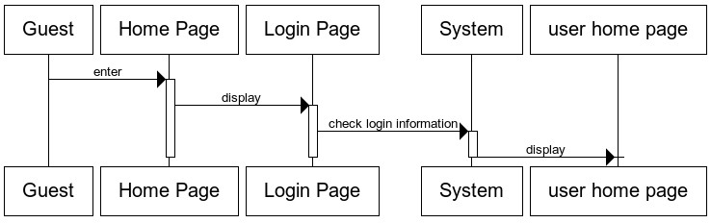

- ‘Cancel’ button.

System show a message box: “Invalid

Username and password”.

**4.2.2 Log out:**

|  |  |  |
| --- | --- | --- |
| **Use Case Name** | Log out | |
| **Actors** | Customer, Admin or Staff. | |
| **Description** | Customer, Admin or Staff wants to log out of the System. | |
| **Pre-conditions** | Actor has logged in. | |
| **Post-conditions** | Success: Actor Logged out. | |
| **Basic flow** | Actor Actions:  1. Actor clicks ‘Log out’ button on the  Actor’s Home menu. | System Responses:  2. System redirect to Logout page, remove session, and then redirect to Login page. |

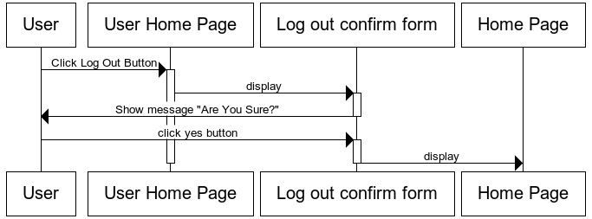

|  |  |  |
| --- | --- | --- |
|  | **Prepared by (Student)** | **Approved by (Faculty)** |
| **Date** | **Project Group No : 1** |  |
| **Signature** | **All members** |  |

|  |  |  |
| --- | --- | --- |
| **Design Plan :** | **Document Name :** TUNGA RESTAURANTS  WEBSITE | **SWD/Form No.** |
| **Effective Date: 14/11/2014** | **Version: 1.0** | **Page No :** 19**/** 172 |

**4.3 Customer:**

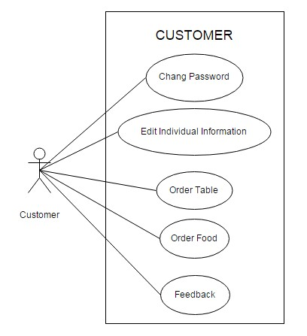

**4.3.1 Change Password:**

|  |  |  |
| --- | --- | --- |
| **Use case name** | Change Password | |
| **Actors** | Customer | |
| **Description** | Change Password | |
| **Requirements** | Actor provides Username and Password | |
| **Pre-conditions** | Actor has logged in as Customer | |
| **Post-conditions** | Success: The password has changed. | |
| **Basic flow** | Actor actions:  1. From User Home page, actor clicks  on to the ‘Change Password’ button. | System response:  2. System redirects to ‘Change Password’ page and display form with the following controls:  ‘Old Password’ textfield.  ‘New Password’ textfield.  ‘Confirm New Password’ textfield. |

|  |  |  |
| --- | --- | --- |
|  | **Prepared by (Student)** | **Approved by (Faculty)** |
| **Date** | **Project Group No : 1** |  |
| **Signature** | **All members** |  |

|  |  |  |
| --- | --- | --- |
| **Design Plan :** | **Document Name :** TUNGA RESTAURANTS  WEBSITE | **SWD/Form No.** |
| **Effective Date: 14/11/2014** | **Version: 1.0** | **Page No :** 20**/** 172 |

|  |  |  |
| --- | --- | --- |
|  | 3. Actor clicks on to ‘Save’ button to  finish adding. | ‘Save’ button.  4. System checks input information. [Exception]  5. System adds new Administrator into the database. |
| **Exception** | [Exception]  1. Actor lefts ‘Old Password’ textfield.  2. Actor lefts ‘New Password’  textfield.  3. Actor lefts ‘Confirm New  Password’ textfield.  4. ‘New Password’ textfield is not same as ‘Confirm New Password’ textfield. | System displays a message to notice  actor:  “Old Password cannot be blank. Please input Old Password.” “New Password cannot be blank. Please input New Password.”  “Confirm New Password cannot be blank. Please input Confirm Password.”  “New Password and Confirm New  Password must be same.” |

**4.3.2 Edit Individual Information:**

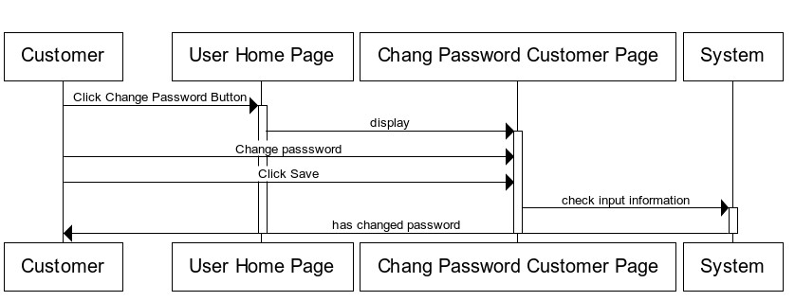

|  |  |  |  |  |  |
| --- | --- | --- | --- | --- | --- |
| **Use Case Name** | | Edit Individual Information | | |  |
| **Actors** | | Customer | | |
| **Description** | | Customer wants to Edit Individual Information. | | |
| **Requirements** | | Customer provides Customer’s information | | |
| **Pre-conditions** | | Actor has logged in as Customer | | |
| **Post-conditions** | | Success: Change Individual Information success.  Fail: Refill information. | | |
|  | | | **Prepared by (Student)** | **Approved by (Faculty)** | |
|  | **Date** | | **Project Group No : 1** |  | |
| **Signature** | | **All members** |  | |

|  |  |  |
| --- | --- | --- |
| **Design Plan :** | **Document Name :** TUNGA RESTAURANTS  WEBSITE | **SWD/Form No.** |
| **Effective Date: 14/11/2014** | **Version: 1.0** | **Page No :** 21**/** 172 |

|  |  |  |
| --- | --- | --- |
| **Basic flow** | Actor Actions:  1. Actor clicks ‘Update Profile’ link in  User Home page  3. Actor inputs individual information  and click ‘Submit’ button. | System Responses:  2. System redirects to update Profile page and displays Update profile form with the following control :  - ‘UserName’ text field, read only.  - ‘Address’ text field  - ‘Phone’ text field  - ‘Email’ text field  - ‘Submit’ button  - ‘Cancel’ button  4. System checks the information  [Exception]  5. System edit individual information into database, show message: ‘Change Individual Information Success!’ and then redirects to User Home page. |
| **Exception** | Actor Actions:  [Exception]  1. Actor lefts ‘Address’ text field blank.  2. Actor lefts ‘Phone’ text field blank.  3. Input phone not in numeric or phone length not in range 10 – 11 character.  4. Actor lefts ‘Email’ text field blank or  input an invalid email address. | System Responses:  System displays message to Actor :  - ‘Address cannot be blank’.  - ‘Phone cannot be blank’.  - ‘The phone number should be  numeric only and must be between  10 and 11 digits’.  - ‘Email is invalid’. |

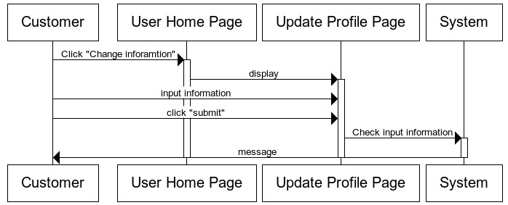

|  |  |  |
| --- | --- | --- |
|  | **Prepared by (Student)** | **Approved by (Faculty)** |
| **Date** | **Project Group No : 1** |  |
| **Signature** | **All members** |  |

|  |  |  |
| --- | --- | --- |
| **Design Plan :** | **Document Name :** TUNGA RESTAURANTS  WEBSITE | **SWD/Form No.** |
| **Effective Date: 14/11/2014** | **Version: 1.0** | **Page No :** 22**/** 172 |

**4.3.3 Order Table:**

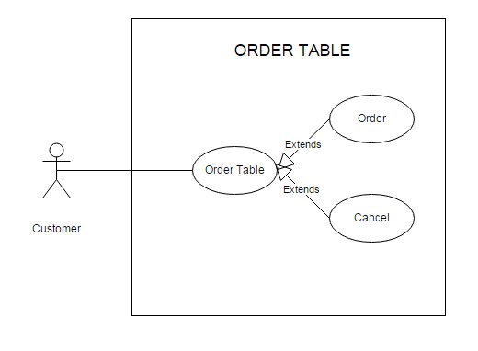

**4.3.3.1 Order:**

|  |  |  |  |  |  |  |
| --- | --- | --- | --- | --- | --- | --- |
| **Use Case Name** | | Order Table | | | |  |
| **Actors** | | Customer | | | |
| **Description** | | Customer wants to Order Table. | | | |
| **Requirements** | | Customer provides ordering table’s information | | | |
| **Pre-conditions** | | Actor has logged in as Customer | | | |
| **Post-conditions** | | Success: order table success  Fail: Refill information. | | | |
| **Basic flow** | | Actor Actions:  1. Actor clicks ‘table reservation’ link in  Home page | | System Responses:  2. System redirects to table reservation page and displays table reservation form with the following control :  - ‘branch’ drop down list field  - ‘room’ drop down list field  - ‘table’ drop down list field  -‘banquet date’ text field  -‘banquet day’ drop down list field | |
|  | | | **Prepared by (Student)** | | **Approved by (Faculty)** | |
|  | **Date** | | **Project Group No : 1** | |  | |
| **Signature** | | **All members** | |  | |

|  |  |  |
| --- | --- | --- |
| **Design Plan :** | **Document Name :** TUNGA RESTAURANTS  WEBSITE | **SWD/Form No.** |
| **Effective Date: 14/11/2014** | **Version: 1.0** | **Page No :** 23**/** 172 |

|  |  |  |
| --- | --- | --- |
|  | 3. Actor inputs order information and  click ‘Submit’ button. | - ‘Submit’ button  - ‘Cancel’ button  4. System checks the information  [Exception]  5. System ordering table information into database, show message: ‘order reservation Success!’ and then redirects to Home page. |
| **Exception** | Actor Actions:  [Exception]  1. Input banquet date and banquet day near (order date time). | System Responses:  System displays message to Actor :  - ‘With dinner banquet, you have order before 11am of banquet date! With lunch banquet, you have order before 16pm the day before’.  - ‘Over table!’. |

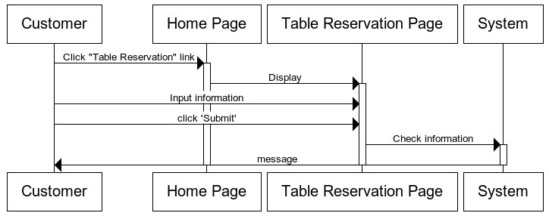

**4.3.3.2 Cancel Ordering Table:**

|  |  |
| --- | --- |
| **Use Case Name** | Cancel Ordering Table |
| **Actors** | Customer |
| **Description** | Customer wants to Cancel Ordering Table. |
| **Requirements** |  |
| **Pre-conditions** | Actor has logged in as Customer |
| **Post-conditions** | Success: Cancel ordering table success |

|  |  |  |
| --- | --- | --- |
|  | **Prepared by (Student)** | **Approved by (Faculty)** |
| **Date** | **Project Group No : 1** |  |
| **Signature** | **All members** |  |

|  |  |  |
| --- | --- | --- |
| **Design Plan :** | **Document Name :** TUNGA RESTAURANTS  WEBSITE | **SWD/Form No.** |
| **Effective Date: 14/11/2014** | **Version: 1.0** | **Page No :** 24**/** 172 |

|  |  |  |
| --- | --- | --- |
|  | Fail: Cancel ordering table faild. | |
| **Basic flow** | Actor Actions:  1. Actor clicks ‘table reservation’ link in  Home page  3. Actor choose ordering tableand click  ‘Cancel Order’ button. | System Responses:  2. System redirects to table reservation page and displays table reservation information form with the following control :  - ‘List Ordering table of customer.  - ‘Cancel Order’ button  4. System checks the information  [Exception]  5. System edit individual information into database, show message: ‘order reservation Success!’ and then redirects to Home page. |
| **Exception** | Actor Actions:  [Exception]  1. Actor choose Ordering table to cancel with conditional not valid. | System Responses:  System displays message to Actor :  - ‘With diner banquet, you have cancel before 11am of banquet  date! With lunch banquet, you have cancel before 16pm the day before’.  - ‘you have confirmed this ordering table! PLZ… Contact with our staff!’. |

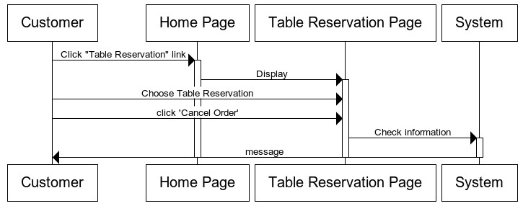

|  |  |  |
| --- | --- | --- |
|  | **Prepared by (Student)** | **Approved by (Faculty)** |
| **Date** | **Project Group No : 1** |  |
| **Signature** | **All members** |  |

|  |  |  |
| --- | --- | --- |
| **Design Plan :** | **Document Name :** TUNGA RESTAURANTS  WEBSITE | **SWD/Form No.** |
| **Effective Date: 14/11/2014** | **Version: 1.0** | **Page No :** 25**/** 172 |

**4.3.4 Order Food:**

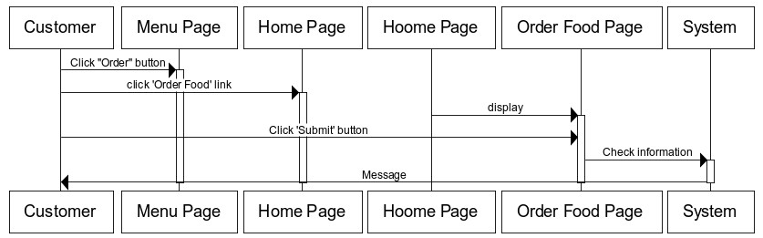

|  |  |  |
| --- | --- | --- |
| **Use Case Name** | Order Food | |
| **Actors** | Customer | |
| **Description** | Customer wants to Order Food. | |
| **Requirements** | Customer provides ordering food’s information | |
| **Pre-conditions** | Actor has logged in as Customer | |
| **Post-conditions** | Success: order food success  Fail: Refill information. | |
| **Basic flow** | Actor Actions:  1. Actor clicks ‘Order’ button in Menu page.  2. Actor click ‘Order Food’ link in Home  Page  4. Actor inputs order information and  click ‘Submit’ button. | System Responses:  3. System redirects to Order Food page and displays Order Food form with the following control :  - List Of Food, which customer order.  - ‘Submit’ button  - ‘Cancel’ button  5. System checks the information  [Exception]  6. System ordering food information into database, show message: ‘order food Success!’ and then redirects to Home page. |
| **Exception** | Actor Actions:  [Exception]  1. Actor order food greater than 10 foods. | System Responses:  System displays message to Actor :  - ‘A Customer only order 10 foods  for a day!’. |

|  |  |  |
| --- | --- | --- |
|  | **Prepared by (Student)** | **Approved by (Faculty)** |
| **Date** | **Project Group No : 1** |  |
| **Signature** | **All members** |  |

|  |  |  |
| --- | --- | --- |
| **Design Plan :** | **Document Name :** TUNGA RESTAURANTS  WEBSITE | **SWD/Form No.** |
| **Effective Date: 14/11/2014** | **Version: 1.0** | **Page No :** 26**/** 172 |

**4.3.5 Feedback:**

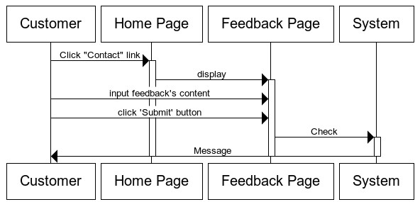

|  |  |  |
| --- | --- | --- |
| **Use Case Name** | Feedback | |
| **Actors** | Customer | |
| **Description** | Customer wants to Feedback. | |
| **Requirements** | Customer provides deedback’s content. | |
| **Pre-conditions** | Actor has logged in as Customer | |
| **Post-conditions** | Success: feedback success.  Fail: Refill information. | |
| **Basic flow** | Actor Actions:  1. Actor clicks ‘contact’ link in Home page  3. Actor inputs feedback’s content and  click ‘Submit’ button. | System Responses:  2. System redirects to feedback page and displays feedback form with the following control :  -‘content’ text field  - ‘Submit’ button  - ‘Cancel’ button  4. System checks the information  [Exception]  5. System ordering table information into database, show message: ‘Send feedback Success!’ and then redirects to Home page. |
| **Exception** | Actor Actions:  [Exception]  1. Actor lefts ‘content’ text field blank. | System Responses:  System displays message to Actor :  - ‘content cann’t be blank! ’ |

|  |  |  |
| --- | --- | --- |
|  | **Prepared by (Student)** | **Approved by (Faculty)** |
| **Date** | **Project Group No : 1** |  |
| **Signature** | **All members** |  |

|  |  |  |
| --- | --- | --- |
| **Design Plan :** | **Document Name :** TUNGA RESTAURANTS  WEBSITE | **SWD/Form No.** |
| **Effective Date: 14/11/2014** | **Version: 1.0** | **Page No :** 27**/** 172 |

**4.4 Staff:**

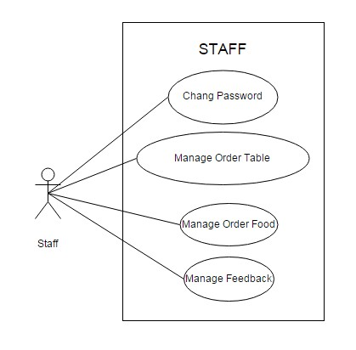

**4.4.1 Change Password:**

|  |  |  |
| --- | --- | --- |
| **Use case name** | Change Password | |
| **Actors** | Staff | |
| **Description** | Change Password | |
| **Requirements** | Actor provides Username and Password | |
| **Pre-conditions** | Actor has logged in as Staff | |
| **Post-conditions** | Success: The password has changed. | |
| **Basic flow** | Actor actions:  1. From Staff Home page, actor clicks  on to the ‘Change Password’ button.  3. Actor clicks on to ‘Save’ button to | System response:  2. System redirects to ‘Change Password’ page and display form with the following controls:  ‘Old Password’ textfield.  ‘New Password’ textfield.  ‘Confirm New Password’ textfield.  ‘Save’ button.  4. System checks input information. |

|  |  |  |
| --- | --- | --- |
|  | **Prepared by (Student)** | **Approved by (Faculty)** |
| **Date** | **Project Group No : 1** |  |
| **Signature** | **All members** |  |

|  |  |  |
| --- | --- | --- |
| **Design Plan :** | **Document Name :** TUNGA RESTAURANTS  WEBSITE | **SWD/Form No.** |
| **Effective Date: 14/11/2014** | **Version: 1.0** | **Page No :** 28**/** 172 |

|  |  |  |
| --- | --- | --- |
|  | finish adding. | [Exception]  5. System adds new Administrator into the database. |
| **Exception** | [Exception]  1. Actor lefts ‘Old Password’ textfield.  2. Actor lefts ‘New Password’  textfield.  3. Actor lefts ‘Confirm New  Password’ textfield.  4. ‘New Password’ textfield is not same as ‘Confirm New Password’ textfield. | System displays a message to notice  actor:  “Old Password cannot be blank. Please input Old Password.” “New Password cannot be blank. Please input New Password.”  “Confirm New Password cannot be blank. Please input Confirm Password.”  “New Password and Confirm New  Password must be same.” |

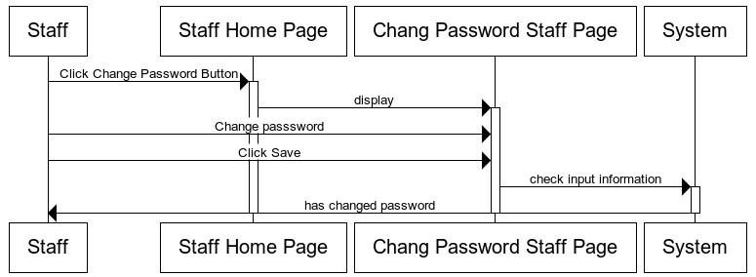

|  |  |  |
| --- | --- | --- |
|  | **Prepared by (Student)** | **Approved by (Faculty)** |
| **Date** | **Project Group No : 1** |  |
| **Signature** | **All members** |  |

|  |  |  |
| --- | --- | --- |
| **Design Plan :** | **Document Name :** TUNGA RESTAURANTS  WEBSITE | **SWD/Form No.** |
| **Effective Date: 14/11/2014** | **Version: 1.0** | **Page No :** 29**/** 172 |

**4.4.2 Manage Order Food:**

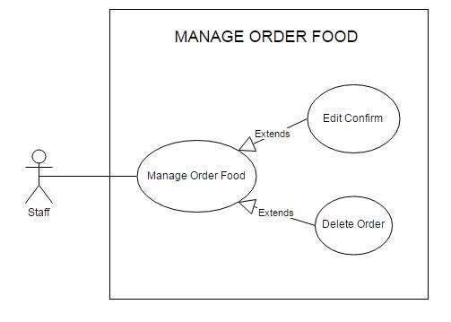

**4.4.2.1 Edit Confirm:**

|  |  |  |
| --- | --- | --- |
| **Use Case Name** | Edit Confirm | |
| **Actors** | Staff | |
| **Description** | Staff wants to Edit Confirm. | |
| **Requirements** | Staff choose Ordering food. | |
| **Pre-conditions** | Actor has logged in as Staff | |
| **Post-conditions** | Success: has confirm.  Fail: confirm fail. | |
| **Basic flow** | Actor Actions:  1. Actor clicks ‘Order Food’ link in Staff  Home page  3. Actor click ‘Confirm’ button. | System Responses:  2. System redirects to Order Food Management page and displays list of ordering food and following control :  - ‘Confirm’ button  4. System checks the information  [Exception]  5. System confirm order into |

|  |  |  |
| --- | --- | --- |
|  | **Prepared by (Student)** | **Approved by (Faculty)** |
| **Date** | **Project Group No : 1** |  |
| **Signature** | **All members** |  |

|  |  |  |
| --- | --- | --- |
| **Design Plan :** | **Document Name :** TUNGA RESTAURANTS  WEBSITE | **SWD/Form No.** |
| **Effective Date: 14/11/2014** | **Version: 1.0** | **Page No :** 30**/** 172 |

|  |  |  |
| --- | --- | --- |
|  |  | database, show message: ‘Order has  just confirm!’ and then redirects to  Staff Home page. |
| **Exception** | Actor Actions:  [Exception]  1. Actor choose ordering food, which have banquet date before current date. | System Responses:  System displays message to Actor :  - ‘You cannot confirm this ordering food!’. |

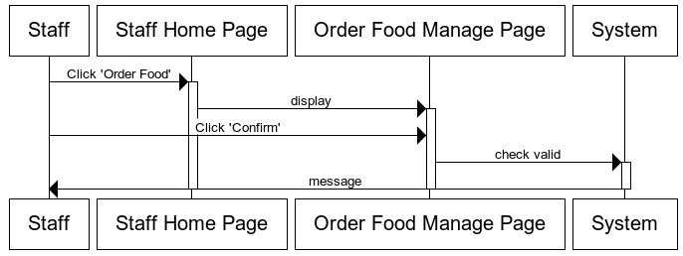

**4.4.2.2 Delete Ordering Food:**

|  |  |  |
| --- | --- | --- |
| **Use Case Name** | Delete Ordering Food | |
| **Actors** | Staff | |
| **Description** | Staff wants to Delete Ordering Food | |
| **Requirements** | Staff choose Ordering food. | |
| **Pre-conditions** | Actor has logged in as Staff | |
| **Post-conditions** | Success: delete success.  Fail: delete fail. | |
| **Basic flow** | Actor Actions:  1. Actor clicks ‘Order Food’ link in Staff  Home page  3. Actor click ‘Delete’ button. | System Responses:  2. System redirects to Order Food Manage page and displays list of ordering food and following control  :  - ‘Delete’ button  4. System checks the information  [Exception] |

|  |  |  |
| --- | --- | --- |
|  | **Prepared by (Student)** | **Approved by (Faculty)** |
| **Date** | **Project Group No : 1** |  |
| **Signature** | **All members** |  |

|  |  |  |
| --- | --- | --- |
| **Design Plan :** | **Document Name :** TUNGA RESTAURANTS  WEBSITE | **SWD/Form No.** |
| **Effective Date: 14/11/2014** | **Version: 1.0** | **Page No :** 31**/** 172 |

|  |  |  |
| --- | --- | --- |
|  |  | 5. System confirm order into  database, show message: ‘Order has just confirm!’ and then redirects to Staff Home page. |
| **Exception** | Actor Actions:  [Exception]  1. Actor choose ordering food, which have banquet date before current date.  2.Actor choose ordering food, which has confirm. | System Responses:  System displays message to Actor :  - ‘You cannot delete this ordering food!’. |

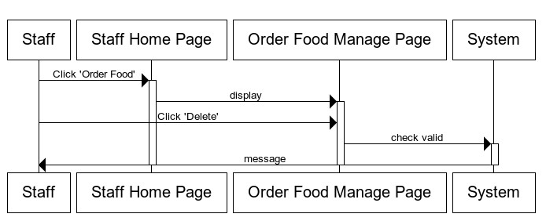

**4.4.3 Manage Order Table:**

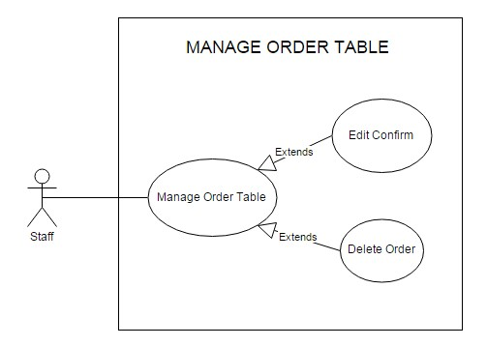

|  |  |  |
| --- | --- | --- |
|  | **Prepared by (Student)** | **Approved by (Faculty)** |
| **Date** | **Project Group No : 1** |  |
| **Signature** | **All members** |  |

|  |  |  |
| --- | --- | --- |
| **Design Plan :** | **Document Name :** TUNGA RESTAURANTS  WEBSITE | **SWD/Form No.** |
| **Effective Date: 14/11/2014** | **Version: 1.0** | **Page No :** 32**/** 172 |

**4.4.3.1 Edit Confirm:**

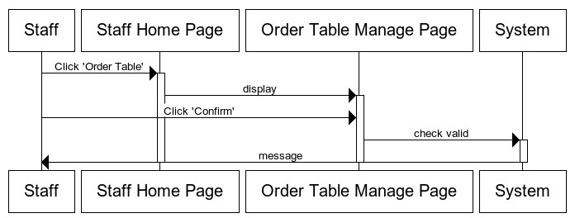

|  |  |  |
| --- | --- | --- |
| **Use Case Name** | Edit Confirm | |
| **Actors** | Staff | |
| **Description** | Staff wants to Edit Confirm. | |
| **Requirements** | Staff choose Ordering Table. | |
| **Pre-conditions** | Actor has logged in as Staff | |
| **Post-conditions** | Success: has confirm.  Fail: confirm fail. | |
| **Basic flow** | Actor Actions:  1. Actor clicks ‘Order Table’ link in Staff  Home page  3. Actor click ‘Confirm’ button. | System Responses:  2. System redirects to Order Table Manage page and displays list of ordering Table and following control :  - ‘Confirm’ button  4. System checks the information  [Exception]  5. System confirm order into database, show message: ‘Order has just confirm!’ and then redirects to Staff Home page. |
| **Exception** | Actor Actions:  [Exception]  1. Actor choose ordering table, which have banquet date before current date. | System Responses:  System displays message to Actor :  - ‘You cannot confirm this ordering  food!’. |

|  |  |  |
| --- | --- | --- |
|  | **Prepared by (Student)** | **Approved by (Faculty)** |
| **Date** | **Project Group No : 1** |  |
| **Signature** | **All members** |  |

|  |  |  |
| --- | --- | --- |
| **Design Plan :** | **Document Name :** TUNGA RESTAURANTS  WEBSITE | **SWD/Form No.** |
| **Effective Date: 14/11/2014** | **Version: 1.0** | **Page No :** 33**/** 172 |

**4.4.3.2 Delete Ordering Table:**

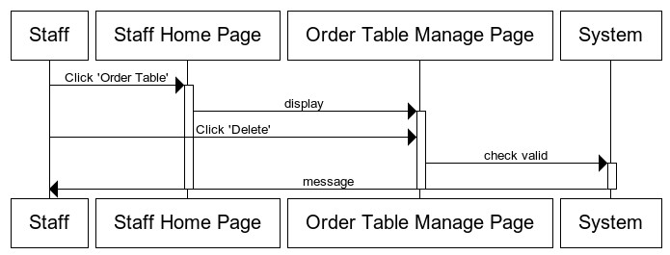

|  |  |  |
| --- | --- | --- |
| **Use Case Name** | Delete Ordering Table | |
| **Actors** | Staff | |
| **Description** | Staff wants to Delete Ordering Table | |
| **Requirements** | Staff choose Ordering table. | |
| **Pre-conditions** | Actor has logged in as Staff | |
| **Post-conditions** | Success: delete success.  Fail: delete fail. | |
| **Basic flow** | Actor Actions:  1. Actor clicks ‘Order Table’ link in Staff  Home page  3. Actor click ‘Delete’ button. | System Responses:  2. System redirects to Order Table Manage page and displays list of ordering table and following control  :  - ‘Delete’ button  4. System checks the information  [Exception]  5. System confirm order into database, show message: ‘Order has just confirm!’ and then redirects to Staff Home page. |
| **Exception** | Actor Actions:  [Exception]  1. Actor choose ordering table, which have banquet date before current date.  2.Actor choose ordering table, which has confirm. | System Responses:  System displays message to Actor :  - ‘You cannot delete this ordering table!’. |

|  |  |  |
| --- | --- | --- |
|  | **Prepared by (Student)** | **Approved by (Faculty)** |
| **Date** | **Project Group No : 1** |  |
| **Signature** | **All members** |  |

|  |  |  |
| --- | --- | --- |
| **Design Plan :** | **Document Name :** TUNGA RESTAURANTS  WEBSITE | **SWD/Form No.** |
| **Effective Date: 14/11/2014** | **Version: 1.0** | **Page No :** 34**/** 172 |

**4.4.4 Manage Feedback:**

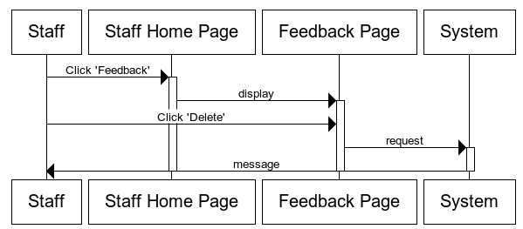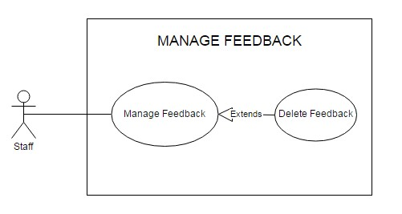

|  |  |  |
| --- | --- | --- |
| **Use Case Name** | Delete Feedback | |
| **Actors** | Staff | |
| **Description** | Staff wants to Delete Feedback | |
| **Requirements** | Staff choose Feedback. | |
| **Pre-conditions** | Actor has logged in as Staff | |
| **Post-conditions** | Success: delete success. | |
| **Basic flow** | Actor Actions:  1. Actor clicks ‘Feedback’ link in Staff  Home page  3. Actor click ‘Delete’ button. | System Responses:  2. System redirects to Feedback page and displays list of feedback and following control :  - ‘Delete’ button  4. System checks the information  5. System feedback into database, show message: ‘Delete feedback Success!’ and then redirects to Staff Home page. |

|  |  |  |
| --- | --- | --- |
|  | **Prepared by (Student)** | **Approved by (Faculty)** |
| **Date** | **Project Group No : 1** |  |
| **Signature** | **All members** |  |

|  |  |  |
| --- | --- | --- |
| **Design Plan :** | **Document Name :** TUNGA RESTAURANTS  WEBSITE | **SWD/Form No.** |
| **Effective Date: 14/11/2014** | **Version: 1.0** | **Page No :** 35**/** 172 |

**4.5 Admin:**

(Note: Management of admin include: all management of staff and private management of admin).

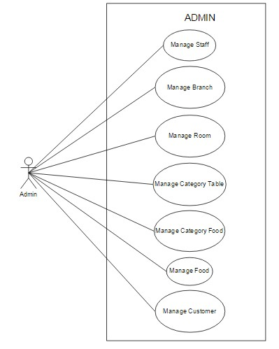

|  |  |  |
| --- | --- | --- |
|  | **Prepared by (Student)** | **Approved by (Faculty)** |
| **Date** | **Project Group No : 1** |  |
| **Signature** | **All members** |  |

|  |  |  |
| --- | --- | --- |
| **Design Plan :** | **Document Name :** TUNGA RESTAURANTS  WEBSITE | **SWD/Form No.** |
| **Effective Date: 14/11/2014** | **Version: 1.0** | **Page No :** 36**/** 172 |

**4.5.1 Manage Staff:**

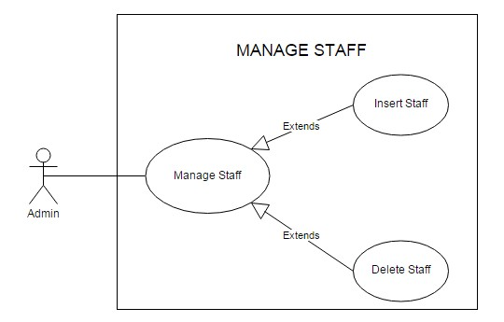

**4.5.1.1 Insert Staff:**

|  |  |  |  |  |  |  |
| --- | --- | --- | --- | --- | --- | --- |
| **Use Case Name** | | Insert Staff | | | |  |
| **Actors** | | Admin | | | |
| **Description** | | Admin wants to insert a staff. | | | |
| **Requirements** | | Admin provides Staff’s information | | | |
| **Pre-conditions** | | Actor has logged in as Admin. | | | |
| **Post-conditions** | | Success: Insert Staff Success.  Fail: Refill information | | | |
| **Basic flow** | | Actor Actions:  1. Actor clicks ‘Staff’ link in Admin  Home page  3. Actor inputs staff’s information and  click ‘Insert’ button. | | System Responses:  2. System redirects to Staff Management page and Insert Staff form with the following control :  - ‘UserName’ text field  - ‘Password’ text field  - ‘Insert’ button  - ‘Cancel’ button  4. System checks the information  [Exception]  5. System inserts the Staff into | |
|  | | | **Prepared by (Student)** | | **Approved by (Faculty)** | |
|  | **Date** | | **Project Group No : 1** | |  | |
| **Signature** | | **All members** | |  | |

|  |  |  |
| --- | --- | --- |
| **Design Plan :** | **Document Name :** TUNGA RESTAURANTS  WEBSITE | **SWD/Form No.** |
| **Effective Date: 14/11/2014** | **Version: 1.0** | **Page No :** 37**/** 172 |

|  |  |  |
| --- | --- | --- |
|  |  | database, show message: ‘Insert  Staff Success!’ and then redirects to  Admin Home page. |
| **Exception** | Actor Actions:  [Exception]  1. Actor lefts ‘UserName’ text field  blank.  2. UserName has already exists.  3. Actor lefts ‘Password’ text field blank. | System Responses:  System displays message to Actor :  - ‘UserName cannot be blank’.  - ‘This Username has already exist!’.  - ‘Password cannot be blank’’. |

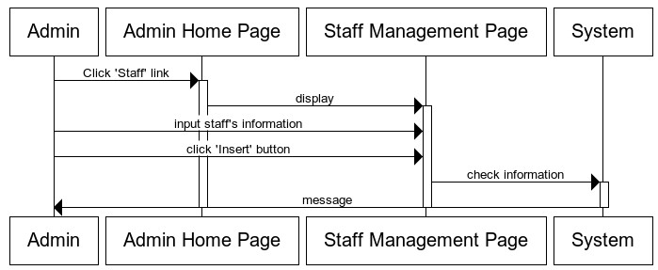

**4.5.1.2 Delete Staff:**

|  |  |  |  |  |  |  |
| --- | --- | --- | --- | --- | --- | --- |
| **Use Case Name** | | Delete Staff | | | |  |
| **Actors** | | Admin | | | |
| **Description** | | Admin wants to Delete Staff | | | |
| **Requirements** | | Admin choose Staff. | | | |
| **Pre-conditions** | | Actor has logged in as Admin | | | |
| **Post-conditions** | | Success: delete success. | | | |
| **Basic flow** | | Actor Actions:  1. Actor clicks ‘Staff’ link in Admin  Home page  3. Actor click ‘Delete’ button. | | System Responses:  2. System redirects to Staff Management page and displays list of Staff and following control :  - ‘Delete’ button | |
|  | | | **Prepared by (Student)** | | **Approved by (Faculty)** | |
|  | **Date** | | **Project Group No : 1** | |  | |
| **Signature** | | **All members** | |  | |

|  |  |  |
| --- | --- | --- |
| **Design Plan :** | **Document Name :** TUNGA RESTAURANTS  WEBSITE | **SWD/Form No.** |
| **Effective Date: 14/11/2014** | **Version: 1.0** | **Page No :** 38**/** 172 |

**4.5.2 Manage Branch:**

4. System checks the information

5. System save into database, show

message: ‘Delete Success!’ and then redirects to Admin Home page.

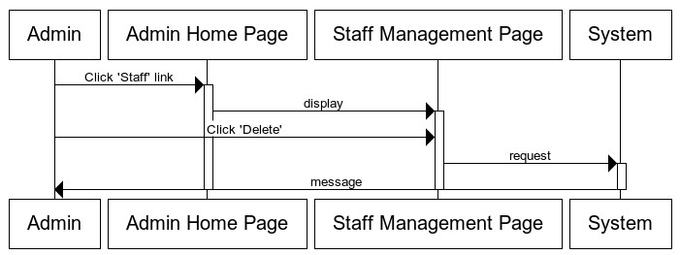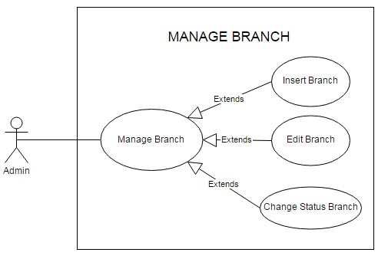

|  |  |  |
| --- | --- | --- |
|  | **Prepared by (Student)** | **Approved by (Faculty)** |
| **Date** | **Project Group No : 1** |  |
| **Signature** | **All members** |  |

|  |  |  |
| --- | --- | --- |
| **Design Plan :** | **Document Name :** TUNGA RESTAURANTS  WEBSITE | **SWD/Form No.** |
| **Effective Date: 14/11/2014** | **Version: 1.0** | **Page No :** 39**/** 172 |

**4.5.2.1 Insert Branch:**

|  |  |  |
| --- | --- | --- |
| **Use Case Name** | Insert Branch | |
| **Actors** | Admin | |
| **Description** | Admin wants to insert a branch. | |
| **Requirements** | Admin provides branch’s information | |
| **Pre-conditions** | Actor has logged in as Admin. | |
| **Post-conditions** | Success: Insert branch Success.  Fail: Refill information | |
| **Basic flow** | Actor Actions:  1. Actor clicks ‘branch’ link in Admin  Home page  3. Actor inputs branch’s information and  click ‘Insert’ button. | System Responses:  2. System redirects to Branch Management page and Insert Branch form with the following control :  - ‘BranchID’ text field  - ‘Name’ text field  - ‘Address’ text field  - ‘Phone’ text field  - Display List Of Rooms and quantity each room.  - ‘Insert’ button  - ‘Cancel’ button  4. System checks the information  [Exception]  5. System inserts the Branch into database, show message: ‘Insert Branch Success!’ and then redirects to Admin Home page. |
| **Exception** | Actor Actions:  [Exception]  1. Actor lefts ‘BranchID’ text field blank.  2. BranchID has already exists.  3. Actor lefts ‘name’ text field blank.  4. Name has already exists.  5.Name is not format ‘roomxx’  6. Actor lefts ‘Address’ text field blank.  7. Actor lefts ‘Phone’ text field blank.  8. Input phone not in numeric or phone length not in range 10 – 11 character. | System Responses:  System displays message to Actor :  - ‘BranchID cannot be blank’.  - ‘This BranchID has already exist!’.  - ‘name cannot be blank’’.  - ‘This name has already exist!’.  -‘Name must format branchxx with xx is numeric.’  - ‘Address cannot be blank’.’  - ‘Phone cannot be blank’.  - ‘The phone number should be  numeric only and must be between |

|  |  |  |
| --- | --- | --- |
|  | **Prepared by (Student)** | **Approved by (Faculty)** |
| **Date** | **Project Group No : 1** |  |
| **Signature** | **All members** |  |

|  |  |  |
| --- | --- | --- |
| **Design Plan :** | **Document Name :** TUNGA RESTAURANTS  WEBSITE | **SWD/Form No.** |
| **Effective Date: 14/11/2014** | **Version: 1.0** | **Page No :** 40**/** 172 |

**4.5.2.2 Edit Branch:**

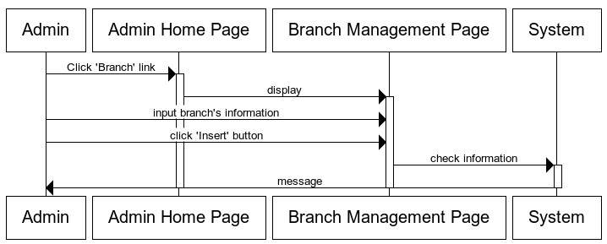

10 and 11 digits’.

|  |  |  |
| --- | --- | --- |
| **Use Case Name** | Edit Branch | |
| **Actors** | Admin | |
| **Description** | Admin wants to Edit Branch. | |
| **Requirements** | Admin provides Branch’s information | |
| **Pre-conditions** | Actor has logged in as Admin | |
| **Post-conditions** | Success: Edit Branch success.  Fail: Refill information. | |
| **Basic flow** | Actor Actions:  1. Actor clicks ‘Branch’ link in Admin  Home page  3. Actor inputs individual information  and click ‘Save’ button. | System Responses:  2. System redirects to Branch Management Page and displays edit branch form with the following control :  - ‘BranchID’ text field, read only.  - ‘Name’ text field,read only.  - ‘Address’ text field  - ‘Phone’ text field  - Display List Of Rooms and quantity each room.  - ‘Save’ button  - ‘Cancel’ button  4. System checks the information  [Exception] |

|  |  |  |
| --- | --- | --- |
|  | **Prepared by (Student)** | **Approved by (Faculty)** |
| **Date** | **Project Group No : 1** |  |
| **Signature** | **All members** |  |

|  |  |  |
| --- | --- | --- |
| **Design Plan :** | **Document Name :** TUNGA RESTAURANTS  WEBSITE | **SWD/Form No.** |
| **Effective Date: 14/11/2014** | **Version: 1.0** | **Page No :** 41**/** 172 |

|  |  |  |
| --- | --- | --- |
|  |  | 5. System save information into  database, show message: ‘Edit Branch Success!’ and then redirects to Admin Home page. |
| **Exception** | Actor Actions:  [Exception]  1. Actor lefts ‘Address’ text field blank.  2. Actor lefts ‘Phone’ text field blank.  3. Input phone not in numeric or phone length not in range 10 – 11 character. | System Responses:  System displays message to Actor :  - ‘Address cannot be blank’.’  - ‘Phone cannot be blank’.  - ‘The phone number should be  numeric only and must be between  10 and 11 digits’. |

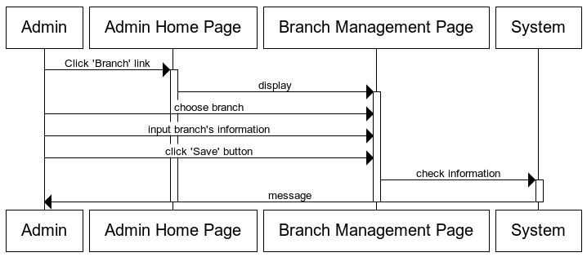

**4.5.2.3 Change Status Branch:**

|  |  |  |  |  |  |  |
| --- | --- | --- | --- | --- | --- | --- |
| **Use Case Name** | | Change Status Branch | | | |  |
| **Actors** | | Admin | | | |
| **Description** | | Admin wants to change status of Branch. | | | |
| **Requirements** | | Admin choose branch. | | | |
| **Pre-conditions** | | Actor has logged in as Admin | | | |
| **Post-conditions** | | Success: change status branch success. | | | |
| **Basic flow** | | Actor Actions:  1. Actor clicks ‘Branch’ link in Admin  Home page | | System Responses:  2. System redirects to Branch Management Page and change status branch form with the following control : | |
|  | | | **Prepared by (Student)** | | **Approved by (Faculty)** | |
|  | **Date** | | **Project Group No : 1** | |  | |
| **Signature** | | **All members** | |  | |

|  |  |  |
| --- | --- | --- |
| **Design Plan :** | **Document Name :** TUNGA RESTAURANTS  WEBSITE | **SWD/Form No.** |
| **Effective Date: 14/11/2014** | **Version: 1.0** | **Page No :** 42**/** 172 |

3. Actor click ‘Active’ button or ‘Not

Active’ button.

- if branch is active, ‘not active’

button display.

- if branch is not active, ‘active’

button display.

4. System checks the information

5. System save information into database, show message: ‘Change Status Success!’ and then redirects to Admin Home page.

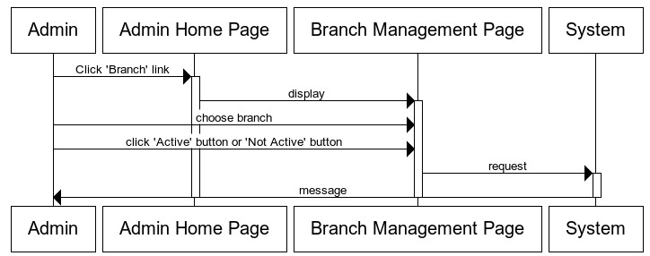

**4.5.3 Manage Room:**

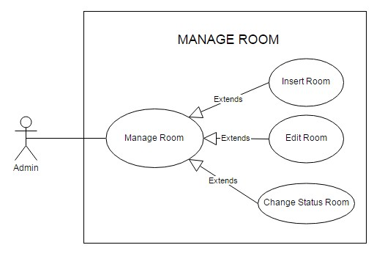

|  |  |  |
| --- | --- | --- |
|  | **Prepared by (Student)** | **Approved by (Faculty)** |
| **Date** | **Project Group No : 1** |  |
| **Signature** | **All members** |  |

|  |  |  |
| --- | --- | --- |
| **Design Plan :** | **Document Name :** TUNGA RESTAURANTS  WEBSITE | **SWD/Form No.** |
| **Effective Date: 14/11/2014** | **Version: 1.0** | **Page No :** 43**/** 172 |

**4.5.3.1 Insert Room:**

|  |  |  |
| --- | --- | --- |
| **Use Case Name** | Insert Room | |
| **Actors** | Admin | |
| **Description** | Admin wants to insert a room. | |
| **Requirements** | Admin provides room’s information | |
| **Pre-conditions** | Actor has logged in as Admin. | |
| **Post-conditions** | Success: Insert room Success.  Fail: Refill information | |
| **Basic flow** | Actor Actions:  1. Actor clicks ‘Room’ link in Admin  Home page  3. Actor inputs room’s information and  click ‘Insert’ button. | System Responses:  2. System redirects to Room Management page and Insert Room form with the following control :  - ‘RoomID’ text field  - ‘Name’ text field  - Display List Of Category table and quantity each category table.  - ‘Insert’ button  - ‘Cancel’ button  4. System checks the information  [Exception]  5. System inserts Room into database, show message: ‘Insert Room Success!’ and then redirects to Admin Home page. |
| **Exception** | Actor Actions:  [Exception]  1. Actor lefts ‘BranchID’ text field blank.  2. BranchID has already exists.  3. Actor lefts ‘name’ text field blank.  4. Name has already exists.  5.Name is not format ‘roomxx’ | System Responses:  System displays message to Actor :  - ‘BranchID cannot be blank’.  - ‘This BranchID has already exist!’.  - ‘name cannot be blank’’.  - ‘This name has already exist!’.  -‘Name must format roomxx with xx is numeric.’ |

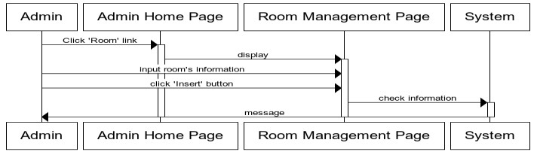

|  |  |  |
| --- | --- | --- |
|  | **Prepared by (Student)** | **Approved by (Faculty)** |
| **Date** | **Project Group No : 1** |  |
| **Signature** | **All members** |  |

|  |  |  |
| --- | --- | --- |
| **Design Plan :** | **Document Name :** TUNGA RESTAURANTS  WEBSITE | **SWD/Form No.** |
| **Effective Date: 14/11/2014** | **Version: 1.0** | **Page No :** 44**/** 172 |

**4.5.3.2 Edit Room:**

|  |  |  |
| --- | --- | --- |
| **Use Case Name** | Edit Room | |
| **Actors** | Admin | |
| **Description** | Admin wants to Edit Room. | |
| **Requirements** | Admin provides Room’s information | |
| **Pre-conditions** | Actor has logged in as Admin | |
| **Post-conditions** | Success: Edit Room success.  Fail: Refill information. | |
| **Basic flow** | Actor Actions:  1. Actor clicks ‘Room’ link in Admin  Home page  3. Actor inputs Rooml information and  click ‘Save’ button. | System Responses:  2. System redirects to Room Management Page and displays edit room form with the following control :  - ‘roomID’ text field, read only.  - ‘name’ text field,read only.  - Display List Of Category table and quantity each category table.  - ‘Save’ button  - ‘Cancel’ button  4. System checks the information  5. System save information into database, show message: ‘Edit Room Success!’ and then redirects to Admin Home page. |

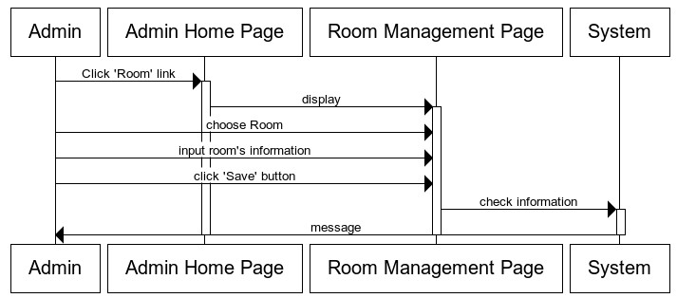

|  |  |  |
| --- | --- | --- |
|  | **Prepared by (Student)** | **Approved by (Faculty)** |
| **Date** | **Project Group No : 1** |  |
| **Signature** | **All members** |  |

|  |  |  |
| --- | --- | --- |
| **Design Plan :** | **Document Name :** TUNGA RESTAURANTS  WEBSITE | **SWD/Form No.** |
| **Effective Date: 14/11/2014** | **Version: 1.0** | **Page No :** 45**/** 172 |

**4.5.3.3 Change Status Room:**

|  |  |  |
| --- | --- | --- |
| **Use Case Name** | Change Status Room | |
| **Actors** | Admin | |
| **Description** | Admin wants to change status of Room. | |
| **Requirements** | Admin choose room. | |
| **Pre-conditions** | Actor has logged in as Admin | |
| **Post-conditions** | Success: change status room success. | |
| **Basic flow** | Actor Actions:  1. Actor clicks ‘Room’ link in Admin  Home page  3. Actor click ‘Active’ button or ‘Not  Active’ button. | System Responses:  2. System redirects to Room  Management Page and change  status room form with the following control :  - if room is active, ‘not active’  button display.  - if room is not active, ‘active’  button display.  4. System checks the information  5. System save information into database, show message: ‘Change Status Success!’ and then redirects to Admin Home page. |

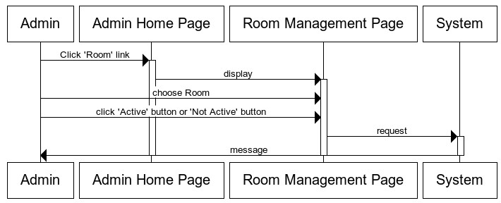

|  |  |  |
| --- | --- | --- |
|  | **Prepared by (Student)** | **Approved by (Faculty)** |
| **Date** | **Project Group No : 1** |  |
| **Signature** | **All members** |  |

|  |  |  |
| --- | --- | --- |
| **Design Plan :** | **Document Name :** TUNGA RESTAURANTS  WEBSITE | **SWD/Form No.** |
| **Effective Date: 14/11/2014** | **Version: 1.0** | **Page No :** 46**/** 172 |

**4.5.4 Manage Category Table:**

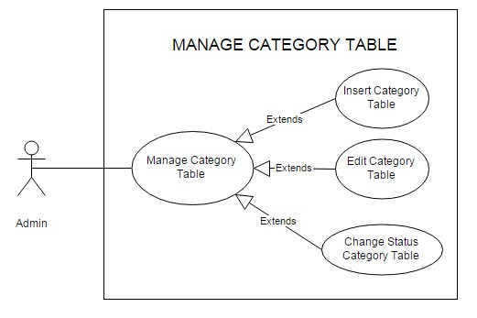

**4.5.4.1 Insert Category Table:**

|  |  |  |
| --- | --- | --- |
| **Use Case Name** | Insert Category Table | |
| **Actors** | Admin | |
| **Description** | Admin wants to insert a category Table. | |
| **Requirements** | Admin provides category table‘s information | |
| **Pre-conditions** | Actor has logged in as Admin. | |
| **Post-conditions** | Success: Insert category table Success.  Fail: Refill information | |
| **Basic flow** | Actor Actions:  1. Actor clicks ‘Table’ link in Admin  Home page  3. Actor inputs table’s information and  click ‘Insert’ button. | System Responses:  2. System redirects to Table Management page and Insert Table form with the following control :  - ‘TableID’ text field  - ‘Name’ text field  - ‘Quantity Chairs’ text field  - ‘Insert’ button  - ‘Cancel’ button  4. System checks the information  [Exception] |

|  |  |  |
| --- | --- | --- |
|  | **Prepared by (Student)** | **Approved by (Faculty)** |
| **Date** | **Project Group No : 1** |  |
| **Signature** | **All members** |  |

|  |  |  |
| --- | --- | --- |
| **Design Plan :** | **Document Name :** TUNGA RESTAURANTS  WEBSITE | **SWD/Form No.** |
| **Effective Date: 14/11/2014** | **Version: 1.0** | **Page No :** 47**/** 172 |

|  |  |  |
| --- | --- | --- |
|  |  | 5. System inserts Table into  database, show message: ‘Insert Table Success!’ and then redirects to Admin Home page. |
| **Exception** | Actor Actions:  [Exception]  1. Actor lefts ‘TableID’ text field blank.  2. TableID has already exists.  3. Actor lefts ‘name’ text field blank.  4. Name has already exists.  5.Name is not format ‘roomxx’  6. Input quantity Chairs not in numerics | System Responses:  System displays message to Actor :  - ‘TableID cannot be blank’.  - ‘This TableID has already exist!’.  - ‘name cannot be blank’’.  - ‘This name has already exist!’.  -‘Name must format tablexx with  xx is numeric.’  -‘quantity chairs’ must numeric. |

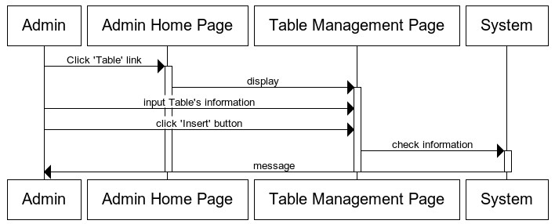

**4.5.4.2 Edit Room:**

|  |  |  |
| --- | --- | --- |
| **Use Case Name** | Edit Table | |
| **Actors** | Admin | |
| **Description** | Admin wants to Edit Table. | |
| **Requirements** | Admin provides Table’s information | |
| **Pre-conditions** | Actor has logged in as Admin | |
| **Post-conditions** | Success: Edit Table success.  Fail: Refill information. | |
| **Basic flow** | Actor Actions:  1. Actor clicks ‘Table’ link in Admin  Home page | System Responses:  2. System redirects to Table  Management Page and displays edit |

|  |  |  |
| --- | --- | --- |
|  | **Prepared by (Student)** | **Approved by (Faculty)** |
| **Date** | **Project Group No : 1** |  |
| **Signature** | **All members** |  |

|  |  |  |
| --- | --- | --- |
| **Design Plan :** | **Document Name :** TUNGA RESTAURANTS  WEBSITE | **SWD/Form No.** |
| **Effective Date: 14/11/2014** | **Version: 1.0** | **Page No :** 48**/** 172 |

3. Actor inputs Table information and

click ‘Save’ button.

Table form with the following control :

- ‘Table ID’ text field, read only.

- ‘name’ text field,read only.

-‘quantity chairs’ text.

- ‘Save’ button

- ‘Cancel’ button

4. System checks the information

5. System save information into database, show message: ‘Edit Table Success!’ and then redirects to Admin Home page.

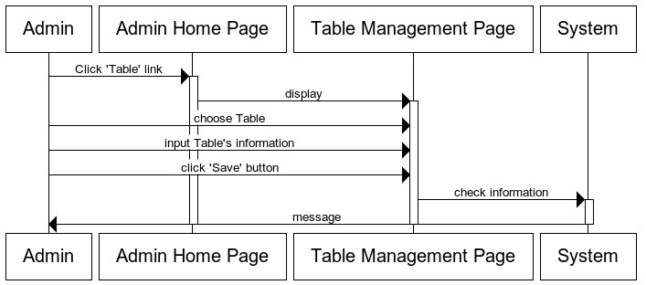

**4.5.4.3 Change Status Table:**

|  |  |  |
| --- | --- | --- |
| **Use Case Name** | Change Status table | |
| **Actors** | Admin | |
| **Description** | Admin wants to change status of table. | |
| **Requirements** | Admin choose table. | |
| **Pre-conditions** | Actor has logged in as Admin | |
| **Post-conditions** | Success: change status table success. | |
| **Basic flow** | Actor Actions:  1. Actor clicks ‘Table’ link in Admin  Home page | System Responses:  2. System redirects to Table  Management Page and change |

|  |  |  |
| --- | --- | --- |
|  | **Prepared by (Student)** | **Approved by (Faculty)** |
| **Date** | **Project Group No : 1** |  |
| **Signature** | **All members** |  |

|  |  |  |
| --- | --- | --- |
| **Design Plan :** | **Document Name :** TUNGA RESTAURANTS  WEBSITE | **SWD/Form No.** |
| **Effective Date: 14/11/2014** | **Version: 1.0** | **Page No :** 49**/** 172 |

3. Actor click ‘Active’ button or ‘Not

Active’ button.

status Table form with the following control :

- if Table is active, ‘not active’

button display.

- if Table is not active, ‘active’

button display.

4. System checks the information

5. System save information into database, show message: ‘Change Status Success!’ and then redirects to Admin Home page.

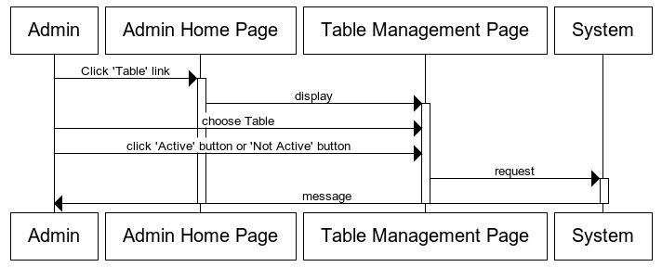

**4.5.5 Manage Category Food:**

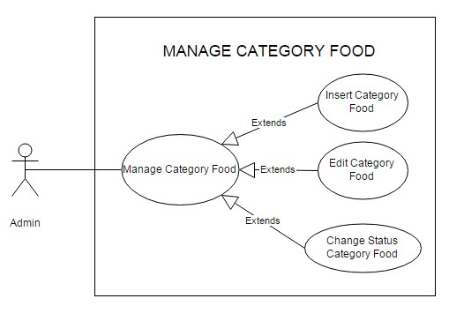

|  |  |  |
| --- | --- | --- |
|  | **Prepared by (Student)** | **Approved by (Faculty)** |
| **Date** | **Project Group No : 1** |  |
| **Signature** | **All members** |  |

|  |  |  |
| --- | --- | --- |
| **Design Plan :** | **Document Name :** TUNGA RESTAURANTS  WEBSITE | **SWD/Form No.** |
| **Effective Date: 14/11/2014** | **Version: 1.0** | **Page No :** 50**/** 172 |

**4.5.5.1 Insert Category Food:**

|  |  |  |
| --- | --- | --- |
| **Use Case Name** | Insert Category Food | |
| **Actors** | Admin | |
| **Description** | Admin wants to insert a category Food. | |
| **Requirements** | Admin provides category Food ‘s information | |
| **Pre-conditions** | Actor has logged in as Admin. | |
| **Post-conditions** | Success: Insert category Food Success.  Fail: Refill information | |
| **Basic flow** | Actor Actions:  1. Actor clicks ‘Food’ link in Admin  Home page  3. Actor inputs category Food’s  information and click ‘Insert’ button. | System Responses:  2. System redirects to category Food Management page and Insert category Food form with the following control :  - ‘categoryFood ID’ text field  - ‘Name’ text field  - ‘Insert’ button  - ‘Cancel’ button  4. System checks the information  [Exception]  5. System inserts category Food into database, show message:  ‘Insert category Food Success!’ and then redirects to Admin Home  page. |
| **Exception** | Actor Actions:  [Exception]  3. Actor lefts ‘name’ text field blank.  4. Name has already exists. | System Responses:  System displays message to Actor :  - ‘name cannot be blank’’.  - ‘This name has already exist!’. |

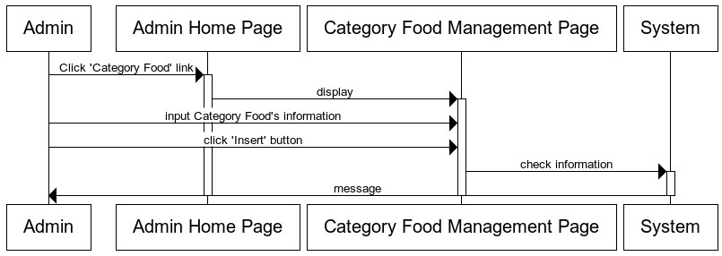

|  |  |  |
| --- | --- | --- |
|  | **Prepared by (Student)** | **Approved by (Faculty)** |
| **Date** | **Project Group No : 1** |  |
| **Signature** | **All members** |  |

|  |  |  |
| --- | --- | --- |
| **Design Plan :** | **Document Name :** TUNGA RESTAURANTS  WEBSITE | **SWD/Form No.** |
| **Effective Date: 14/11/2014** | **Version: 1.0** | **Page No :** 51**/** 172 |

**4.5.5.2 Edit Category Food:**

|  |  |  |
| --- | --- | --- |
| **Use Case Name** | Edit Category Food | |
| **Actors** | Admin | |
| **Description** | Admin wants to Edit Category Food. | |
| **Requirements** | Admin provides Category Food’s information | |
| **Pre-conditions** | Actor has logged in as Admin | |
| **Post-conditions** | Success: Edit Category Food success.  Fail: Refill information. | |
| **Basic flow** | Actor Actions:  1. Actor clicks ‘Category Food’ link in  Admin Home page  3. Actor inputs Category Food information and click ‘Save’ button. | System Responses:  2. System redirects to Category Food Management Page and displays edit Category Food form with the following control :  - ‘Category Food ID’ text field, read only.  - ‘name’ text field.  - ‘Save’ button  - ‘Cancel’ button  4. System checks the information  5. System save information into database, show message: ‘Edit Category Food Success!’ and then redirects to Admin Home page. |

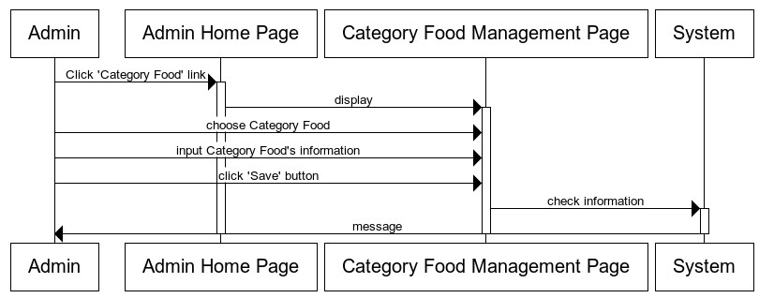

|  |  |  |
| --- | --- | --- |
|  | **Prepared by (Student)** | **Approved by (Faculty)** |
| **Date** | **Project Group No : 1** |  |
| **Signature** | **All members** |  |

|  |  |  |
| --- | --- | --- |
| **Design Plan :** | **Document Name :** TUNGA RESTAURANTS  WEBSITE | **SWD/Form No.** |
| **Effective Date: 14/11/2014** | **Version: 1.0** | **Page No :** 52**/** 172 |

**4.5.5.3 Change Status Category Table:**

|  |  |  |
| --- | --- | --- |
| **Use Case Name** | Change Status Category Food | |
| **Actors** | Admin | |
| **Description** | Admin wants to change status of Category Food. | |
| **Requirements** | Admin choose Category Food. | |
| **Pre-conditions** | Actor has logged in as Admin | |
| **Post-conditions** | Success: change status Category Food success. | |
| **Basic flow** | Actor Actions:  1. Actor clicks ‘Category Food’ link in  Admin Home page  3. Actor click ‘Use’ button or ‘Not Use’  button. | System Responses:  2. System redirects to Category  Food Management Page and change status Category Food form with the following control :  - if Category Food is use, ‘Not Use’  button display.  - if Category Food is not use, ‘Use’  button display.  4. System checks the information  5. System save information into database, show message: ‘Change Status Success!’ and then redirects to Admin Home page. |

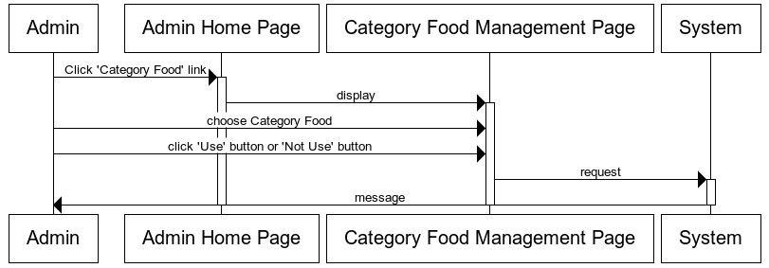

|  |  |  |
| --- | --- | --- |
|  | **Prepared by (Student)** | **Approved by (Faculty)** |
| **Date** | **Project Group No : 1** |  |
| **Signature** | **All members** |  |

|  |  |  |
| --- | --- | --- |
| **Design Plan :** | **Document Name :** TUNGA RESTAURANTS  WEBSITE | **SWD/Form No.** |
| **Effective Date: 14/11/2014** | **Version: 1.0** | **Page No :** 53**/** 172 |

**4.5.6 Manage Food:**

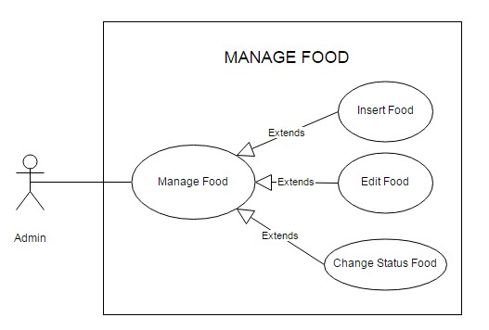

**4.5.6.1 Insert Food:**

|  |  |  |
| --- | --- | --- |
| **Use Case Name** | Insert Food | |
| **Actors** | Admin | |
| **Description** | Admin wants to insert a Food. | |
| **Requirements** | Admin provides Food ‘s information | |
| **Pre-conditions** | Actor has logged in as Admin. | |
| **Post-conditions** | Success: Insert Food Success.  Fail: Refill information | |
| **Basic flow** | Actor Actions:  1. Actor clicks ‘Food’ link in Admin  Home page | System Responses:  2. System redirects to Food Management page and Insert Food form with the following control :  - ‘categoryFood ID’ dropdownlist  - ‘Name’ text field  - ‘Image’ text field  - ‘Description’ text field  - ‘Price’ text field  - ‘Insert’ button  - ‘Cancel’ button |

|  |  |  |
| --- | --- | --- |
|  | **Prepared by (Student)** | **Approved by (Faculty)** |
| **Date** | **Project Group No : 1** |  |
| **Signature** | **All members** |  |

|  |  |  |
| --- | --- | --- |
| **Design Plan :** | **Document Name :** TUNGA RESTAURANTS  WEBSITE | **SWD/Form No.** |
| **Effective Date: 14/11/2014** | **Version: 1.0** | **Page No :** 54**/** 172 |

|  |  |  |
| --- | --- | --- |
|  | 3. Actor inputs Food’s information and  click ‘Insert’ button. | 4. System checks the information  [Exception]  5. System inserts Food into database, show message: ‘Insert Food Success!’ and then redirects to Admin Home page. |
| **Exception** | Actor Actions:  [Exception]  1. Actor lefts ‘name’ text field blank.  2. Name has already exists.  3. Actor lefts ‘image’ text field blank.  4. Actor lefts ‘price’ text field blank.  5. Input price not in numeric | System Responses:  System displays message to Actor :  - ‘name cannot be blank’’.  - ‘This name has already exist!’.  - ‘image cannot be blank’’.  - ‘price cannot be blank’’.  -‘price should be numeric’ |

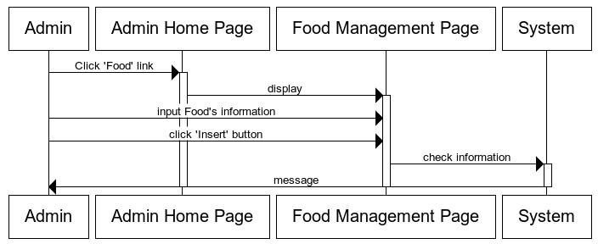

**4.5.6.2 Edit Category Food:**

|  |  |  |  |  |  |  |
| --- | --- | --- | --- | --- | --- | --- |
| **Use Case Name** | | Edit Food | | | |  |
| **Actors** | | Admin | | | |
| **Description** | | Admin wants to Edit Food. | | | |
| **Requirements** | | Admin provides Food’s information | | | |
| **Pre-conditions** | | Actor has logged in as Admin | | | |
| **Post-conditions** | | Success: Edit Food success.  Fail: Refill information. | | | |
| **Basic flow** | | Actor Actions:  1. Actor clicks ‘Food’ link in Admin  Home page | | System Responses:  2. System redirects to Food  Management Page and displays edit | |
|  | | | **Prepared by (Student)** | | **Approved by (Faculty)** | |
|  | **Date** | | **Project Group No : 1** | |  | |
| **Signature** | | **All members** | |  | |

|  |  |  |
| --- | --- | --- |
| **Design Plan :** | **Document Name :** TUNGA RESTAURANTS  WEBSITE | **SWD/Form No.** |
| **Effective Date: 14/11/2014** | **Version: 1.0** | **Page No :** 55**/** 172 |

3. Actor inputs Category Food information and click ‘Save’ button.

Food form with the following control :

- ‘Food ID’ text field, read only.

-‘category food id’ dropdownlist

- ‘name’ text field.

- ‘image’ text field.

- ‘description’ text field.

- ‘price’ text field.

- ‘Save’ button

- ‘Cancel’ button

4. System checks the information

5. System save information into database, show message: ‘Edit Food Success!’ and then redirects to Admin Home page.

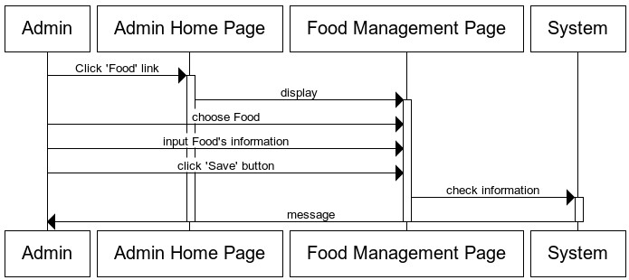

**4.5.6.3 Change Status Food:**

|  |  |
| --- | --- |
| **Use Case Name** | Change Status Food |
| **Actors** | Admin |
| **Description** | Admin wants to change status of Food. |
| **Requirements** | Admin choose Food. |
| **Pre-conditions** | Actor has logged in as Admin |
| **Post-conditions** | Success: change status Food success. |

|  |  |  |
| --- | --- | --- |
|  | **Prepared by (Student)** | **Approved by (Faculty)** |
| **Date** | **Project Group No : 1** |  |
| **Signature** | **All members** |  |

|  |  |  |
| --- | --- | --- |
| **Design Plan :** | **Document Name :** TUNGA RESTAURANTS  WEBSITE | **SWD/Form No.** |
| **Effective Date: 14/11/2014** | **Version: 1.0** | **Page No :** 56**/** 172 |

**Basic flow** Actor Actions:

1. Actor clicks ‘Food’ link in Admin

Home page

3. Actor click ‘Use’ button or ‘Not Use’

button.

System Responses:

2. System redirects to Food

Management Page and change

status Food form with the following control :

- if Food is use, ‘Not Use’ button

display.

- if Food is not use, ‘Use’ button

display.

4. System checks the information

5. System save information into database, show message: ‘Change Status Success!’ and then redirects to Admin Home page.

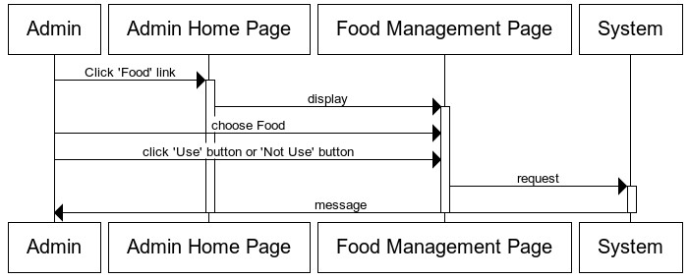

**4.5.7 Manage Customer:**

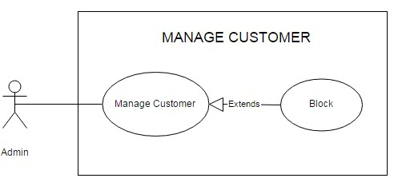

|  |  |  |
| --- | --- | --- |
|  | **Prepared by (Student)** | **Approved by (Faculty)** |
| **Date** | **Project Group No : 1** |  |
| **Signature** | **All members** |  |

|  |  |  |
| --- | --- | --- |
| **Design Plan :** | **Document Name :** TUNGA RESTAURANTS  WEBSITE | **SWD/Form No.** |
| **Effective Date: 14/11/2014** | **Version: 1.0** | **Page No :** 57**/** 172 |

|  |  |  |
| --- | --- | --- |
| **Use Case Name** | Block Customer | |
| **Actors** | Admin | |
| **Description** | Admin wants to Block Customer. | |
| **Requirements** | Admin choose Customer. | |
| **Pre-conditions** | Actor has logged in as Admin | |
| **Post-conditions** | Success: block customer success. | |
| **Basic flow** | Actor Actions:  1. Actor clicks ‘Customer’ link in Admin  Home page  3. Actor click ‘Block’ button | System Responses:  2. System redirects to Customer Management Page and block customer form with the following control :  -‘Block’ button.  4. System checks the information  5. System save information into database, show message: ‘Block Customer Success!’ and then redirects to Admin Home page. |

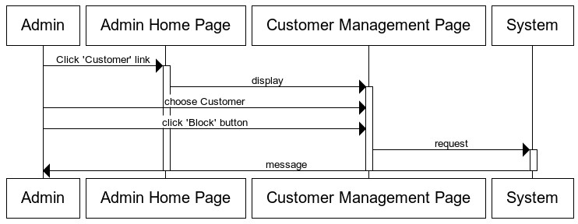

|  |  |  |
| --- | --- | --- |
|  | **Prepared by (Student)** | **Approved by (Faculty)** |
| **Date** | **Project Group No : 1** |  |
| **Signature** | **All members** |  |

|  |  |  |
| --- | --- | --- |
| **Design Plan :** | **Document Name :** TUNGA RESTAURANTS  WEBSITE | **SWD/Form No.** |
| **Effective Date: 14/11/2014** | **Version: 1.0** | **Page No :** 58**/** 172 |

**5 Data Flow Diagram**

User

Order

User details



Staff

Staff Details

View Information Order

TUNGA RESTAURANTS WEBSITE

View product

Registry user

Admin Details

Manage Resource

Admin



Guest

*Level 0 – Context Diagram*

|  |  |  |
| --- | --- | --- |
|  | **Prepared by (Student)** | **Approved by (Faculty)** |
| **Date** | **Project Group No : 1** |  |
| **Signature** | **All members** |  |

|  |  |  |
| --- | --- | --- |
| **Design Plan :** | **Document Name :** TUNGA RESTAURANTS  WEBSITE | **SWD/Form No.** |
| **Effective Date: 14/11/2014** | **Version: 1.0** | **Page No :** 59**/** 172 |

Resource

Management

Authentication

Request

Resource Details



Admin

Authentication Details

Username, password



Authentication

Username, password



Staff

Authentication Details

Request



Resource Details



Order Management

/Individual

Management

|  |  |  |
| --- | --- | --- |
|  | **Prepared by (Student)** | **Approved by (Faculty)** |
| **Date** | **Project Group No : 1** |  |
| **Signature** | **All members** |  |

|  |  |  |
| --- | --- | --- |
| **Design Plan :** | **Document Name :** TUNGA RESTAURANTS  WEBSITE | **SWD/Form No.** |
| **Effective Date: 14/11/2014** | **Version: 1.0** | **Page No :** 60**/** 172 |

Authentication

Authentication Details

Username, password



User

Request



Resource Details



Order/Feedback/ Individual Management

Guest

Request

Resource Details



Registry user

*Level 1 DFD: Application Process*

|  |  |  |
| --- | --- | --- |
|  | **Prepared by (Student)** | **Approved by (Faculty)** |
| **Date** | **Project Group No : 1** |  |
| **Signature** | **All members** |  |

|  |  |  |
| --- | --- | --- |
| **Design Plan :** | **Document Name :** TUNGA RESTAURANTS  WEBSITE | **SWD/Form No.** |
| **Effective Date: 14/11/2014** | **Version: 1.0** | **Page No :** 61**/** 172 |

Admin



Staff

User

Authentication



Authentication

Authentication

Request Result



Request Result

Request Result

Admin

Staff

User

*Level 1_1: Authentication Process*



|  |  |  |
| --- | --- | --- |
|  | **Prepared by (Student)** | **Approved by (Faculty)** |
| **Date** | **Project Group No : 1** |  |
| **Signature** | **All members** |  |

|  |  |  |
| --- | --- | --- |
| **Design Plan :** | **Document Name :** TUNGA RESTAURANTS  WEBSITE | **SWD/Form No.** |
| **Effective Date: 14/11/2014** | **Version: 1.0** | **Page No :** 62**/** 172 |

Admin

Request

Branch

result

Resource management



command

result

command Food

result

Room



command command

command result

result command



result command

result

Category Food

CategoryTable



DetailBranch



DetailRoom



|  |  |  |
| --- | --- | --- |
|  | **Prepared by (Student)** | **Approved by (Faculty)** |
| **Date** | **Project Group No : 1** |  |
| **Signature** | **All members** |  |

|  |  |  |
| --- | --- | --- |
| **Design Plan :** | **Document Name :** TUNGA RESTAURANTS  WEBSITE | **SWD/Form No.** |
| **Effective Date: 14/11/2014** | **Version: 1.0** | **Page No :** 63**/** 172 |

Admin

Reques

result

Resource management

result

command

Admin

OrderTable



command command

command result

result command

result

command

result

Customer



Feedback DetailOrderFood



OrderFood

*Level 1_2: Resource Management*

*Process For Admin*

|  |  |  |
| --- | --- | --- |
|  | **Prepared by (Student)** | **Approved by (Faculty)** |
| **Date** | **Project Group No : 1** |  |
| **Signature** | **All members** |  |

|  |  |  |
| --- | --- | --- |
| **Design Plan :** | **Document Name :** TUNGA RESTAURANTS  WEBSITE | **SWD/Form No.** |
| **Effective Date: 14/11/2014** | **Version: 1.0** | **Page No :** 64**/** 172 |

Staff

Request

result

Admin

command result

command command

Order

Management

/Individual

Management

result command

result

command

result

DetailOrderFood

OrderTable



Feedback

OrderFood



*Level 1_3: Order Management /Individual Management*

*Process For Staff*

|  |  |  |
| --- | --- | --- |
|  | **Prepared by (Student)** | **Approved by (Faculty)** |
| **Date** | **Project Group No : 1** |  |
| **Signature** | **All members** |  |

|  |  |  |
| --- | --- | --- |
| **Design Plan :** | **Document Name :** TUNGA RESTAURANTS  WEBSITE | **SWD/Form No.** |
| **Effective Date: 14/11/2014** | **Version: 1.0** | **Page No :** 65**/** 172 |

Customer

Request

OrderTable

result

command command

result

Order/Individ ual Management

result command



result

command

result

DetailOrderFood

Customer

command

OrderFood



Feedback



*Level 1_4: Order/Individual Management Process*

*For Customer*

|  |  |  |
| --- | --- | --- |
|  | **Prepared by (Student)** | **Approved by (Faculty)** |
| **Date** | **Project Group No : 1** |  |
| **Signature** | **All members** |  |

|  |  |  |
| --- | --- | --- |
| **Design Plan :** | **Document Name :** TUNGA RESTAURANTS  WEBSITE | **SWD/Form No.** |
| **Effective Date: 14/11/2014** | **Version: 1.0** | **Page No :** 66**/** 172 |

Guest

Request

Registry user



/view product

command result



Customer



*Level 1_5: Registry user Process For Guest*

|  |  |  |
| --- | --- | --- |
|  | **Prepared by (Student)** | **Approved by (Faculty)** |
| **Date** | **Project Group No : 1** |  |
| **Signature** | **All members** |  |

|  |  |  |
| --- | --- | --- |
| **Design Plan :** | **Document Name :** TUNGA RESTAURANTS  WEBSITE | **SWD/Form No.** |
| **Effective Date: 14/11/2014** | **Version: 1.0** | **Page No :** 67**/** 172 |

**6 Process Diagram:**

**5.1 Login:**

**5.1.1 Admin Login:**

Start

Login Faild

Input Username and password

Not

Exist

Check in

Admin



Exist

Role=0



Admin

Resource Management

Check

Role

Role=1



Staff

View Order Information/

Individual Management

End

|  |  |  |
| --- | --- | --- |
|  | **Prepared by (Student)** | **Approved by (Faculty)** |
| **Date** | **Project Group No : 1** |  |
| **Signature** | **All members** |  |

|  |  |  |
| --- | --- | --- |
| **Design Plan :** | **Document Name :** TUNGA RESTAURANTS  WEBSITE | **SWD/Form No.** |
| **Effective Date: 14/11/2014** | **Version: 1.0** | **Page No :** 68**/** 172 |

**5.1.2 Customer Login:**

Start

Login Faild

Input Username and password

Not

Exist

Check in

Customer

Exist



Check



Status

Status=False

Status=True

Deny Login

Student Order/Feedback/ Individual

Management



End

|  |  |  |
| --- | --- | --- |
|  | **Prepared by (Student)** | **Approved by (Faculty)** |
| **Date** | **Project Group No : 1** |  |
| **Signature** | **All members** |  |

|  |  |  |
| --- | --- | --- |
| **Design Plan :** | **Document Name :** TUNGA RESTAURANTS  WEBSITE | **SWD/Form No.** |
| **Effective Date: 14/11/2014** | **Version: 1.0** | **Page No :** 69**/** 172 |

**5.2 Registry user (for guest):**

Start

Input Individual Information

Check Valid data

False



Registry

Faild

True



Save in database

Registry

Successfully

End

|  |  |  |
| --- | --- | --- |
|  | **Prepared by (Student)** | **Approved by (Faculty)** |
| **Date** | **Project Group No : 1** |  |
| **Signature** | **All members** |  |

|  |  |  |
| --- | --- | --- |
| **Design Plan :** | **Document Name :** TUNGA RESTAURANTS  WEBSITE | **SWD/Form No.** |
| **Effective Date: 14/11/2014** | **Version: 1.0** | **Page No :** 70**/** 172 |

**5.3 Order/Individual Management (for customer):**

**5.3.1 View Individual Information:**

Start

Display Individual Information



End

|  |  |  |
| --- | --- | --- |
|  | **Prepared by (Student)** | **Approved by (Faculty)** |
| **Date** | **Project Group No : 1** |  |
| **Signature** | **All members** |  |

|  |  |  |
| --- | --- | --- |
| **Design Plan :** | **Document Name :** TUNGA RESTAURANTS  WEBSITE | **SWD/Form No.** |
| **Effective Date: 14/11/2014** | **Version: 1.0** | **Page No :** 71**/** 172 |

**5.3.2 Change Individual Information**

Start

Input data

Check Valid data

False



Edit Faild

True

Save in database

Edit

Successfully

End

|  |  |  |
| --- | --- | --- |
|  | **Prepared by (Student)** | **Approved by (Faculty)** |
| **Date** | **Project Group No : 1** |  |
| **Signature** | **All members** |  |

|  |  |  |
| --- | --- | --- |
| **Design Plan :** | **Document Name :** TUNGA RESTAURANTS  WEBSITE | **SWD/Form No.** |
| **Effective Date: 14/11/2014** | **Version: 1.0** | **Page No :** 72**/** 172 |

**5.3.3 Change Password:**

Start

Input old and new password

Check old password

False

Old password incorect

True



Save in database

Edit

Successfully

End

|  |  |  |
| --- | --- | --- |
|  | **Prepared by (Student)** | **Approved by (Faculty)** |
| **Date** | **Project Group No : 1** |  |
| **Signature** | **All members** |  |

|  |  |  |
| --- | --- | --- |
| **Design Plan :** | **Document Name :** TUNGA RESTAURANTS  WEBSITE | **SWD/Form No.** |
| **Effective Date: 14/11/2014** | **Version: 1.0** | **Page No :** 73**/** 172 |

**5.3.4 Order Table:**

Start

Input Order Table Information

Check Valid data

False



Order

Faild

True



Save in database

Order

Successfully

End

|  |  |  |
| --- | --- | --- |
|  | **Prepared by (Student)** | **Approved by (Faculty)** |
| **Date** | **Project Group No : 1** |  |
| **Signature** | **All members** |  |

|  |  |  |
| --- | --- | --- |
| **Design Plan :** | **Document Name :** TUNGA RESTAURANTS  WEBSITE | **SWD/Form No.** |
| **Effective Date: 14/11/2014** | **Version: 1.0** | **Page No :** 74**/** 172 |

**5.3.5 View Ordering Table Information:**

Start

Display Ordering Table Information



End

|  |  |  |
| --- | --- | --- |
|  | **Prepared by (Student)** | **Approved by (Faculty)** |
| **Date** | **Project Group No : 1** |  |
| **Signature** | **All members** |  |

|  |  |  |
| --- | --- | --- |
| **Design Plan :** | **Document Name :** TUNGA RESTAURANTS  WEBSITE | **SWD/Form No.** |
| **Effective Date: 14/11/2014** | **Version: 1.0** | **Page No :** 75**/** 172 |

**5.3.6 Cancel Ordering Table:**

Start

Choose

Ordering

Check

Conditional

True

Confirm delete

False



False

True

Save in database

Delete

Faild

Delete

Successfully

Delete

Faild



End

|  |  |  |
| --- | --- | --- |
|  | **Prepared by (Student)** | **Approved by (Faculty)** |
| **Date** | **Project Group No : 1** |  |
| **Signature** | **All members** |  |

|  |  |  |
| --- | --- | --- |
| **Design Plan :** | **Document Name :** TUNGA RESTAURANTS  WEBSITE | **SWD/Form No.** |
| **Effective Date: 14/11/2014** | **Version: 1.0** | **Page No :** 76**/** 172 |

**5.3.7 Feedback:**

Start

Input

Feedback

Check Valid data

False



Feedback

Faild

True



Save in database

Order

Successfully

End

|  |  |  |
| --- | --- | --- |
|  | **Prepared by (Student)** | **Approved by (Faculty)** |
| **Date** | **Project Group No : 1** |  |
| **Signature** | **All members** |  |

|  |  |  |
| --- | --- | --- |
| **Design Plan :** | **Document Name :** TUNGA RESTAURANTS  WEBSITE | **SWD/Form No.** |
| **Effective Date: 14/11/2014** | **Version: 1.0** | **Page No :** 77**/** 172 |

**5.3.8 Order Food:**

Start

Input Order Food Information

Check Valid data

False



Order

Faild

True



Save in database

Order

Successfully

End

|  |  |  |
| --- | --- | --- |
|  | **Prepared by (Student)** | **Approved by (Faculty)** |
| **Date** | **Project Group No : 1** |  |
| **Signature** | **All members** |  |

|  |  |  |
| --- | --- | --- |
| **Design Plan :** | **Document Name :** TUNGA RESTAURANTS  WEBSITE | **SWD/Form No.** |
| **Effective Date: 14/11/2014** | **Version: 1.0** | **Page No :** 78**/** 172 |

**5.3.9 View Ordering Food Information:**

Start

Display Ordering Food Information



End

|  |  |  |
| --- | --- | --- |
|  | **Prepared by (Student)** | **Approved by (Faculty)** |
| **Date** | **Project Group No : 1** |  |
| **Signature** | **All members** |  |

|  |  |  |
| --- | --- | --- |
| **Design Plan :** | **Document Name :** TUNGA RESTAURANTS  WEBSITE | **SWD/Form No.** |
| **Effective Date: 14/11/2014** | **Version: 1.0** | **Page No :** 79**/** 172 |

**5.4 Order Management /Individual Management (for staff):**

**5.4.1 Change Password:**

Start

Input old and

new password

Check old password

False

Old password incorect

True



Save in

database

Edit

Successfully

End

|  |  |  |
| --- | --- | --- |
|  | **Prepared by (Student)** | **Approved by (Faculty)** |
| **Date** | **Project Group No : 1** |  |
| **Signature** | **All members** |  |

|  |  |  |
| --- | --- | --- |
| **Design Plan :** | **Document Name :** TUNGA RESTAURANTS  WEBSITE | **SWD/Form No.** |
| **Effective Date: 14/11/2014** | **Version: 1.0** | **Page No :** 80**/** 172 |

**5.4.2 View Ordering Table Information:**

Start

Display Ordering Table Information



End

|  |  |  |
| --- | --- | --- |
|  | **Prepared by (Student)** | **Approved by (Faculty)** |
| **Date** | **Project Group No : 1** |  |
| **Signature** | **All members** |  |

|  |  |  |
| --- | --- | --- |
| **Design Plan :** | **Document Name :** TUNGA RESTAURANTS  WEBSITE | **SWD/Form No.** |
| **Effective Date: 14/11/2014** | **Version: 1.0** | **Page No :** 81**/** 172 |

**5.4.3 Delete Ordering Table:**

Start

Choose

Ordering

Check

Conditional

True

Confirm delete



False



False

True

Save in database

Delete

Faild

Delete

Successfully

Delete

Faild

End

|  |  |  |
| --- | --- | --- |
|  | **Prepared by (Student)** | **Approved by (Faculty)** |
| **Date** | **Project Group No : 1** |  |
| **Signature** | **All members** |  |

|  |  |  |
| --- | --- | --- |
| **Design Plan :** | **Document Name :** TUNGA RESTAURANTS  WEBSITE | **SWD/Form No.** |
| **Effective Date: 14/11/2014** | **Version: 1.0** | **Page No :** 82**/** 172 |

**5.4.4 View Feedback:**

Start

Display



Feedback

End

|  |  |  |
| --- | --- | --- |
|  | **Prepared by (Student)** | **Approved by (Faculty)** |
| **Date** | **Project Group No : 1** |  |
| **Signature** | **All members** |  |

|  |  |  |
| --- | --- | --- |
| **Design Plan :** | **Document Name :** TUNGA RESTAURANTS  WEBSITE | **SWD/Form No.** |
| **Effective Date: 14/11/2014** | **Version: 1.0** | **Page No :** 83**/** 172 |

**5.4.5 View Ordering Food Information:**

Start

Display Ordering Food Information



End

|  |  |  |
| --- | --- | --- |
|  | **Prepared by (Student)** | **Approved by (Faculty)** |
| **Date** | **Project Group No : 1** |  |
| **Signature** | **All members** |  |

|  |  |  |
| --- | --- | --- |
| **Design Plan :** | **Document Name :** TUNGA RESTAURANTS  WEBSITE | **SWD/Form No.** |
| **Effective Date: 14/11/2014** | **Version: 1.0** | **Page No :** 84**/** 172 |

**5.4.6 Delete Ordering Food:**

Start

Choose

Ordering

Check

Conditional

True

Confirm delete

False



False

True

Save in database

Delete

Faild

Delete

Successfully

Delete

Faild



End

|  |  |  |
| --- | --- | --- |
|  | **Prepared by (Student)** | **Approved by (Faculty)** |
| **Date** | **Project Group No : 1** |  |
| **Signature** | **All members** |  |

|  |  |  |
| --- | --- | --- |
| **Design Plan :** | **Document Name :** TUNGA RESTAURANTS  WEBSITE | **SWD/Form No.** |
| **Effective Date: 14/11/2014** | **Version: 1.0** | **Page No :** 85**/** 172 |

**5.4.7 Search Order Table by banquet date:**

Start

Input

Banquet date

Search in database

Check



Exits?

False

True

Display

Order table

End

|  |  |  |
| --- | --- | --- |
|  | **Prepared by (Student)** | **Approved by (Faculty)** |
| **Date** | **Project Group No : 1** |  |
| **Signature** | **All members** |  |

|  |  |  |
| --- | --- | --- |
| **Design Plan :** | **Document Name :** TUNGA RESTAURANTS  WEBSITE | **SWD/Form No.** |
| **Effective Date: 14/11/2014** | **Version: 1.0** | **Page No :** 86**/** 172 |

**5.4.8 Search Order Food By Order Date:**

Start

Input

order date

Search in database

Check



Exits?

False

True

Display

Order table

End

|  |  |  |
| --- | --- | --- |
|  | **Prepared by (Student)** | **Approved by (Faculty)** |
| **Date** | **Project Group No : 1** |  |
| **Signature** | **All members** |  |

|  |  |  |
| --- | --- | --- |
| **Design Plan :** | **Document Name :** TUNGA RESTAURANTS  WEBSITE | **SWD/Form No.** |
| **Effective Date: 14/11/2014** | **Version: 1.0** | **Page No :** 87**/** 172 |

**5.5 Resource Management (for admin):**

(Note: resource management for admin includes all process of staff and add process of admin)

**5.5.1 Change individual password:**

Start

Input old and new password

Check old password

False

Old password incorect

True



Save in database

Edit

Successfully

End

|  |  |  |
| --- | --- | --- |
|  | **Prepared by (Student)** | **Approved by (Faculty)** |
| **Date** | **Project Group No : 1** |  |
| **Signature** | **All members** |  |

|  |  |  |
| --- | --- | --- |
| **Design Plan :** | **Document Name :** TUNGA RESTAURANTS  WEBSITE | **SWD/Form No.** |
| **Effective Date: 14/11/2014** | **Version: 1.0** | **Page No :** 88**/** 172 |

**5.5.2 View Staff:**

Start

Display

Staff



End

|  |  |  |
| --- | --- | --- |
|  | **Prepared by (Student)** | **Approved by (Faculty)** |
| **Date** | **Project Group No : 1** |  |
| **Signature** | **All members** |  |

|  |  |  |
| --- | --- | --- |
| **Design Plan :** | **Document Name :** TUNGA RESTAURANTS  WEBSITE | **SWD/Form No.** |
| **Effective Date: 14/11/2014** | **Version: 1.0** | **Page No :** 89**/** 172 |

**5.5.3 Add Staff:**

Start

Input

New Staff

Check Valid data

False



Add Faild

True



Save in database

Add

Successfully

End

|  |  |  |
| --- | --- | --- |
|  | **Prepared by (Student)** | **Approved by (Faculty)** |
| **Date** | **Project Group No : 1** |  |
| **Signature** | **All members** |  |

|  |  |  |
| --- | --- | --- |
| **Design Plan :** | **Document Name :** TUNGA RESTAURANTS  WEBSITE | **SWD/Form No.** |
| **Effective Date: 14/11/2014** | **Version: 1.0** | **Page No :** 90**/** 172 |

**5.5.4 Delete Staff:**

Start

Choose

Staff

Confirm delete

False



Delete

Faild

True

Save in database

Delete

Successfully

End

|  |  |  |
| --- | --- | --- |
|  | **Prepared by (Student)** | **Approved by (Faculty)** |
| **Date** | **Project Group No : 1** |  |
| **Signature** | **All members** |  |

|  |  |  |
| --- | --- | --- |
| **Design Plan :** | **Document Name :** TUNGA RESTAURANTS  WEBSITE | **SWD/Form No.** |
| **Effective Date: 14/11/2014** | **Version: 1.0** | **Page No :** 91**/** 172 |

**5.5.5 View Branch:**

Start

Display

Branch



End

|  |  |  |
| --- | --- | --- |
|  | **Prepared by (Student)** | **Approved by (Faculty)** |
| **Date** | **Project Group No : 1** |  |
| **Signature** | **All members** |  |

|  |  |  |
| --- | --- | --- |
| **Design Plan :** | **Document Name :** TUNGA RESTAURANTS  WEBSITE | **SWD/Form No.** |
| **Effective Date: 14/11/2014** | **Version: 1.0** | **Page No :** 92**/** 172 |

**5.5.6 Add Branch:**

Start

Input

Branch

Check Valid data

False



Add Faild

True



Save in database

Add

Successfully

End

|  |  |  |
| --- | --- | --- |
|  | **Prepared by (Student)** | **Approved by (Faculty)** |
| **Date** | **Project Group No : 1** |  |
| **Signature** | **All members** |  |

|  |  |  |
| --- | --- | --- |
| **Design Plan :** | **Document Name :** TUNGA RESTAURANTS  WEBSITE | **SWD/Form No.** |
| **Effective Date: 14/11/2014** | **Version: 1.0** | **Page No :** 93**/** 172 |

**5.5.7 Edit branch:**

Start

Choose

branch

Input data

Check Valid data

False



Edit Faild

True

Save in database

Edit

Successfully

End

|  |  |  |
| --- | --- | --- |
|  | **Prepared by (Student)** | **Approved by (Faculty)** |
| **Date** | **Project Group No : 1** |  |
| **Signature** | **All members** |  |

|  |  |  |
| --- | --- | --- |
| **Design Plan :** | **Document Name :** TUNGA RESTAURANTS  WEBSITE | **SWD/Form No.** |
| **Effective Date: 14/11/2014** | **Version: 1.0** | **Page No :** 94**/** 172 |

**5.5.8 Change Status Branch:**

Start

Choose

branch

Input

Status

False Change



Confirm Faild

True

Save in database

Edit

Successfully

End

|  |  |  |
| --- | --- | --- |
|  | **Prepared by (Student)** | **Approved by (Faculty)** |
| **Date** | **Project Group No : 1** |  |
| **Signature** | **All members** |  |

|  |  |  |
| --- | --- | --- |
| **Design Plan :** | **Document Name :** TUNGA RESTAURANTS  WEBSITE | **SWD/Form No.** |
| **Effective Date: 14/11/2014** | **Version: 1.0** | **Page No :** 95**/** 172 |

**5.1.1 View Room:**

Start

Display

Room



End

|  |  |  |
| --- | --- | --- |
|  | **Prepared by (Student)** | **Approved by (Faculty)** |
| **Date** | **Project Group No : 1** |  |
| **Signature** | **All members** |  |

|  |  |  |
| --- | --- | --- |
| **Design Plan :** | **Document Name :** TUNGA RESTAURANTS  WEBSITE | **SWD/Form No.** |
| **Effective Date: 14/11/2014** | **Version: 1.0** | **Page No :** 96**/** 172 |

**5.5.12 Add Room:**

Start

Input Room

Check Valid data

False

Add Faild

True



Save in database

Add

Successfully

End

|  |  |  |
| --- | --- | --- |
|  | **Prepared by (Student)** | **Approved by (Faculty)** |
| **Date** | **Project Group No : 1** |  |
| **Signature** | **All members** |  |

|  |  |  |
| --- | --- | --- |
| **Design Plan :** | **Document Name :** TUNGA RESTAURANTS  WEBSITE | **SWD/Form No.** |
| **Effective Date: 14/11/2014** | **Version: 1.0** | **Page No :** 97**/** 172 |

**5.5.13 Edit Room:**

Start

Choose room

Input data

Check Valid data

False



Edit Faild

True

Save in database

Edit

Successfully

End

|  |  |  |
| --- | --- | --- |
|  | **Prepared by (Student)** | **Approved by (Faculty)** |
| **Date** | **Project Group No : 1** |  |
| **Signature** | **All members** |  |

|  |  |  |
| --- | --- | --- |
| **Design Plan :** | **Document Name :** TUNGA RESTAURANTS  WEBSITE | **SWD/Form No.** |
| **Effective Date: 14/11/2014** | **Version: 1.0** | **Page No :** 98**/** 172 |

**5.5.14 View Category Table:**

Start

Display

Category Table



End

|  |  |  |
| --- | --- | --- |
|  | **Prepared by (Student)** | **Approved by (Faculty)** |
| **Date** | **Project Group No : 1** |  |
| **Signature** | **All members** |  |

|  |  |  |
| --- | --- | --- |
| **Design Plan :** | **Document Name :** TUNGA RESTAURANTS  WEBSITE | **SWD/Form No.** |
| **Effective Date: 14/11/2014** | **Version: 1.0** | **Page No :** 99**/** 172 |

**5.5.15 Add Category Table:**

Start

Input

Category Table

Check Valid data

False

Add Faild

True



Save in database

Add

Successfully

End

|  |  |  |
| --- | --- | --- |
|  | **Prepared by (Student)** | **Approved by (Faculty)** |
| **Date** | **Project Group No : 1** |  |
| **Signature** | **All members** |  |

|  |  |  |
| --- | --- | --- |
| **Design Plan :** | **Document Name :** TUNGA RESTAURANTS  WEBSITE | **SWD/Form No.** |
| **Effective Date: 14/11/2014** | **Version: 1.0** | **Page No :** 100**/** 172 |

**5.5.16 Edit Category Table:**

Start

Choose

Category Table

Input data

Check Valid data

False



Edit Faild

True

Save in database

Edit

Successfully

End

|  |  |  |
| --- | --- | --- |
|  | **Prepared by (Student)** | **Approved by (Faculty)** |
| **Date** | **Project Group No : 1** |  |
| **Signature** | **All members** |  |

|  |  |  |
| --- | --- | --- |
| **Design Plan :** | **Document Name :** TUNGA RESTAURANTS  WEBSITE | **SWD/Form No.** |
| **Effective Date: 14/11/2014** | **Version: 1.0** | **Page No :** 101**/** 172 |

**5.5.17 View Detail Room:**

Start

Display

Detail Room



End

|  |  |  |
| --- | --- | --- |
|  | **Prepared by (Student)** | **Approved by (Faculty)** |
| **Date** | **Project Group No : 1** |  |
| **Signature** | **All members** |  |

|  |  |  |
| --- | --- | --- |
| **Design Plan :** | **Document Name :** TUNGA RESTAURANTS  WEBSITE | **SWD/Form No.** |
| **Effective Date: 14/11/2014** | **Version: 1.0** | **Page No :** 102**/** 172 |

**5.5.18 Add Detail Room:**

Start

Input

Detail Room

Check Valid data

False

Add Faild

True



Save in database

Add

Successfully

End

|  |  |  |
| --- | --- | --- |
|  | **Prepared by (Student)** | **Approved by (Faculty)** |
| **Date** | **Project Group No : 1** |  |
| **Signature** | **All members** |  |

|  |  |  |
| --- | --- | --- |
| **Design Plan :** | **Document Name :** TUNGA RESTAURANTS  WEBSITE | **SWD/Form No.** |
| **Effective Date: 14/11/2014** | **Version: 1.0** | **Page No :** 103**/** 172 |

**5.5.19 Edit Detail Room:**

Start

Choose

Detail Room

Input data

Check Valid data

False



Edit Faild

True

Save in database

Edit

Successfully

End

|  |  |  |
| --- | --- | --- |
|  | **Prepared by (Student)** | **Approved by (Faculty)** |
| **Date** | **Project Group No : 1** |  |
| **Signature** | **All members** |  |

|  |  |  |
| --- | --- | --- |
| **Design Plan :** | **Document Name :** TUNGA RESTAURANTS  WEBSITE | **SWD/Form No.** |
| **Effective Date: 14/11/2014** | **Version: 1.0** | **Page No :** 104**/** 172 |

**5.5.20 Change Status Detail Room:**

Start

Choose

Detail Room

Input

Status

False Change



Confirm Faild

True

Save in database

Edit

Successfully

End

|  |  |  |
| --- | --- | --- |
|  | **Prepared by (Student)** | **Approved by (Faculty)** |
| **Date** | **Project Group No : 1** |  |
| **Signature** | **All members** |  |

|  |  |  |
| --- | --- | --- |
| **Design Plan :** | **Document Name :** TUNGA RESTAURANTS  WEBSITE | **SWD/Form No.** |
| **Effective Date: 14/11/2014** | **Version: 1.0** | **Page No :** 105**/** 172 |

**5.5.21 View Detail Branch:**

Start

Display

Detail Branch



End

|  |  |  |
| --- | --- | --- |
|  | **Prepared by (Student)** | **Approved by (Faculty)** |
| **Date** | **Project Group No : 1** |  |
| **Signature** | **All members** |  |

|  |  |  |
| --- | --- | --- |
| **Design Plan :** | **Document Name :** TUNGA RESTAURANTS  WEBSITE | **SWD/Form No.** |
| **Effective Date: 14/11/2014** | **Version: 1.0** | **Page No :** 106**/** 172 |

**5.5.22 Add Detail Branch:**

Start

Input

Detail Branch

Check Valid data

False



Add Faild

True



Save in database

Add

Successfully

End

|  |  |  |
| --- | --- | --- |
|  | **Prepared by (Student)** | **Approved by (Faculty)** |
| **Date** | **Project Group No : 1** |  |
| **Signature** | **All members** |  |

|  |  |  |
| --- | --- | --- |
| **Design Plan :** | **Document Name :** TUNGA RESTAURANTS  WEBSITE | **SWD/Form No.** |
| **Effective Date: 14/11/2014** | **Version: 1.0** | **Page No :** 107**/** 172 |

**5.5.23 Edit Detail Branch:**

Start

Choose

Detail Branch

Input data

Check Valid data

False



Edit Faild

True

Save in database

Edit

Successfully

End

|  |  |  |
| --- | --- | --- |
|  | **Prepared by (Student)** | **Approved by (Faculty)** |
| **Date** | **Project Group No : 1** |  |
| **Signature** | **All members** |  |



|  |  |  |
| --- | --- | --- |
| **Design Plan :** | **Document Name :** TUNGA RESTAURANTS  WEBSITE | **SWD/Form No.** |
| **Effective Date: 14/11/2014** | **Version: 1.0** | **Page No :** 108**/** 172 |

**5.5.24 Change Status Detail Branch:**

Start

Choose

Detail Branch

Input

Status

False Change

Confirm Faild

True

Save in database

Edit

Successfully

End

|  |  |  |
| --- | --- | --- |
|  | **Prepared by (Student)** | **Approved by (Faculty)** |
| **Date** | **Project Group No : 1** |  |
| **Signature** | **All members** |  |

|  |  |  |
| --- | --- | --- |
| **Design Plan :** | **Document Name :** TUNGA RESTAURANTS  WEBSITE | **SWD/Form No.** |
| **Effective Date: 14/11/2014** | **Version: 1.0** | **Page No :** 109**/** 172 |

**5.5.25 View Category Food:**

Start

Display

Category Food



End

|  |  |  |
| --- | --- | --- |
|  | **Prepared by (Student)** | **Approved by (Faculty)** |
| **Date** | **Project Group No : 1** |  |
| **Signature** | **All members** |  |

|  |  |  |
| --- | --- | --- |
| **Design Plan :** | **Document Name :** TUNGA RESTAURANTS  WEBSITE | **SWD/Form No.** |
| **Effective Date: 14/11/2014** | **Version: 1.0** | **Page No :** 110**/** 172 |

**5.5.26 Add Category Food:**

Start

Input

Category Food

Check Valid data

False

Add Faild

True



Save in database

Add

Successfully

End

|  |  |  |
| --- | --- | --- |
|  | **Prepared by (Student)** | **Approved by (Faculty)** |
| **Date** | **Project Group No : 1** |  |
| **Signature** | **All members** |  |

|  |  |  |
| --- | --- | --- |
| **Design Plan :** | **Document Name :** TUNGA RESTAURANTS  WEBSITE | **SWD/Form No.** |
| **Effective Date: 14/11/2014** | **Version: 1.0** | **Page No :** 111**/** 172 |

**5.5.27 Edit Category Food:**

Start

Choose

Category Food

Input data

Check Valid data

False



Edit Faild

True

Save in database

Edit

Successfully

End

|  |  |  |
| --- | --- | --- |
|  | **Prepared by (Student)** | **Approved by (Faculty)** |
| **Date** | **Project Group No : 1** |  |
| **Signature** | **All members** |  |

|  |  |  |
| --- | --- | --- |
| **Design Plan :** | **Document Name :** TUNGA RESTAURANTS  WEBSITE | **SWD/Form No.** |
| **Effective Date: 14/11/2014** | **Version: 1.0** | **Page No :** 112**/** 172 |

**5.5.28 Change Status Category Food:**

Start

Choose

Category Food

Input

Status

False Change



Confirm Faild

True

Save in database

Edit

Successfully

End

|  |  |  |
| --- | --- | --- |
|  | **Prepared by (Student)** | **Approved by (Faculty)** |
| **Date** | **Project Group No : 1** |  |
| **Signature** | **All members** |  |

|  |  |  |
| --- | --- | --- |
| **Design Plan :** | **Document Name :** TUNGA RESTAURANTS  WEBSITE | **SWD/Form No.** |
| **Effective Date: 14/11/2014** | **Version: 1.0** | **Page No :** 113**/** 172 |

**5.5.29 View Food:**

Start

Display Food



End

|  |  |  |
| --- | --- | --- |
|  | **Prepared by (Student)** | **Approved by (Faculty)** |
| **Date** | **Project Group No : 1** |  |
| **Signature** | **All members** |  |

|  |  |  |
| --- | --- | --- |
| **Design Plan :** | **Document Name :** TUNGA RESTAURANTS  WEBSITE | **SWD/Form No.** |
| **Effective Date: 14/11/2014** | **Version: 1.0** | **Page No :** 114**/** 172 |

**5.5.30 Add Food:**

Start

Input Food

Check Valid data

False

Add Faild

True



Save in database

Add

Successfully

End

|  |  |  |
| --- | --- | --- |
|  | **Prepared by (Student)** | **Approved by (Faculty)** |
| **Date** | **Project Group No : 1** |  |
| **Signature** | **All members** |  |

|  |  |  |
| --- | --- | --- |
| **Design Plan :** | **Document Name :** TUNGA RESTAURANTS  WEBSITE | **SWD/Form No.** |
| **Effective Date: 14/11/2014** | **Version: 1.0** | **Page No :** 115**/** 172 |

**5.5.31 Edit Food:**

Start

Choose Food

Input data

Check Valid data

False



Edit Faild

True

Save in database

Edit

Successfully

End

|  |  |  |
| --- | --- | --- |
|  | **Prepared by (Student)** | **Approved by (Faculty)** |
| **Date** | **Project Group No : 1** |  |
| **Signature** | **All members** |  |

|  |  |  |
| --- | --- | --- |
| **Design Plan :** | **Document Name :** TUNGA RESTAURANTS  WEBSITE | **SWD/Form No.** |
| **Effective Date: 14/11/2014** | **Version: 1.0** | **Page No :** 116**/** 172 |

**5.5.32 Change Status Food:**

Start

Choose Food

Input

Status

False Change



Confirm Faild

True

Save in database

Edit

Successfully

End

|  |  |  |
| --- | --- | --- |
|  | **Prepared by (Student)** | **Approved by (Faculty)** |
| **Date** | **Project Group No : 1** |  |
| **Signature** | **All members** |  |

|  |  |  |
| --- | --- | --- |
| **Design Plan :** | **Document Name :** TUNGA RESTAURANTS  WEBSITE | **SWD/Form No.** |
| **Effective Date: 14/11/2014** | **Version: 1.0** | **Page No :** 117**/** 172 |

**5.5.33 Search food by name:**

Start

Input food name

Search in database

Check



Exits?

False

True

Display food

End

|  |  |  |
| --- | --- | --- |
|  | **Prepared by (Student)** | **Approved by (Faculty)** |
| **Date** | **Project Group No : 1** |  |
| **Signature** | **All members** |  |

|  |  |  |
| --- | --- | --- |
| **Design Plan :** | **Document Name :** TUNGA RESTAURANTS  WEBSITE | **SWD/Form No.** |
| **Effective Date: 14/11/2014** | **Version: 1.0** | **Page No :** 118**/** 172 |

**5.5.34 Block Customer:**

Start

Choose

Customer

Confirm

Block BlockFaild

False



True

Save in database

Delete

Successfully

End

|  |  |  |
| --- | --- | --- |
|  | **Prepared by (Student)** | **Approved by (Faculty)** |
| **Date** | **Project Group No : 1** |  |
| **Signature** | **All members** |  |

|  |  |  |
| --- | --- | --- |
| **Design Plan :** | **Document Name :** TUNGA RESTAURANTS  WEBSITE | **SWD/Form No.** |
| **Effective Date: 14/11/2014** | **Version: 1.0** | **Page No :** 119**/** 172 |

**7 Entity Relationship (ER) Diagram:**

6.1 **Logical model :**

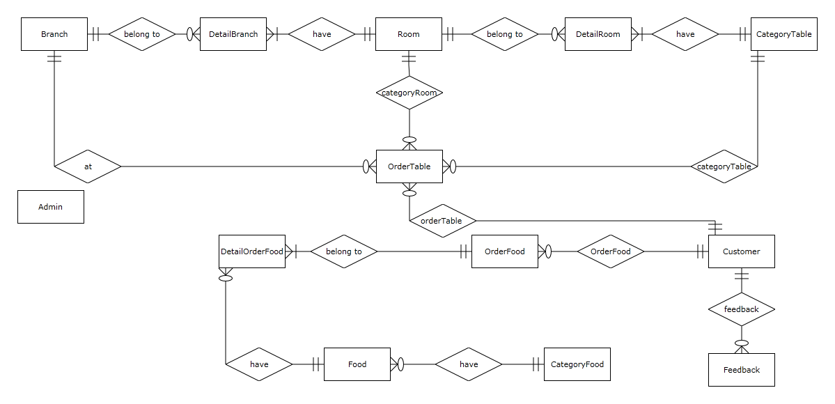

|  |  |  |
| --- | --- | --- |
|  | **Prepared by (Student)** | **Approved by (Faculty)** |
| **Date** | **Project Group No : 1** |  |
| **Signature** | **All members** |  |

|  |  |  |
| --- | --- | --- |
| **Design Plan :** | **Document Name :** TUNGA RESTAURANTS  WEBSITE | **SWD/Form No.** |
| **Effective Date: 14/11/2014** | **Version: 1.0** | **Page No :** 120**/** 172 |

6.2 **Entity:**

6.2.1 **Admin:**

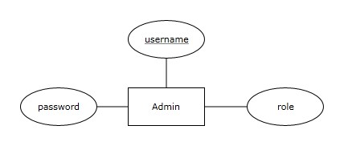

6.2.2 **Branch:**

6.2.3 **Room:**

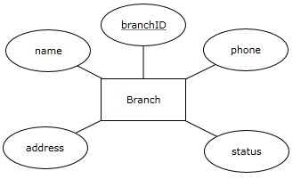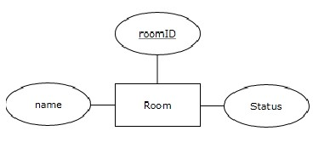

|  |  |  |
| --- | --- | --- |
|  | **Prepared by (Student)** | **Approved by (Faculty)** |
| **Date** | **Project Group No : 1** |  |
| **Signature** | **All members** |  |

|  |  |  |
| --- | --- | --- |
| **Design Plan :** | **Document Name :** TUNGA RESTAURANTS  WEBSITE | **SWD/Form No.** |
| **Effective Date: 14/11/2014** | **Version: 1.0** | **Page No :** 121**/** 172 |

6.2.4 **DetailBranch:**

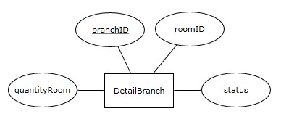

6.2.5 **Category Table:**

6.2.6 **DetailRoom:**

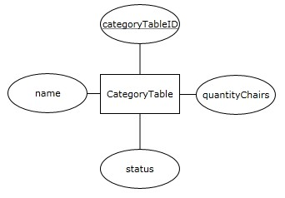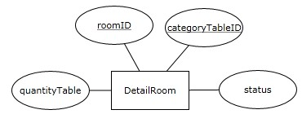

|  |  |  |
| --- | --- | --- |
|  | **Prepared by (Student)** | **Approved by (Faculty)** |
| **Date** | **Project Group No : 1** |  |
| **Signature** | **All members** |  |

|  |  |  |
| --- | --- | --- |
| **Design Plan :** | **Document Name :** TUNGA RESTAURANTS  WEBSITE | **SWD/Form No.** |
| **Effective Date: 14/11/2014** | **Version: 1.0** | **Page No :** 122**/** 172 |

6.2.7 **CategoryFood:**

6.2.8 **Food:**

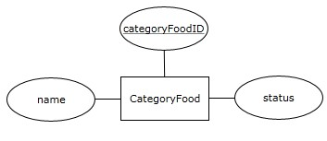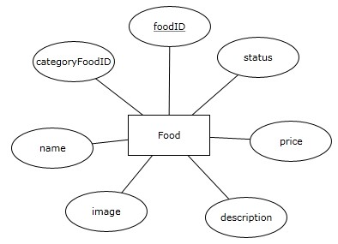

6.2.9 **Customer:**

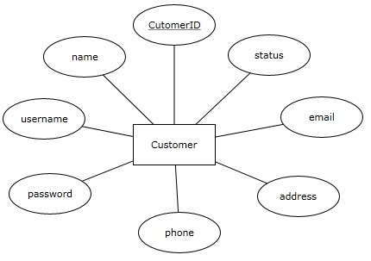

|  |  |  |
| --- | --- | --- |
|  | **Prepared by (Student)** | **Approved by (Faculty)** |
| **Date** | **Project Group No : 1** |  |
| **Signature** | **All members** |  |

|  |  |  |
| --- | --- | --- |
| **Design Plan :** | **Document Name :** TUNGA RESTAURANTS  WEBSITE | **SWD/Form No.** |
| **Effective Date: 14/11/2014** | **Version: 1.0** | **Page No :** 123**/** 172 |

6.2.10 **Feedback:**

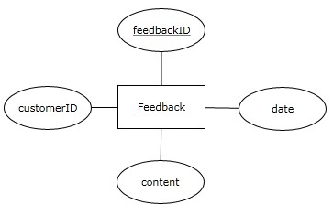

6.2.11 **OrderFood:**

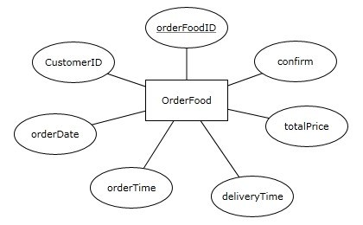

|  |  |  |
| --- | --- | --- |
|  | **Prepared by (Student)** | **Approved by (Faculty)** |
| **Date** | **Project Group No : 1** |  |
| **Signature** | **All members** |  |

|  |  |  |
| --- | --- | --- |
| **Design Plan :** | **Document Name :** TUNGA RESTAURANTS  WEBSITE | **SWD/Form No.** |
| **Effective Date: 14/11/2014** | **Version: 1.0** | **Page No :** 124**/** 172 |

6.2.12 **DetailOrderFood:**

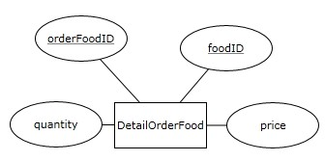

6.2.13 **OrderTable:**

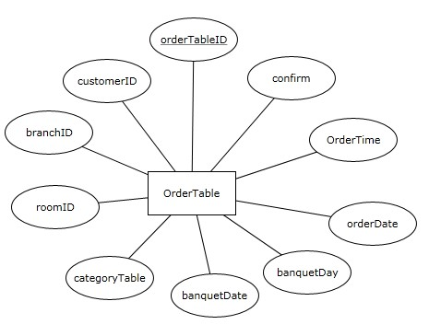

|  |  |  |
| --- | --- | --- |
|  | **Prepared by (Student)** | **Approved by (Faculty)** |
| **Date** | **Project Group No : 1** |  |
| **Signature** | **All members** |  |

|  |  |  |
| --- | --- | --- |
| **Design Plan :** | **Document Name :** TUNGA RESTAURANTS  WEBSITE | **SWD/Form No.** |
| **Effective Date: 14/11/2014** | **Version: 1.0** | **Page No :** 125**/** 172 |

6.3 **E-R Diagram:**

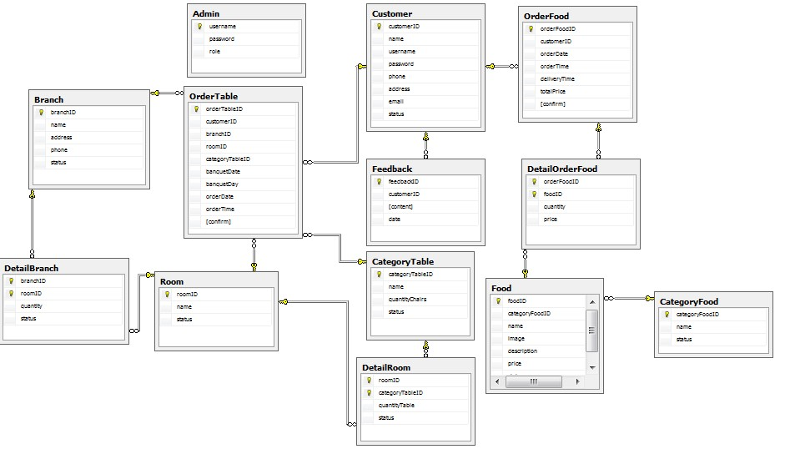

|  |  |  |
| --- | --- | --- |
|  | **Prepared by (Student)** | **Approved by (Faculty)** |
| **Date** | **Project Group No : 1** |  |
| **Signature** | **All members** |  |

|  |  |  |
| --- | --- | --- |
| **Design Plan :** | **Document Name :** TUNGA RESTAURANTS  WEBSITE | **SWD/Form No.** |
| **Effective Date: 14/11/2014** | **Version: 1.0** | **Page No :** 126**/** 172 |

**8 Database Design / Structure:**

|  |  |  |  |  |
| --- | --- | --- | --- | --- |
| **Table: Admin** | | | | |
| **Field Name** | **Data Type** | **Allow**  **Null** | **Key** | **Description** |
| username | Varchar(20) | No | PK | username of admin |
| password | Varchar(20) | No |  | Password |
| role | Bit | No |  | Role of admin  True: Admin  False: Staff |

|  |  |  |  |  |
| --- | --- | --- | --- | --- |
| **Table: Branch** | | | | |
| **Field Name** | **Data Type** | **Allow**  **Null** | **Key** | **Description** |
| branchID | Varchar(10) | No | PK | Id branch |
| name | Varchar(50) | No | Unique | name |
| address | Varchar(200) | No |  | Address |
| phone | Varchar(20) | No |  | Phone |
| status | Bit | No |  | Status of branch True: Active False: Not Active. |

|  |  |  |  |  |
| --- | --- | --- | --- | --- |
| **Table: Room** | | | | |
| **Field Name** | **Data Type** | **Allow**  **Null** | **Key** | **Description** |
| roomID | Varchar(10) | No | PK | Id of room |
| Name | varchar(50) | No | Unique | name |
| Status | bit | No |  | Status of Room  True: use  False: not use |

|  |  |  |
| --- | --- | --- |
|  | **Prepared by (Student)** | **Approved by (Faculty)** |
| **Date** | **Project Group No : 1** |  |
| **Signature** | **All members** |  |

|  |  |  |
| --- | --- | --- |
| **Design Plan :** | **Document Name :** TUNGA RESTAURANTS  WEBSITE | **SWD/Form No.** |
| **Effective Date: 14/11/2014** | **Version: 1.0** | **Page No :** 127**/** 172 |

|  |  |  |  |  |  |
| --- | --- | --- | --- | --- | --- |
| **Table:DetailBranch** | | | | | |
| **Field**  **Name** | **Data Type** | **Allow**  **Null** | **Key** | | **Description** |
| branchID | Varchar(10) | No | FK(Branch) | PK | ID of DetailBranch table |
| roomID | Varchar(10) | No | FK(Room) |
| quantity | int | No |  | | Quantity room |
| Status | Bit | No |  | | Status of room in a branch  True: use  False: not use |

|  |  |  |  |  |
| --- | --- | --- | --- | --- |
| **Table:CategoryTable** | | | | |
| **Field Name** | **Data**  **Type** | **Allow**  **Null** | **Key** | **Description** |
| categoryTableID | Varchar  (10) | No | PK | Id of category table |
| Name | Varchar  (50) | No | Unique | Name |
| quantityChairs | int | No |  | Quantity chairs in table |
| Status | bit | No |  | Status of category table  True: use  False: not use |

|  |  |  |  |  |  |
| --- | --- | --- | --- | --- | --- |
| **Table: DetailRoom** | | | | | |
| **Field Name** | **Data Type** | **Allow**  **Null** | **Key** | | **Description** |
| roomID | Varchar(10) | No | FK (Room) | PK | ID of Detail  Room |
| categoryTableID | Varchar(10) | No | FK ( CategoryTable) |
| quantityTable | int | No |  | | Quantity table |
| Status | bit | No |  | | Status of table in a room  True: use  False: not use |

|  |  |  |
| --- | --- | --- |
|  | **Prepared by (Student)** | **Approved by (Faculty)** |
| **Date** | **Project Group No : 1** |  |
| **Signature** | **All members** |  |

|  |  |  |
| --- | --- | --- |
| **Design Plan :** | **Document Name :** TUNGA RESTAURANTS  WEBSITE | **SWD/Form No.** |
| **Effective Date: 14/11/2014** | **Version: 1.0** | **Page No :** 128**/** 172 |

|  |  |  |  |  |
| --- | --- | --- | --- | --- |
| **Table:CategoryFood** | | | | |
| **Field Name** | **Data Type** | **Allow**  **Null** | **Key** | **Description** |
| categoryFoodID | int | No | PK | Id of category food |
| name | Varchar(50) | No | Unique | name |
| status | bit | No |  | Status of category food  True: product  False: not product |

|  |  |  |  |  |
| --- | --- | --- | --- | --- |
| **Table:Food** | | | | |
| **Field Name** | **Data**  **Type** | **Allow**  **Null** | **Key** | **Description** |
| foodID | int | No | PK | Id of food |
| categoryFoodID | int | No | FK (CategoryFood) |  |
| name | Varchar(5  0) | No | Unique | Name |
| image | Varchar(2  00) | No | Unique | image |
| description | Varchar(5  00) | Yes |  | description |
| price | Float | No |  | price |
| status | bit | No |  | Status of food  True: product False: not product |

|  |  |  |
| --- | --- | --- |
|  | **Prepared by (Student)** | **Approved by (Faculty)** |
| **Date** | **Project Group No : 1** |  |
| **Signature** | **All members** |  |

|  |  |  |
| --- | --- | --- |
| **Design Plan :** | **Document Name :** TUNGA RESTAURANTS  WEBSITE | **SWD/Form No.** |
| **Effective Date: 14/11/2014** | **Version: 1.0** | **Page No :** 129**/** 172 |

|  |  |  |  |  |
| --- | --- | --- | --- | --- |
| **Table:Customer** | | | | |
| **Field Name** | **Data Type** | **Allow**  **Null** | **Key** | **Description** |
| customerID | int | No | PK | Id of food |
| name | Varchar(50) | No |  | Name |
| username | Varchar(20) | No | unique | Username of customer |
| password | Varchar(20) | No |  | password |
| phone | Varchar(20) | No |  | Phone |
| address | Varchar(200) | No |  | Address |
| email | Varchar(50) | No |  | Email |
| status | Bit | No |  | Status of customer  True: active  False: block |

|  |  |  |  |  |
| --- | --- | --- | --- | --- |
| **Table:Feedback** | | | | |
| **Field Name** | **Data Type** | **Allow**  **Null** | **Key** | **Description** |
| feedbackID | int | No | PK | Id of feedback |
| customerID | int | No | FK (Customer) | Id of customer |
| content | Varchar(1000) | No |  | Content feedback |
| date | datetime | No |  | Date time feedback |

|  |  |  |  |  |
| --- | --- | --- | --- | --- |
| **Table:OrderFood** | | | | |
| **Field Name** | **Data Type** | **Allow**  **Null** | **Key** | **Description** |
| orderFoodID | int | No | PK | Id of ordering food |
| customerID | int | No | FK (Customer) | Id of customer |
| orderDate | date | No |  | Order date |
| orderTime | time | No |  | Order time |
| deliveryTime | time | No |  | Delivery time |
| totalPrice | float | No |  | Total price |
| confirm | Bit | No |  | Status of odering food  True: yet  False: not yet |

|  |  |  |
| --- | --- | --- |
|  | **Prepared by (Student)** | **Approved by (Faculty)** |
| **Date** | **Project Group No : 1** |  |
| **Signature** | **All members** |  |

|  |  |  |
| --- | --- | --- |
| **Design Plan :** | **Document Name :** TUNGA RESTAURANTS  WEBSITE | **SWD/Form No.** |
| **Effective Date: 14/11/2014** | **Version: 1.0** | **Page No :** 130**/** 172 |

|  |  |  |  |  |  |
| --- | --- | --- | --- | --- | --- |
| **Table:Detail Order Food** | | | | | |
| **Field Name** | **Data**  **Type** | **Allow**  **Null** | **Key** | | **Description** |
| orderFoodID | int | No | FK (OrderFood) | PK | Id of detail order food |
| foodID | int | No | FK (Food) |
| quantity | int | No |  | | Quantity food |
| price | float | No |  | | price |

|  |  |  |  |  |  |
| --- | --- | --- | --- | --- | --- |
| **Table:OrderTable** | | | | | |
| **Field Name** | **Data Type** | **Allow**  **Null** | | **Key** | **Description** |
| orderTableID | Int | No | PK | | Id of ordering table |
| customerID | Int | No | FK (Customer) | | Id of customer |
| branchID | Varchar(10) | No | FK (Branch) | | Id of branch |
| roomID | Varchar(10) | No | FK (Room) | | Id of room |
| categoryTable | Varchar(10) | No | FK (CategoryTable) | | Id of category table |
| banquetDate | Date | No |  | | Banquet date |
| banquetDay | Bit | No |  | | Banquet day  True: dinner  False: lunch |
| orderDate | Date | No |  | | Order date |
| orderTime | Time | No |  | | Order time |
| confirm | Bit | No |  | | Status of odering table  True: yet  False: not yet |

|  |  |  |
| --- | --- | --- |
|  | **Prepared by (Student)** | **Approved by (Faculty)** |
| **Date** | **Project Group No : 1** |  |
| **Signature** | **All members** |  |

|  |  |  |
| --- | --- | --- |
| **Design Plan :** | **Document Name :** TUNGA RESTAURANTS  WEBSITE | **SWD/Form No.** |
| **Effective Date: 14/11/2014** | **Version: 1.0** | **Page No :** 131**/** 172 |

**Review 2 Task Sheet**

|  |  |  |  |  |  |  |
| --- | --- | --- | --- | --- | --- | --- |
| **Group: 1** | | **Project Name:**  **Tunga Restaurant**  **Website** | **Timeline** | | | |
| **Num** | **Job** | **Description** | **Start**  **Date** | **Date**  **Finish** | **Student Name** | **Status** |
| **04** | **P R V I E**  **W**  **2** | **Use Case and Sequence**  **Diagram** | **27**  **-**  **10**  **-**  **14** | **03**  **-**  **11**  **-**  **14** | **Nguyen Anh Tu Nguyen Minh Dung Nguyen Thanh Binh Nguyen Kim Huy** | Complete |
| **05** | **Data Flow Diagram** | Complete |
| **06** | **Process Diagram** | Complete |
| **07** | **Entity Relationship(ER) Diagram** | Complete |
| **08** | **Database**  **Design/Structure** | Complete |

Team Leader’s Signature Instructor’ Signature

Nguyen Anh Tu Mr. Ngo Phuoc Nguyen

|  |  |  |
| --- | --- | --- |
|  | **Prepared by (Student)** | **Approved by (Faculty)** |
| **Date** | **Project Group No : 1** |  |
| **Signature** | **All members** |  |

|  |  |  |
| --- | --- | --- |
| **Design Plan :** | **Document Name :** TUNGA RESTAURANTS  WEBSITE | **SWD/Form No.** |
| **Effective Date: 14/11/2014** | **Version: 1.0** | **Page No :** 132**/** 172 |

**9 Interface Design:**

9.1 **index.jsp:**

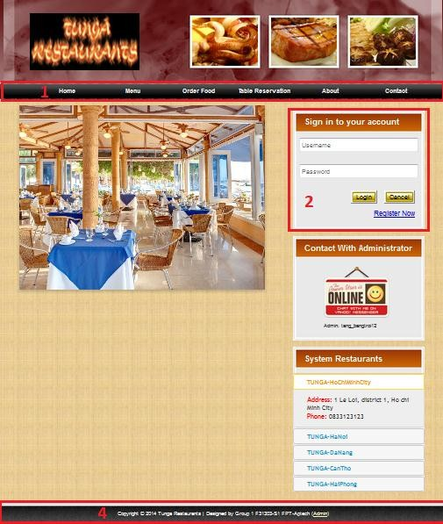

|  |  |  |
| --- | --- | --- |
|  | **Prepared by (Student)** | **Approved by (Faculty)** |
| **Date** | **Project Group No : 1** |  |
| **Signature** | **All members** |  |

|  |  |  |
| --- | --- | --- |
| **Design Plan :** | **Document Name :** TUNGA RESTAURANTS  WEBSITE | **SWD/Form No.** |
| **Effective Date: 14/11/2014** | **Version: 1.0** | **Page No :** 133**/** 172 |

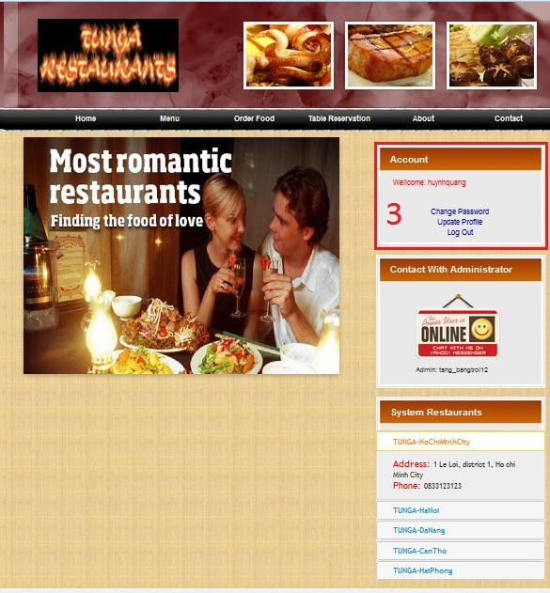

|  |  |
| --- | --- |
| **NO** | **Name** |
| 1 | Menu |
| 2 | Login |
| 3 | Manage Account |
| 4 | Bottom |

|  |  |  |
| --- | --- | --- |
|  | **Prepared by (Student)** | **Approved by (Faculty)** |
| **Date** | **Project Group No : 1** |  |
| **Signature** | **All members** |  |

|  |  |  |
| --- | --- | --- |
| **Design Plan :** | **Document Name :** TUNGA RESTAURANTS  WEBSITE | **SWD/Form No.** |
| **Effective Date: 14/11/2014** | **Version: 1.0** | **Page No :** 134**/** 172 |

9.1.1 **Menu:**



|  |  |  |  |
| --- | --- | --- | --- |
| **NO** | **Name** | **Type** | **Event** |
| 1 | Menu Home | Link | Click |
| 2 | Menu Menu | Link | Click |
| 3 | Menu Order Food | Link | Click |
| 4 | Menu Table Reservation | Link | Click |
| 5 | Menu About | Link | Click |
| 6 | Menu Contact | Link | Click |

➢ **Description event:**

• Click (Menu Home): redirect to index.jsp

• Click (Menu Menu): redirect to menu.jsp

• Click (Menu Order Food): redirect to orderFood.jsp

• Click (Menu Table Reservation): redirect to tableReservation.jsp

• Click (Menu About): redirect to about.jsp

• Click (Menu Contact): redirect to feedback.jsp

|  |  |  |
| --- | --- | --- |
|  | **Prepared by (Student)** | **Approved by (Faculty)** |
| **Date** | **Project Group No : 1** |  |
| **Signature** | **All members** |  |

|  |  |  |
| --- | --- | --- |
| **Design Plan :** | **Document Name :** TUNGA RESTAURANTS  WEBSITE | **SWD/Form No.** |
| **Effective Date: 14/11/2014** | **Version: 1.0** | **Page No :** 135**/** 172 |

9.1.2 **Login:**

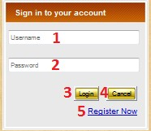

|  |  |  |  |  |
| --- | --- | --- | --- | --- |
| **NO** | **Name** | **Type** | **Validation** | **Event** |
| 1 | txtUsername | TextBox | required |  |
| 2 | txtPassword | TextBox | required |  |
| 3 | btnLogin | Button |  | Click |
| 4 | btnCancel | Button |  | Click |
| 5 | Link Register | Link |  | Click |

➢ **Description event:**

• Click (btnLogin):

- If username or pass word invalid: display message.

- If login success: login with user account.

• Click (btnCancel): back.

• Click (Link Register): redirect to register.jsp.

|  |  |  |
| --- | --- | --- |
|  | **Prepared by (Student)** | **Approved by (Faculty)** |
| **Date** | **Project Group No : 1** |  |
| **Signature** | **All members** |  |

|  |  |  |
| --- | --- | --- |
| **Design Plan :** | **Document Name :** TUNGA RESTAURANTS  WEBSITE | **SWD/Form No.** |
| **Effective Date: 14/11/2014** | **Version: 1.0** | **Page No :** 136**/** 172 |

9.1.3 **Manage Account:**

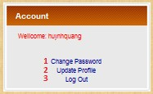

|  |  |  |  |
| --- | --- | --- | --- |
| **NO** | **Name** | **Type** | **Event** |
| 1 | Link Change Password | Link | Click |
| 2 | Link Update Profile | Link | Click |
| 3 | Link Log Out | Link | Click |

➢ **Description event:**

• Click (Link Change Password): redirect to changePass.jsp

• Click (Link Update Profile): redirect to updateProfile.jsp

• Click (Link Log Out): Log Out.

9.1.4 **Bottom:**



|  |  |  |  |
| --- | --- | --- | --- |
| **NO** | **Name** | **Type** | **Event** |
| 1 | Link Admin | Link | Click |

➢ **Description event:**

• Click (Link Admin): redirect to adminLogin.jsp

|  |  |  |
| --- | --- | --- |
|  | **Prepared by (Student)** | **Approved by (Faculty)** |
| **Date** | **Project Group No : 1** |  |
| **Signature** | **All members** |  |

|  |  |  |
| --- | --- | --- |
| **Design Plan :** | **Document Name :** TUNGA RESTAURANTS  WEBSITE | **SWD/Form No.** |
| **Effective Date: 14/11/2014** | **Version: 1.0** | **Page No :** 137**/** 172 |

9.2 **changePass.jsp:**

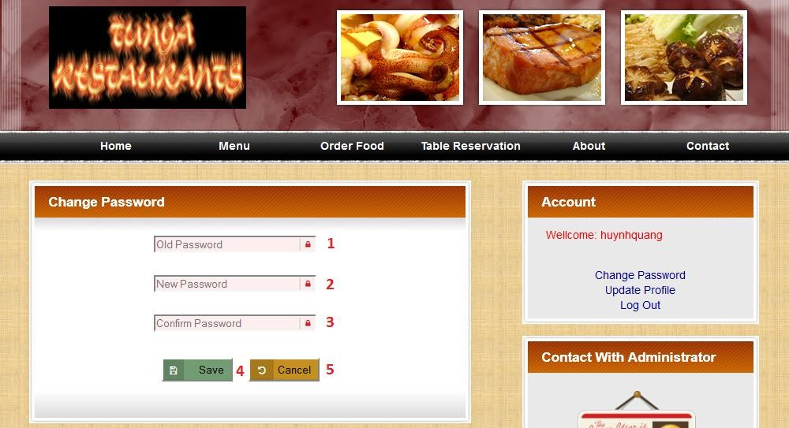

|  |  |  |  |  |
| --- | --- | --- | --- | --- |
| **NO** | **Name** | **Type** | **Validation** | **Event** |
| 1 | txtOldPassword | TextBox | required |  |
| 2 | txtNewPassword | TextBox | required |  |
| 3 | txtConfirmPassword | TextBox | required |  |
| 4 | btnSave | Button |  | Click |
| 5 | btnCancel | Button |  | Click |

➢ **Description event:**

• Click (btnSave):

- If data invalid: display message.

- If success: login with user account.

• Click (btnCancel): back.

|  |  |  |
| --- | --- | --- |
|  | **Prepared by (Student)** | **Approved by (Faculty)** |
| **Date** | **Project Group No : 1** |  |
| **Signature** | **All members** |  |

|  |  |  |
| --- | --- | --- |
| **Design Plan :** | **Document Name :** TUNGA RESTAURANTS  WEBSITE | **SWD/Form No.** |
| **Effective Date: 14/11/2014** | **Version: 1.0** | **Page No :** 138**/** 172 |

9.3 **updateProfile.jsp:**

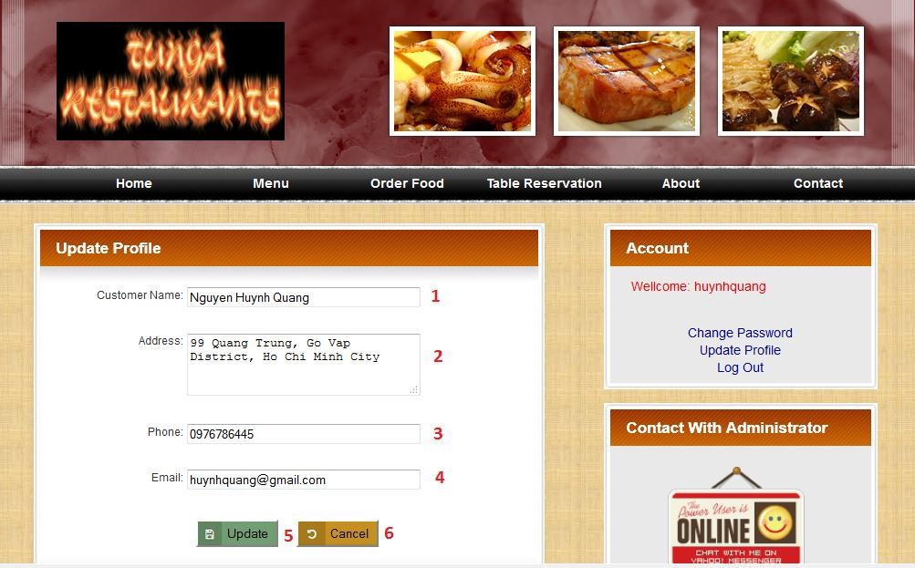

|  |  |  |  |  |
| --- | --- | --- | --- | --- |
| **NO** | **Name** | **Type** | **Validation** | **Event** |
| 1 | txtCustomerName | TextBox | required |  |
| 2 | txtAddress | TextBox | required |  |
| 3 | txtPhone | TextBox | required |  |
| 4 | txtEmail | TextBox | required |  |
| 5 | btnUpdate | Button |  | Click |
| 6 | btnCancel | Button |  | Click |

➢ **Description event:**

• Click (btnSave):

- If data invalid: display message.

- If success: login with user account.

• Click (btnCancel): back.

|  |  |  |
| --- | --- | --- |
|  | **Prepared by (Student)** | **Approved by (Faculty)** |
| **Date** | **Project Group No : 1** |  |
| **Signature** | **All members** |  |

|  |  |  |
| --- | --- | --- |
| **Design Plan :** | **Document Name :** TUNGA RESTAURANTS  WEBSITE | **SWD/Form No.** |
| **Effective Date: 14/11/2014** | **Version: 1.0** | **Page No :** 139**/** 172 |

9.4 **menu.jsp:**

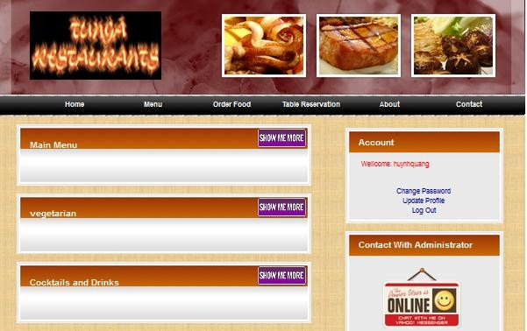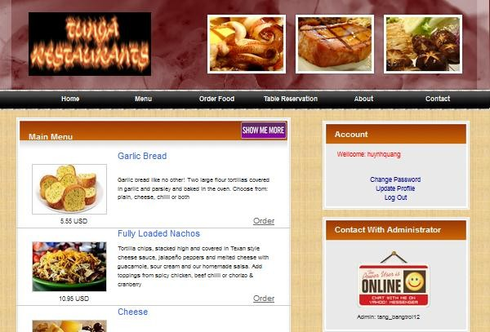

|  |  |  |
| --- | --- | --- |
|  | **Prepared by (Student)** | **Approved by (Faculty)** |
| **Date** | **Project Group No : 1** |  |
| **Signature** | **All members** |  |

|  |  |  |
| --- | --- | --- |
| **Design Plan :** | **Document Name :** TUNGA RESTAURANTS  WEBSITE | **SWD/Form No.** |
| **Effective Date: 14/11/2014** | **Version: 1.0** | **Page No :** 140**/** 172 |

9.5 **orderFood.jsp:**

9.5.1 **Display Order Form:**

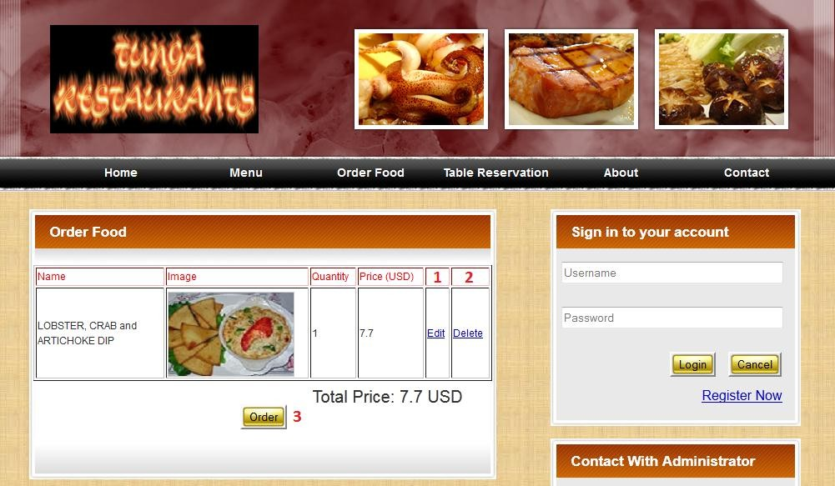

|  |  |  |  |
| --- | --- | --- | --- |
| **NO** | **Name** | **Type** | **Event** |
| 1 | linkEdit | link | Click |
| 2 | linkDelete | link | Click |
| 3 | btnOrder | Button | Click |

➢ **Description event:**

• Click (linkEdit): display Edit Form.

• Click (link Delete): Delete.

• Click (btnOrder): save into database.

|  |  |  |
| --- | --- | --- |
|  | **Prepared by (Student)** | **Approved by (Faculty)** |
| **Date** | **Project Group No : 1** |  |
| **Signature** | **All members** |  |

|  |  |  |
| --- | --- | --- |
| **Design Plan :** | **Document Name :** TUNGA RESTAURANTS  WEBSITE | **SWD/Form No.** |
| **Effective Date: 14/11/2014** | **Version: 1.0** | **Page No :** 141**/** 172 |

9.5.2 **Display Edit Form:**

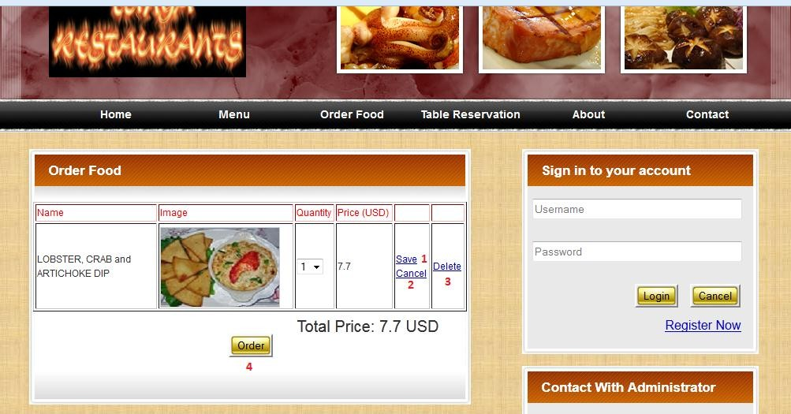

|  |  |  |  |
| --- | --- | --- | --- |
| **NO** | **Name** | **Type** | **Event** |
| 1 | linkSave | link | Click |
| 2 | linkCancel | link | Click |
| 3 | linkDelete | link | Click |
| 4 | btnOrder | Button | Click |

➢ **Description event:**

• Click (linkSave): edit.

• Click (linkCancel): back.

• Click (link Delete): Delete.

• Click (btnOrder): save into database.

|  |  |  |
| --- | --- | --- |
|  | **Prepared by (Student)** | **Approved by (Faculty)** |
| **Date** | **Project Group No : 1** |  |
| **Signature** | **All members** |  |

|  |  |  |
| --- | --- | --- |
| **Design Plan :** | **Document Name :** TUNGA RESTAURANTS  WEBSITE | **SWD/Form No.** |
| **Effective Date: 14/11/2014** | **Version: 1.0** | **Page No :** 142**/** 172 |

9.6 **tableReservation.jsp:**

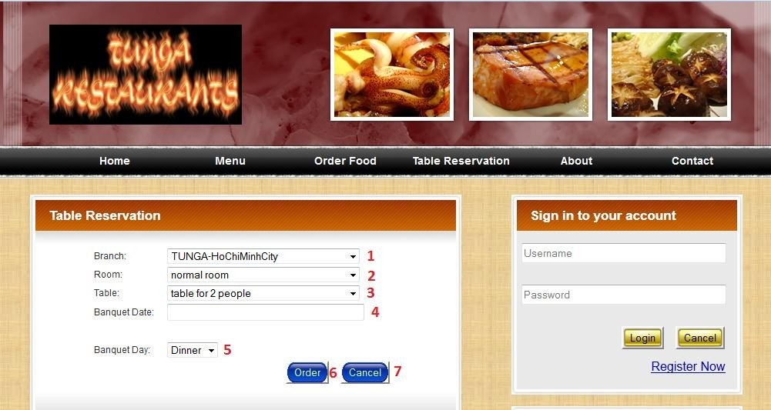

|  |  |  |  |  |
| --- | --- | --- | --- | --- |
| **NO** | **Name** | **Type** | **Validation** | **Event** |
| 1 | slBranch | Select | required |  |
| 2 | slRoom | Select | required |  |
| 3 | slTable | Select | required |  |
| 4 | txtBanquetDate | TextBox | required |  |
| 5 | slBanquetDay | Select | required |  |
| 6 | btnOrder | Button |  | Click |
| 7 | btnCancel | Button |  | Click |

➢ **Description event:**

• Click (btnOrder):

- If data invalid: display message.

- If order success: save into database.

• Click (btnCancel): back.

|  |  |  |
| --- | --- | --- |
|  | **Prepared by (Student)** | **Approved by (Faculty)** |
| **Date** | **Project Group No : 1** |  |
| **Signature** | **All members** |  |

|  |  |  |
| --- | --- | --- |
| **Design Plan :** | **Document Name :** TUNGA RESTAURANTS  WEBSITE | **SWD/Form No.** |
| **Effective Date: 14/11/2014** | **Version: 1.0** | **Page No :** 143**/** 172 |

9.7 **feedback.jsp:**

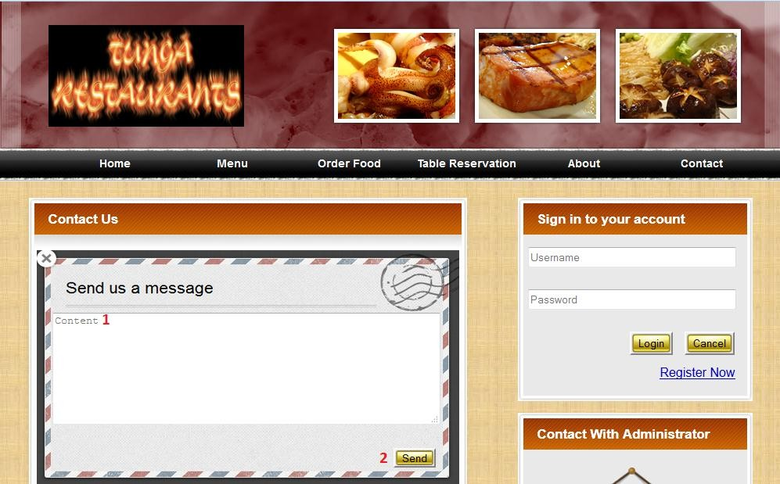

|  |  |  |  |  |
| --- | --- | --- | --- | --- |
| **NO** | **Name** | **Type** | **Validation** | **Event** |
| 1 | txtContent | textBox | required |  |
| 2 | btnSend | Button |  | Click |

➢ **Description event:**

• Click (btnSend):

- If data invalid: display message.

- If success: save into database.

|  |  |  |
| --- | --- | --- |
|  | **Prepared by (Student)** | **Approved by (Faculty)** |
| **Date** | **Project Group No : 1** |  |
| **Signature** | **All members** |  |

|  |  |  |
| --- | --- | --- |
| **Design Plan :** | **Document Name :** TUNGA RESTAURANTS  WEBSITE | **SWD/Form No.** |
| **Effective Date: 14/11/2014** | **Version: 1.0** | **Page No :** 144**/** 172 |

9.8 **adLogin.jsp:**

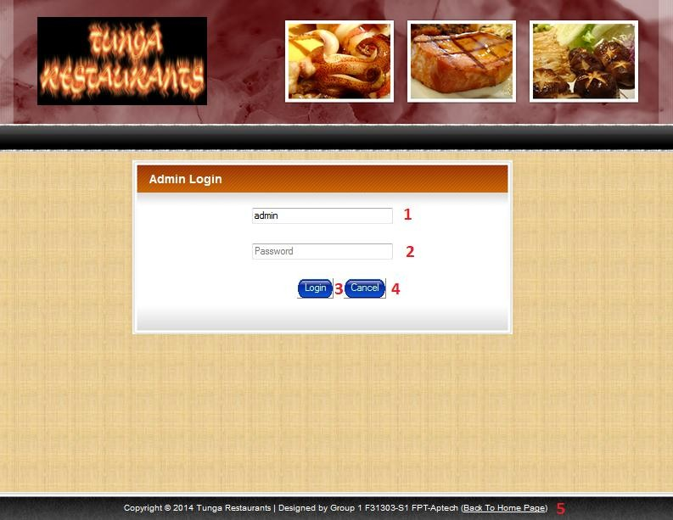

|  |  |  |  |  |
| --- | --- | --- | --- | --- |
| **NO** | **Name** | **Type** | **Validation** | **Event** |
| 1 | txtUsername | TextBox | required |  |
| 2 | txtPassword | TextBox | required |  |
| 3 | btnLogin | Button |  | Click |
| 4 | btnCancel | Button |  | Click |
| 5 | Link Back To Home Page | Link |  | Click |

➢ **Description event:**

• Click (btnLogin):

- If username or pass word invalid: display message.

- If login success: If user is admin, login with admin account. If user is staff, login with staff account.

• Click (btnCancel): back.

• Click (Link Back To Home Page): redirect to index.jsp.

|  |  |  |
| --- | --- | --- |
|  | **Prepared by (Student)** | **Approved by (Faculty)** |
| **Date** | **Project Group No : 1** |  |
| **Signature** | **All members** |  |

|  |  |  |
| --- | --- | --- |
| **Design Plan :** | **Document Name :** TUNGA RESTAURANTS  WEBSITE | **SWD/Form No.** |
| **Effective Date: 14/11/2014** | **Version: 1.0** | **Page No :** 145**/** 172 |

9.9 **adHome.jsp:**

9.9.1 **adHome.jsp For Staff:**

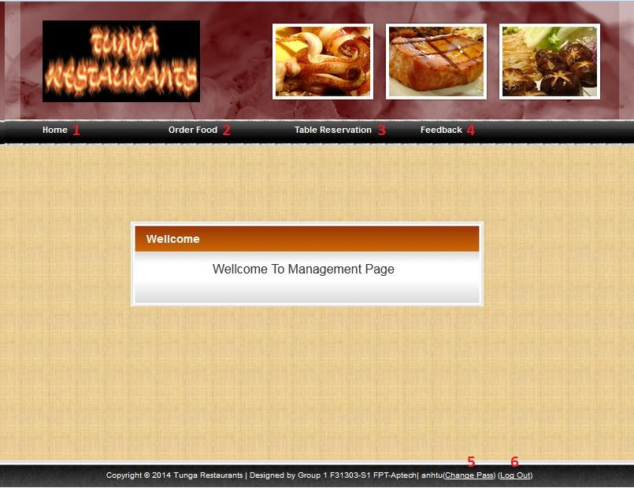

|  |  |  |  |
| --- | --- | --- | --- |
| **NO** | **Name** | **Type** | **Event** |
| 1 | Menu Home | Link | Click |
| 2 | Menu Order Food | Link | Click |
| 3 | Menu Table Reservation | Link | Click |
| 4 | Menu Feedback | Link | Click |
| 5 | Change Pass | Link | Click |
| 6 | Log Out | Link | Click |

|  |  |  |
| --- | --- | --- |
|  | **Prepared by (Student)** | **Approved by (Faculty)** |
| **Date** | **Project Group No : 1** |  |
| **Signature** | **All members** |  |

|  |  |  |
| --- | --- | --- |
| **Design Plan :** | **Document Name :** TUNGA RESTAURANTS  WEBSITE | **SWD/Form No.** |
| **Effective Date: 14/11/2014** | **Version: 1.0** | **Page No :** 146**/** 172 |

➢ **Description event:**

• Click (Menu Home): redirect to adHome.jsp

• Click (Menu Order Food): redirect to adOrderFood.jsp.

• Click (Menu Table Reservation): redirect to adOrderTable.jsp.

• Click (Menu Feedback): redirect to adFeedback.jsp.

• Click (Change Pass): redirect to adChangePass.jsp.

• Click (Log Out): Log Out, redirect to adLogin.jsp

|  |  |  |
| --- | --- | --- |
|  | **Prepared by (Student)** | **Approved by (Faculty)** |
| **Date** | **Project Group No : 1** |  |
| **Signature** | **All members** |  |

|  |  |  |
| --- | --- | --- |
| **Design Plan :** | **Document Name :** TUNGA RESTAURANTS  WEBSITE | **SWD/Form No.** |
| **Effective Date: 14/11/2014** | **Version: 1.0** | **Page No :** 147**/** 172 |

9.9.2 **adHome.jsp For Admin:**

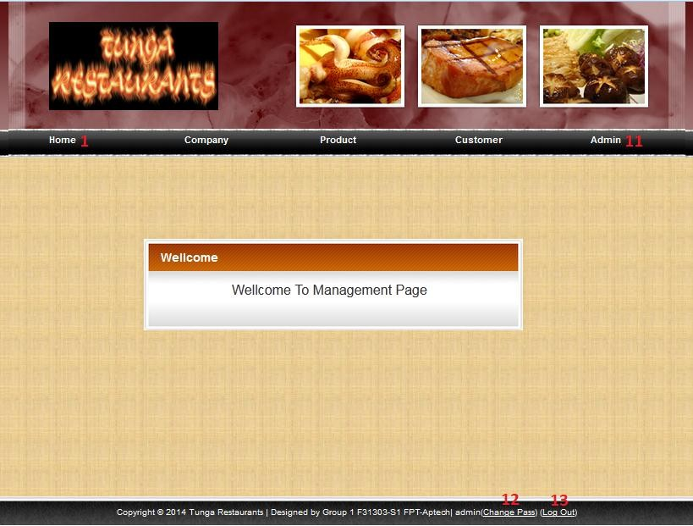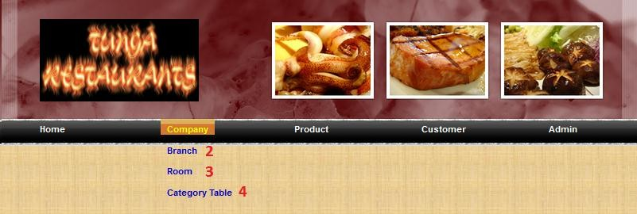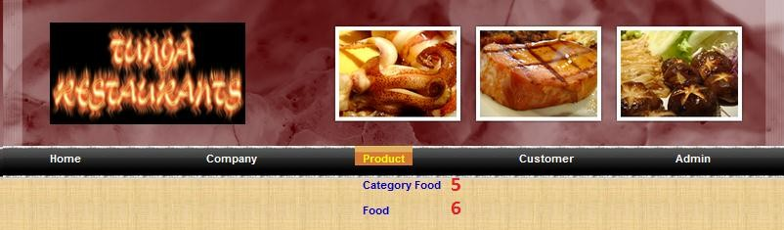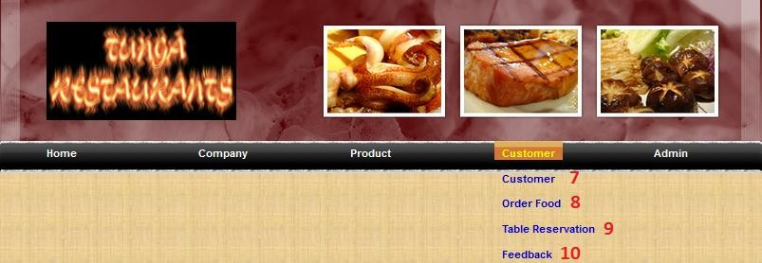

|  |  |  |
| --- | --- | --- |
|  | **Prepared by (Student)** | **Approved by (Faculty)** |
| **Date** | **Project Group No : 1** |  |
| **Signature** | **All members** |  |

|  |  |  |
| --- | --- | --- |
| **Design Plan :** | **Document Name :** TUNGA RESTAURANTS  WEBSITE | **SWD/Form No.** |
| **Effective Date: 14/11/2014** | **Version: 1.0** | **Page No :** 148**/** 172 |

|  |  |  |  |
| --- | --- | --- | --- |
| **NO** | **Name** | **Type** | **Event** |
| 1 | Menu Home | Link | Click |
| 2 | Menu Branch | Link | Click |
| 3 | Menu Room | Link | Click |
| 4 | Menu Category Table | Link | Click |
| 5 | Menu Category Food | Link | Click |
| 6 | Menu Food | Link | Click |
| 7 | Menu Customer | Link | Click |
| 8 | Menu Order Food | Link | Click |
| 9 | Menu Table Reservation | Link | Click |
| 10 | Menu Feedback | Link | Click |
| 11 | Menu Admin | Link | Click |
| 12 | Change Pass | Link | Click |
| 13 | Log Out | Link | Click |

➢ **Description event:**

• Click (Menu Home): redirect to adHome.jsp

• Click (Menu Branch): redirect to adBranch.jsp.

• Click (Menu Room): redirect to adRoom.jsp.

• Click (Menu Category Table): redirect to adCategoryTable.jsp.

|  |  |  |
| --- | --- | --- |
|  | **Prepared by (Student)** | **Approved by (Faculty)** |
| **Date** | **Project Group No : 1** |  |
| **Signature** | **All members** |  |

|  |  |  |
| --- | --- | --- |
| **Design Plan :** | **Document Name :** TUNGA RESTAURANTS  WEBSITE | **SWD/Form No.** |
| **Effective Date: 14/11/2014** | **Version: 1.0** | **Page No :** 149**/** 172 |

• Click (Menu Category Food): redirect to adCategoryFood.jsp.

• Click (Menu Food): redirect to adFood.jsp

• Click(Menu Table Reservation): redirect to adOrderTable.jsp

• Click(Menu Feedback): redirect to adFeedback.jsp

• Click(Menu Admin): redirect to adAdmin.jsp

• Click(Change Pass): redirect to adChangePass.jsp

• Click(Log Out): Log Out and redirect to adLogin.jsp

|  |  |  |
| --- | --- | --- |
|  | **Prepared by (Student)** | **Approved by (Faculty)** |
| **Date** | **Project Group No : 1** |  |
| **Signature** | **All members** |  |

|  |  |  |
| --- | --- | --- |
| **Design Plan :** | **Document Name :** TUNGA RESTAURANTS  WEBSITE | **SWD/Form No.** |
| **Effective Date: 14/11/2014** | **Version: 1.0** | **Page No :** 150**/** 172 |

9.10 **adChangePass.jsp:**

|  |  |  |  |  |
| --- | --- | --- | --- | --- |
| **NO** | **Name** | **Type** | **Validation** | **Event** |
| 1 | txtOldPassword | TextBox | required |  |
| 2 | txtNewPassword | TextBox | required |  |
| 3 | txtConfirmPassword | TextBox | required |  |
| 4 | btnSave | Button |  | Click |
| 5 | btnCancel | Button |  | Click |

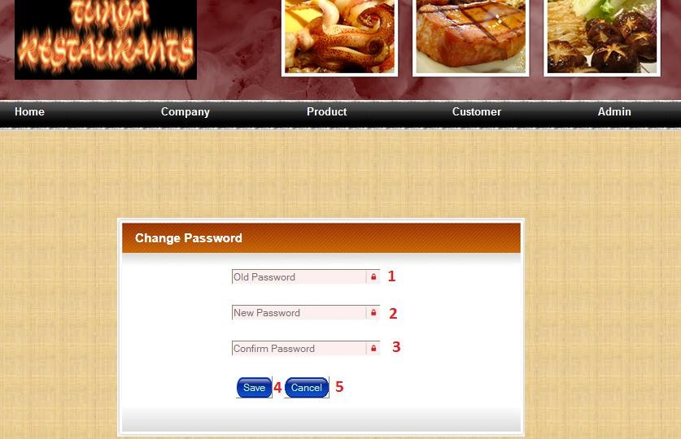

➢ **Description event:**

• Click (btnSave):

- If data invalid: display message.

- If success: login with user account.

• Click (btnCancel): back.

|  |  |  |
| --- | --- | --- |
|  | **Prepared by (Student)** | **Approved by (Faculty)** |
| **Date** | **Project Group No : 1** |  |
| **Signature** | **All members** |  |

|  |  |  |
| --- | --- | --- |
| **Design Plan :** | **Document Name :** TUNGA RESTAURANTS  WEBSITE | **SWD/Form No.** |
| **Effective Date: 14/11/2014** | **Version: 1.0** | **Page No :** 151**/** 172 |

9.11 **adBranch.jsp:**

9.11.1 **Display Insert Form:**

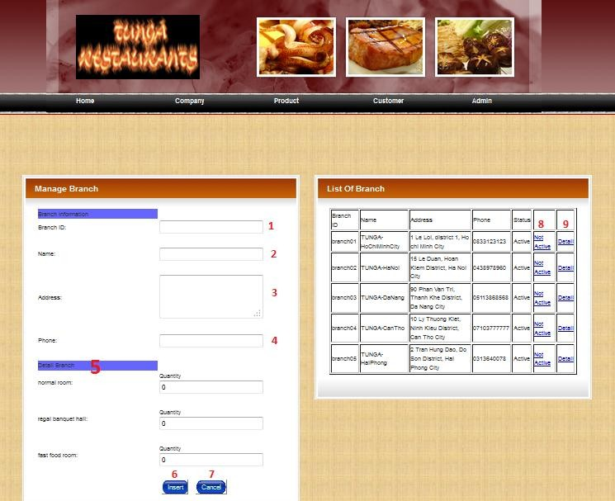

|  |  |  |  |  |  |
| --- | --- | --- | --- | --- | --- |
| **NO** | **Name** | **Type** | **Validation** | **Event** | **Description** |
| 1 | txtBranchID | TextBox | required |  |  |
| 2 | txtName | TextBox | required |  |  |
| 3 | txtAddress | TextArea | required |  |  |
| 4 | txtPhone | TextBox | required |  |  |
| 5 | Detail Branch | TextBox | required |  | Input quantity every |

|  |  |  |
| --- | --- | --- |
|  | **Prepared by (Student)** | **Approved by (Faculty)** |
| **Date** | **Project Group No : 1** |  |
| **Signature** | **All members** |  |

|  |  |  |
| --- | --- | --- |
| **Design Plan :** | **Document Name :** TUNGA RESTAURANTS  WEBSITE | **SWD/Form No.** |
| **Effective Date: 14/11/2014** | **Version: 1.0** | **Page No :** 152**/** 172 |

|  |  |  |  |  |  |
| --- | --- | --- | --- | --- | --- |
|  |  |  |  |  | category room in new branch |
| 6 | btnInsert | Button |  | Click |  |
| 7 | btnCancel | Button |  | Click |  |
| 8 | linkChangeStatus | Link |  | Click |  |
| 9 | linkDetail | Link |  | Click |  |

➢ **Description event:**

• Click (btnInsert): if data valid, insert new branch into database.

• Click (btnCancel): back.

• Click (linkChangeStatus): change status of branch.

• Click (linkDetail): display update form.

|  |  |  |
| --- | --- | --- |
|  | **Prepared by (Student)** | **Approved by (Faculty)** |
| **Date** | **Project Group No : 1** |  |
| **Signature** | **All members** |  |

|  |  |  |
| --- | --- | --- |
| **Design Plan :** | **Document Name :** TUNGA RESTAURANTS  WEBSITE | **SWD/Form No.** |
| **Effective Date: 14/11/2014** | **Version: 1.0** | **Page No :** 153**/** 172 |

9.11.2 **Display Update Form:**

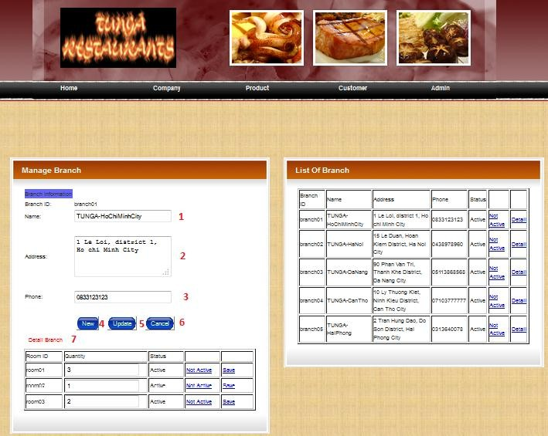

|  |  |  |  |  |  |
| --- | --- | --- | --- | --- | --- |
| **NO** | **Name** | **Type** | **Validation** | **Event** | **Description** |
| 1 | txtName | TextBox | required |  |  |
| 2 | txtAddress | TextArea | required |  |  |
| 3 | txtPhone | TextBox | required |  |  |
| 4 | btnNew | Button |  | Click |  |

|  |  |  |
| --- | --- | --- |
|  | **Prepared by (Student)** | **Approved by (Faculty)** |
| **Date** | **Project Group No : 1** |  |
| **Signature** | **All members** |  |

|  |  |  |
| --- | --- | --- |
| **Design Plan :** | **Document Name :** TUNGA RESTAURANTS  WEBSITE | **SWD/Form No.** |
| **Effective Date: 14/11/2014** | **Version: 1.0** | **Page No :** 154**/** 172 |

|  |  |  |  |  |  |
| --- | --- | --- | --- | --- | --- |
| 5 | btnUpdate | Button |  | Click |  |
| 6 | btnCancel | Link |  | Click |  |
| 7 | Detail Branch | TextBox |  |  | Update Detail For Branch. |

➢ **Description event:**

• Click (btnNew): display insert form.

• Click (btnUpdate): if data valid, update branch into database.

• Click (btnCancel): back.

|  |  |  |
| --- | --- | --- |
|  | **Prepared by (Student)** | **Approved by (Faculty)** |
| **Date** | **Project Group No : 1** |  |
| **Signature** | **All members** |  |

|  |  |  |
| --- | --- | --- |
| **Design Plan :** | **Document Name :** TUNGA RESTAURANTS  WEBSITE | **SWD/Form No.** |
| **Effective Date: 14/11/2014** | **Version: 1.0** | **Page No :** 155**/** 172 |

9.12 **adRoom.jsp:**

9.12.1 **Display Insert Form:**

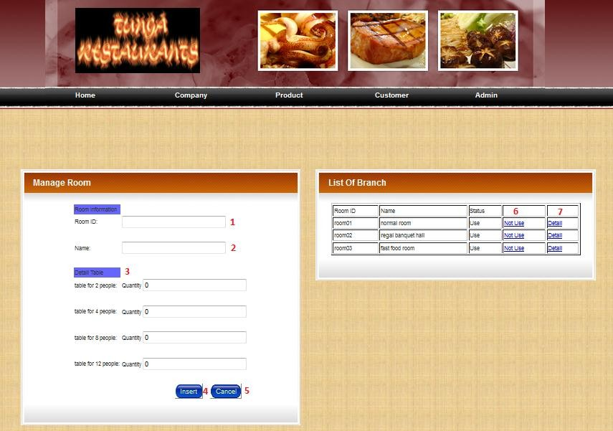

|  |  |  |  |  |  |
| --- | --- | --- | --- | --- | --- |
| **NO** | **Name** | **Type** | **Validation** | **Event** | **Description** |
| 1 | txtRoomID | TextBox | required |  |  |
| 2 | txtName | TextBox | required |  |  |
| 3 | DetailRoom | TextBox | required |  | Input quantity every  category table in new room |
| 4 | btnInsert | Button |  | Click |  |
| 5 | btnCancel | Button |  | Click |  |

|  |  |  |
| --- | --- | --- |
|  | **Prepared by (Student)** | **Approved by (Faculty)** |
| **Date** | **Project Group No : 1** |  |
| **Signature** | **All members** |  |

|  |  |  |
| --- | --- | --- |
| **Design Plan :** | **Document Name :** TUNGA RESTAURANTS  WEBSITE | **SWD/Form No.** |
| **Effective Date: 14/11/2014** | **Version: 1.0** | **Page No :** 156**/** 172 |

|  |  |  |  |  |  |
| --- | --- | --- | --- | --- | --- |
| 6 | linkChangeStatus | Link |  | Click |  |
| 7 | linkDetail | Link |  | Click |  |

➢ **Description event:**

• Click (btnInsert): if data valid, insert new room into database.

• Click (btnCancel): back.

• Click (linkChangeStatus): change status of room.

• Click (linkDetail): display update form.

|  |  |  |
| --- | --- | --- |
|  | **Prepared by (Student)** | **Approved by (Faculty)** |
| **Date** | **Project Group No : 1** |  |
| **Signature** | **All members** |  |

|  |  |  |
| --- | --- | --- |
| **Design Plan :** | **Document Name :** TUNGA RESTAURANTS  WEBSITE | **SWD/Form No.** |
| **Effective Date: 14/11/2014** | **Version: 1.0** | **Page No :** 157**/** 172 |

9.12.2 **Display Update Form:**

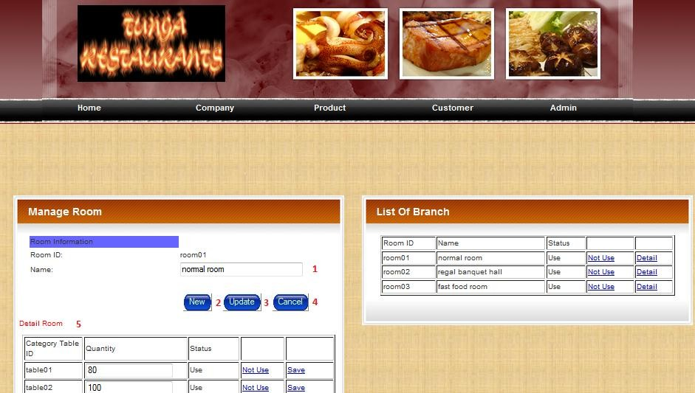

|  |  |  |  |  |  |
| --- | --- | --- | --- | --- | --- |
| **NO** | **Name** | **Type** | **Validation** | **Event** | **Description** |
| 1 | txtName | TextBox | required |  |  |
| 2 | btnNew | Button |  | Click |  |
| 3 | btnUpdate | Button |  | Click |  |
| 4 | btnCancel | Link |  | Click |  |
| 5 | Detail Branch | TextBox |  |  | Update Detail For Branch. |

➢ **Description event:**

• Click (btnNew): display insert form.

• Click (btnUpdate): if data valid, update room into database.

• Click (btnCancel): back.

|  |  |  |
| --- | --- | --- |
|  | **Prepared by (Student)** | **Approved by (Faculty)** |
| **Date** | **Project Group No : 1** |  |
| **Signature** | **All members** |  |

|  |  |  |
| --- | --- | --- |
| **Design Plan :** | **Document Name :** TUNGA RESTAURANTS  WEBSITE | **SWD/Form No.** |
| **Effective Date: 14/11/2014** | **Version: 1.0** | **Page No :** 158**/** 172 |

9.13 **adCategoryTable.jsp:**

9.13.1 **Display Insert Form:**

|  |  |  |  |  |
| --- | --- | --- | --- | --- |
| **NO** | **Name** | **Type** | **Validation** | **Event** |
| 1 | txtName | TextBox | required |  |
| 2 | txtQuantityChairs | TextBox | required |  |
| 3 | btnInsert | Button |  | Click |
| 4 | btnCancel | Button |  | Click |
| 5 | linkChangeStatus | Link |  | Click |
| 6 | linkEdit | Link |  | Click |

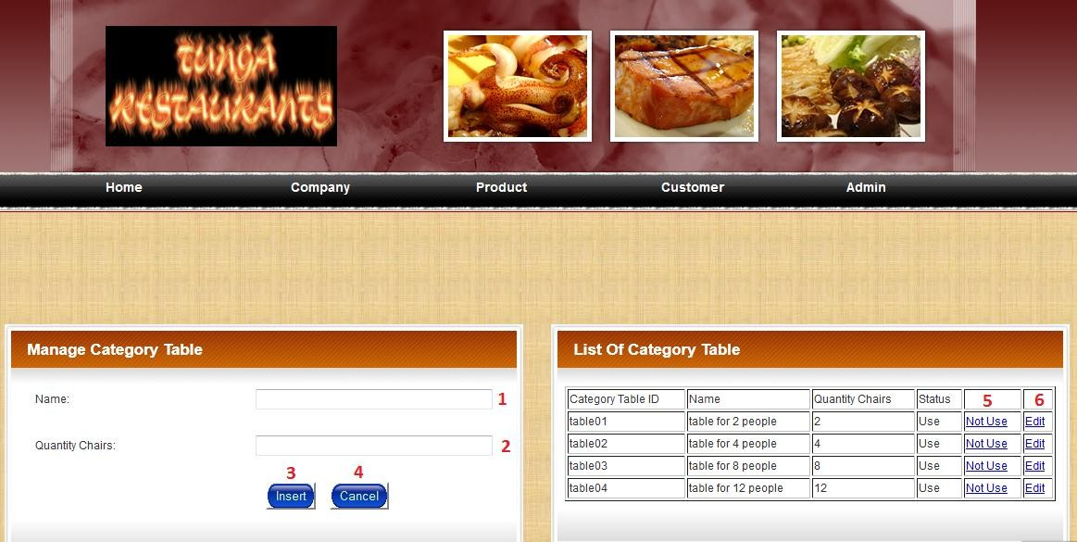

➢ **Description event:**

• Click (btnInsert): if data valid, insert new room into database.

• Click (btnCancel): back.

• Click (linkChangeStatus): change status of room.

• Click (linkDetail): display update form.

|  |  |  |
| --- | --- | --- |
|  | **Prepared by (Student)** | **Approved by (Faculty)** |
| **Date** | **Project Group No : 1** |  |
| **Signature** | **All members** |  |

|  |  |  |
| --- | --- | --- |
| **Design Plan :** | **Document Name :** TUNGA RESTAURANTS  WEBSITE | **SWD/Form No.** |
| **Effective Date: 14/11/2014** | **Version: 1.0** | **Page No :** 159**/** 172 |

9.13.2 **Display Update Form:**

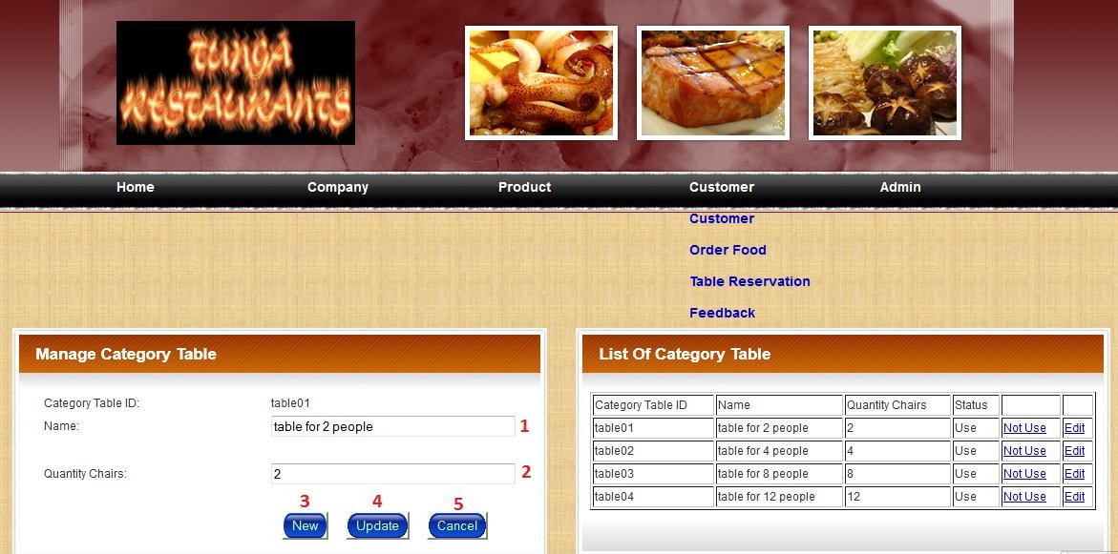

|  |  |  |  |  |
| --- | --- | --- | --- | --- |
| **NO** | **Name** | **Type** | **Validation** | **Event** |
| 1 | txtName | TextBox | required |  |
| 2 | txtQuantitychairs | TextBox | required |  |
| 3 | btnNew | Button |  | Click |
| 4 | btnUpdate | Button |  | Click |
| 5 | btnCancel | Link |  | Click |

➢ **Description event:**

• Click (btnNew): display insert form.

• Click (btnUpdate): if data valid, update room into database.

• Click (btnCancel): back.

|  |  |  |
| --- | --- | --- |
|  | **Prepared by (Student)** | **Approved by (Faculty)** |
| **Date** | **Project Group No : 1** |  |
| **Signature** | **All members** |  |

|  |  |  |
| --- | --- | --- |
| **Design Plan :** | **Document Name :** TUNGA RESTAURANTS  WEBSITE | **SWD/Form No.** |
| **Effective Date: 14/11/2014** | **Version: 1.0** | **Page No :** 160**/** 172 |

9.14 **adCategoryFood.jsp:**

9.14.1 **display Insert Form:**

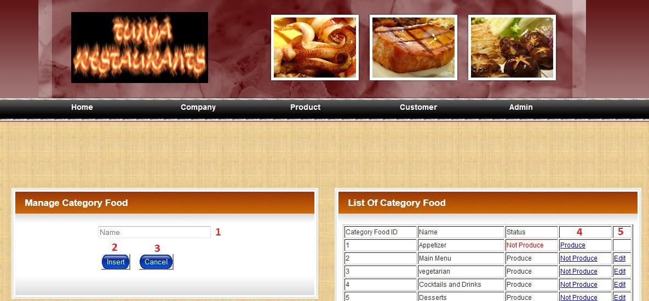

|  |  |  |  |  |
| --- | --- | --- | --- | --- |
| **NO** | **Name** | **Type** | **Validation** | **Event** |
| 1 | txtName | TextBox | required |  |
| 3 | btnInsert | Button |  | Click |
| 4 | btnCancel | Button |  | Click |
| 5 | linkChangeStatus | Link |  | Click |
| 6 | linkEdit | Link |  | Click |

➢ **Description event:**

• Click (btnInsert): if data valid, insert new categorytable into database.

• Click (btnCancel): back.

• Click (linkChangeStatus): change status of room.

• Click (linkDetail): display update form.

|  |  |  |
| --- | --- | --- |
|  | **Prepared by (Student)** | **Approved by (Faculty)** |
| **Date** | **Project Group No : 1** |  |
| **Signature** | **All members** |  |

|  |  |  |
| --- | --- | --- |
| **Design Plan :** | **Document Name :** TUNGA RESTAURANTS  WEBSITE | **SWD/Form No.** |
| **Effective Date: 14/11/2014** | **Version: 1.0** | **Page No :** 161**/** 172 |

9.14.2 **Display Update Form:**

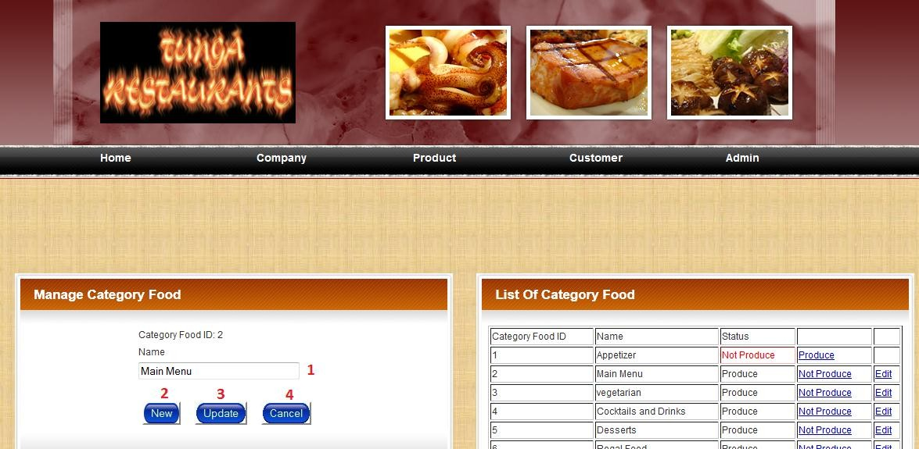

|  |  |  |  |  |
| --- | --- | --- | --- | --- |
| **NO** | **Name** | **Type** | **Validation** | **Event** |
| 1 | txtName | TextBox | required |  |
| 2 | btnNew | Button |  | Click |
| 3 | btnUpdate | Button |  | Click |
| 4 | btnCancel | Link |  | Click |

➢ **Description event:**

• Click (btnNew): display insert form.

• Click (btnUpdate): if data valid, update category table into database.

• Click (btnCancel): back.

|  |  |  |
| --- | --- | --- |
|  | **Prepared by (Student)** | **Approved by (Faculty)** |
| **Date** | **Project Group No : 1** |  |
| **Signature** | **All members** |  |

|  |  |  |
| --- | --- | --- |
| **Design Plan :** | **Document Name :** TUNGA RESTAURANTS  WEBSITE | **SWD/Form No.** |
| **Effective Date: 14/11/2014** | **Version: 1.0** | **Page No :** 162**/** 172 |

9.15 **adFood.jsp:**

9.15.1 **Display Insert Form:**

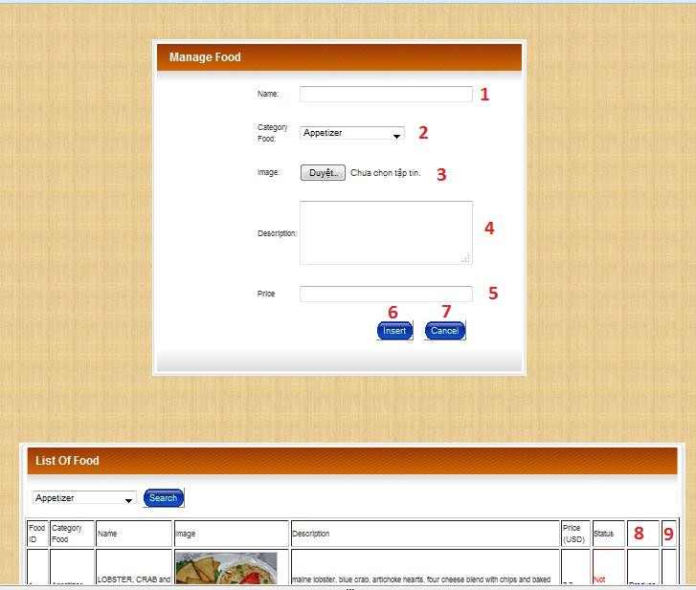

|  |  |  |  |  |
| --- | --- | --- | --- | --- |
| **NO** | **Name** | **Type** | **Validation** | **Event** |
| 1 | txtName | TextBox | required |  |
| 2 | slCategoryFood | Select | required |  |
| 3 | fileImage | File | required |  |

|  |  |  |
| --- | --- | --- |
|  | **Prepared by (Student)** | **Approved by (Faculty)** |
| **Date** | **Project Group No : 1** |  |
| **Signature** | **All members** |  |

|  |  |  |
| --- | --- | --- |
| **Design Plan :** | **Document Name :** TUNGA RESTAURANTS  WEBSITE | **SWD/Form No.** |
| **Effective Date: 14/11/2014** | **Version: 1.0** | **Page No :** 163**/** 172 |

|  |  |  |  |  |
| --- | --- | --- | --- | --- |
| 4 | txtDescription | TextBox | required |  |
| 5 | txtPrice | TextBox | required |  |
| 6 | btnInsert | Button |  | Click |
| 7 | btnCancel | Button |  | Click |
| 8 | linkChangeStatus | Link |  | Click |
| 9 | linkDetail | Link |  | Click |

➢ **Description event:**

• Click (btnInsert): if data valid, insert new food into database.

• Click (btnCancel): back.

• Click (linkChangeStatus): change status of food.

• Click (linkDetail): display update form.

|  |  |  |
| --- | --- | --- |
|  | **Prepared by (Student)** | **Approved by (Faculty)** |
| **Date** | **Project Group No : 1** |  |
| **Signature** | **All members** |  |

|  |  |  |
| --- | --- | --- |
| **Design Plan :** | **Document Name :** TUNGA RESTAURANTS  WEBSITE | **SWD/Form No.** |
| **Effective Date: 14/11/2014** | **Version: 1.0** | **Page No :** 164**/** 172 |

9.15.2 **Display Update Form:**

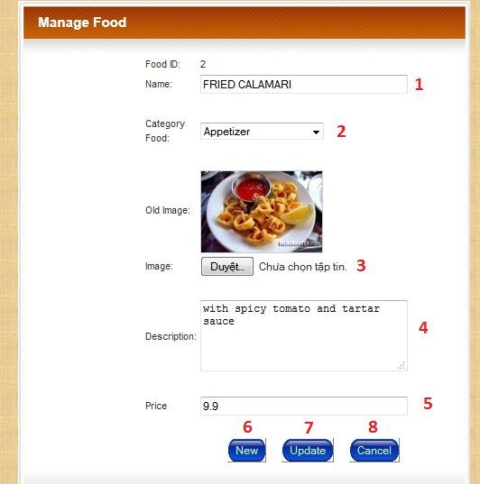

|  |  |  |  |  |
| --- | --- | --- | --- | --- |
| **NO** | **Name** | **Type** | **Validation** | **Event** |
| 1 | txtName | TextBox | required |  |
| 2 | slCategoryTable | Select | required |  |
| 3 | fileImage | File |  |  |
| 4 | txtDescription | TextBox |  |  |

|  |  |  |
| --- | --- | --- |
|  | **Prepared by (Student)** | **Approved by (Faculty)** |
| **Date** | **Project Group No : 1** |  |
| **Signature** | **All members** |  |

|  |  |  |
| --- | --- | --- |
| **Design Plan :** | **Document Name :** TUNGA RESTAURANTS  WEBSITE | **SWD/Form No.** |
| **Effective Date: 14/11/2014** | **Version: 1.0** | **Page No :** 165**/** 172 |

|  |  |  |  |  |
| --- | --- | --- | --- | --- |
| 5 | txtPrice | TextBox | required |  |
| 5 | btnNew | Button |  | Click |
| 6 | btnUpdate | Button |  | Click |
| 7 | btnCancel | Link |  | Click |

➢ **Description event:**

• Click (btnNew): display insert form.

• Click (btnUpdate): if data valid, update food into database.

• Click (btnCancel): back.

|  |  |  |
| --- | --- | --- |
|  | **Prepared by (Student)** | **Approved by (Faculty)** |
| **Date** | **Project Group No : 1** |  |
| **Signature** | **All members** |  |

|  |  |  |
| --- | --- | --- |
| **Design Plan :** | **Document Name :** TUNGA RESTAURANTS  WEBSITE | **SWD/Form No.** |
| **Effective Date: 14/11/2014** | **Version: 1.0** | **Page No :** 166**/** 172 |

9.16 **adCustomer.jsp:**

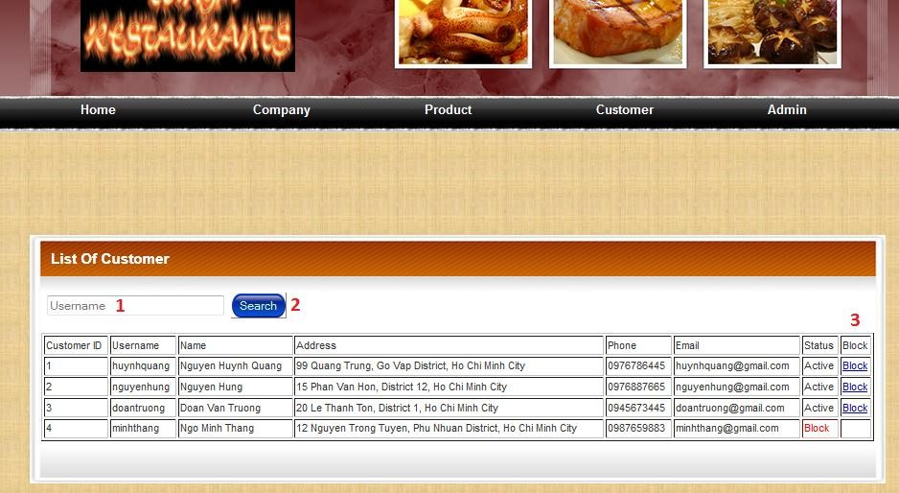

|  |  |  |  |  |
| --- | --- | --- | --- | --- |
| **NO** | **Name** | **Type** | **Validation** | **Event** |
| 1 | txtUsername | TextBox | required |  |
| 2 | btnSearch | Button |  | Click |
| 3 | linkBlock | link |  | Click |

➢ **Description event:**

• Click (btnSearch): search customer by username.

• Click (linkBlock): block customer.

|  |  |  |
| --- | --- | --- |
|  | **Prepared by (Student)** | **Approved by (Faculty)** |
| **Date** | **Project Group No : 1** |  |
| **Signature** | **All members** |  |

|  |  |  |
| --- | --- | --- |
| **Design Plan :** | **Document Name :** TUNGA RESTAURANTS  WEBSITE | **SWD/Form No.** |
| **Effective Date: 14/11/2014** | **Version: 1.0** | **Page No :** 167**/** 172 |

9.17 **adOrderFood.jsp:**

|  |  |  |  |  |
| --- | --- | --- | --- | --- |
| **NO** | **Name** | **Type** | **Validation** | **Event** |
| 1 | txtOrderDate | TextBox | required |  |
| 2 | btnSearch | Button |  | Click |
| 3 | linkConfirm | link |  | Click |
| 4 | linkDelete | link |  | Click |
| 5 | linkDetail | link |  | Click |

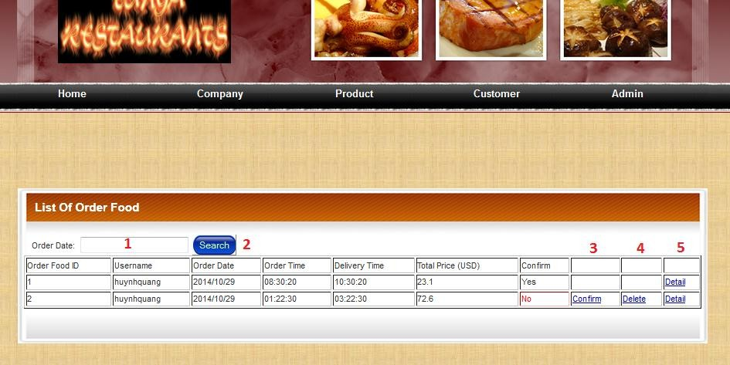

➢ **Description event:**

• Click (btnSearch): search order food by order date.

• Click (linkBlock): block customer.

• Click (linkConfirm): Confirm order food.

• Click (lickDelete): delete order food.

• Click (lickDetail): view detail order food.

|  |  |  |
| --- | --- | --- |
|  | **Prepared by (Student)** | **Approved by (Faculty)** |
| **Date** | **Project Group No : 1** |  |
| **Signature** | **All members** |  |

|  |  |  |
| --- | --- | --- |
| **Design Plan :** | **Document Name :** TUNGA RESTAURANTS  WEBSITE | **SWD/Form No.** |
| **Effective Date: 14/11/2014** | **Version: 1.0** | **Page No :** 168**/** 172 |

9.18 **adOrderTable.jsp:**

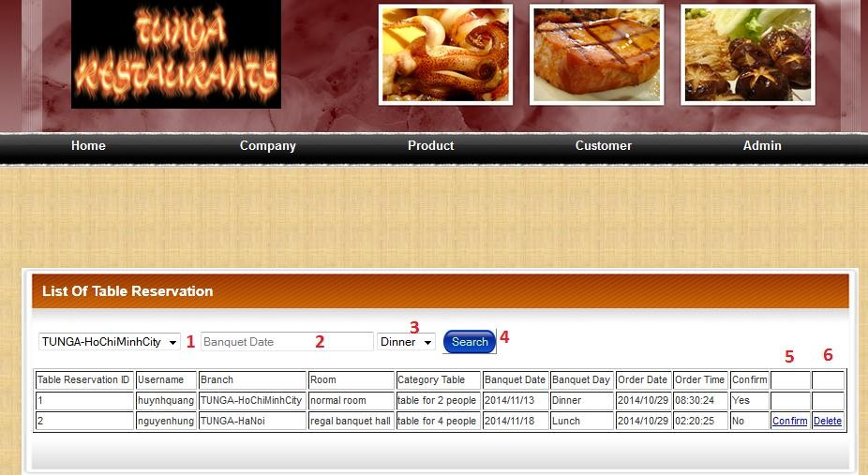

|  |  |  |  |  |
| --- | --- | --- | --- | --- |
| **NO** | **Name** | **Type** | **Validation** | **Event** |
| 1 | slBranch | Select | required |  |
| 2 | txtBanquetDate | TextBox | required |  |
| 3 | slBanquetDay | Select | required |  |
| 4 | btnSearch | Button |  | Click |
| 5 | linkConfirm | link |  | Click |
| 6 | linkDelete | link |  | Click |

➢ **Description event:**

• Click (btnSearch): search order table by banquet date.

• Click (linkConfirm): Confirm ordertable.

• Click (lickDelete): delete order table.

|  |  |  |
| --- | --- | --- |
|  | **Prepared by (Student)** | **Approved by (Faculty)** |
| **Date** | **Project Group No : 1** |  |
| **Signature** | **All members** |  |

|  |  |  |
| --- | --- | --- |
| **Design Plan :** | **Document Name :** TUNGA RESTAURANTS  WEBSITE | **SWD/Form No.** |
| **Effective Date: 14/11/2014** | **Version: 1.0** | **Page No :** 169**/** 172 |

9.19 **adFeedback.jsp:**

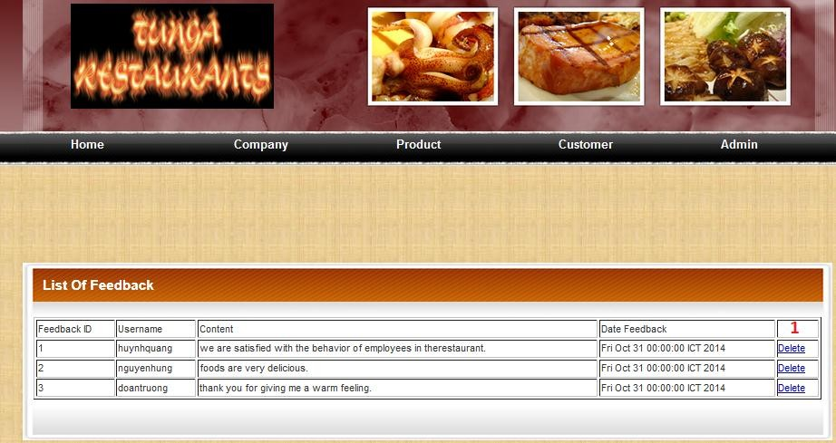

|  |  |  |  |  |
| --- | --- | --- | --- | --- |
| **NO** | **Name** | **Type** | **Validation** | **Event** |
| 1 | linkDelete | link |  | Click |

➢ **Description event:**

• Click (linkDelete): Delete feedback.

|  |  |  |
| --- | --- | --- |
|  | **Prepared by (Student)** | **Approved by (Faculty)** |
| **Date** | **Project Group No : 1** |  |
| **Signature** | **All members** |  |

|  |  |  |
| --- | --- | --- |
| **Design Plan :** | **Document Name :** TUNGA RESTAURANTS  WEBSITE | **SWD/Form No.** |
| **Effective Date: 14/11/2014** | **Version: 1.0** | **Page No :** 170**/** 172 |

9.20 **adAdmin.jsp:**

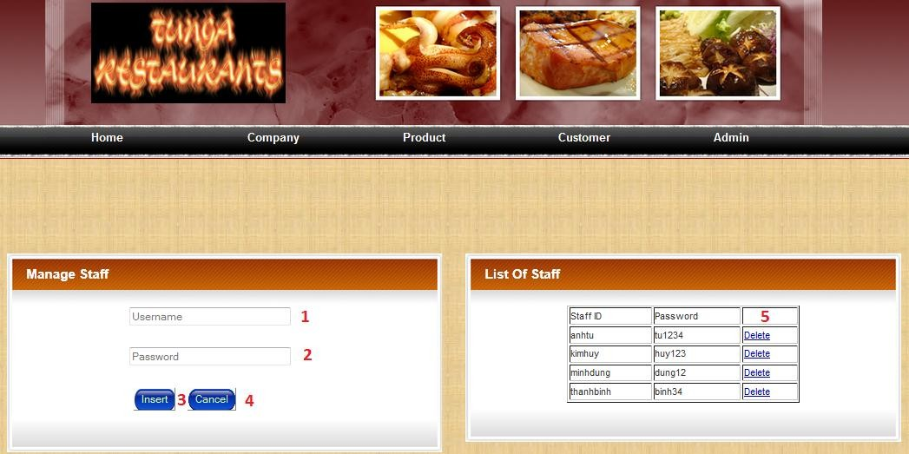

|  |  |  |  |  |
| --- | --- | --- | --- | --- |
| **NO** | **Name** | **Type** | **Validation** | **Event** |
| 1 | txtUsername | TextBox | required |  |
| 2 | txtPassword | TextBox | required |  |
| 3 | btnInsert | Button |  | Click |
| 4 | btnCancel | Button |  | Click |
| 6 | linkDelete | link |  | Click |

➢ **Description event:**

• Click (btnInsert): insert new staff into database.

• Click (linkCancel): Back.

• Click (lickDelete): delete staff.

|  |  |  |
| --- | --- | --- |
|  | **Prepared by (Student)** | **Approved by (Faculty)** |
| **Date** | **Project Group No : 1** |  |
| **Signature** | **All members** |  |

|  |  |  |
| --- | --- | --- |
| **Design Plan :** | **Document Name :** TUNGA RESTAURANTS  WEBSITE | **SWD/Form No.** |
| **Effective Date: 14/11/2014** | **Version: 1.0** | **Page No :** 171**/** 172 |

**Review 3 Task Sheet**

|  |  |  |  |  |  |  |
| --- | --- | --- | --- | --- | --- | --- |
| **Group: 1** | | **Project Name:**  **Tunga Restaurants Website** | **Timeline** | | | |
| **Num** | **Job** | **Description** | **Start**  **Date** | **Date**  **Finish** | **Student Name** | **Status** |
| **01** | **R ev ie w**  **3** | **index.jsp** | **03**  **–**  **11**  **-**  **20**  **14** | **14**  **–**  **11**  **–**  **20**  **14** | **All** | Completed |
| **02** | **changepass.jsp** | **Nguyen Thanh**  **Binh** | Completed |
| **03** | **updateProfile.jsp** | **Nguyen Thanh**  **Binh** | Completed |
| **04** | **menu.jsp** | **All** | Completed |
| **05** | **orderFood.jsp** | **Nguyen Anh Tu** | Completed |
| **06** | **tableReservation.jsp** | **Nguyen Anh Tu** | Completed |
| **07** | **feedback.jsp** | **Nguyen Thanh**  **Binh** | Completed |
| **08** | **adLogin.jsp** | **All** | Completed |
| **09** | **adHome.jsp** | **All** | Completed |
| **10** | **adChangePass.jsp** | **Nguyen Minh**  **Dung** | Completed |
| **11** | **adBranch.jsp** | **Nguyen Kim Huy** | Completed |
| **12** | **adRoom.jsp** | **Nguyen Kim Huy** | Completed |
| **13** | **adCategoryTable.jsp** | **Nguyen Kim Huy** | Completed |
| **14** | **adCategoryFood.jsp** | **Nguyen Minh**  **Dung** | Completed |

|  |  |  |
| --- | --- | --- |
|  | **Prepared by (Student)** | **Approved by (Faculty)** |
| **Date** | **Project Group No : 1** |  |
| **Signature** | **All members** |  |

|  |  |  |
| --- | --- | --- |
| **Design Plan :** | **Document Name :** TUNGA RESTAURANTS  WEBSITE | **SWD/Form No.** |
| **Effective Date: 14/11/2014** | **Version: 1.0** | **Page No :** 172**/** 172 |

|  |  |  |  |  |  |  |
| --- | --- | --- | --- | --- | --- | --- |
| **15** |  | **adFood.jsp** |  |  | **Nguyen Minh**  **Dung** | Completed |
| **16** | **adCustomer.jsp** | **Nguyen Thanh**  **Binh** | Completed |
| **17** | **adOrderTable.jsp** | **Nguyen Anh Tu** | Completed |
| **18** | **adOrderFood.jsp** | **Nguyen Anh Tu** | Completed |
| **19** | **adFeedback.jsp** | **Nguyen Thanh**  **Binh** | Completed |
| **20** | **adAdmin.jsp** | **Nguyen Minh**  **Dung** | Completed |

Team Leader’s Signature Instructor’ Signature

Nguyen Anh Tu Mr. Ngo Phuoc Nguyen

|  |  |  |
| --- | --- | --- |
|  | **Prepared by (Student)** | **Approved by (Faculty)** |
| **Date** | **Project Group No : 1** |  |
| **Signature** | **All members** |  |